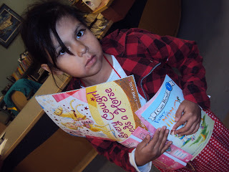

http://schoollibraryservices.blogspot.ca/2012/11/i-love-reading.html
Access to Books Maskwacis Community
2011-2013
Objective: Empowering People, Strengthening Communities, and
Creating Sustainability by Nurturing Reading

(College - Employees Participate in Communities)
Copyright: Access to books: 2011-2013 by CC By Manisha Khetarpal is licensed under a Creative Commons Attribution 4.0 International License, September 2013

"Nothing frees the mind more than reading books!"
A mother-daughter book drive initiative for FNs by neurosurgeon Dr. Mojgan Hodai
So, what has been done so far
about access to books in Hobbema?

This report shows various ways of sourcing books from foundations, colleges, family literacy organizations, public libraries, internal school community budgets, Adopt a School programs, garage sales, gently used book stores, councillors, publishers, children’s service agencies, pediatricians, organizing book exchanges, reading programs; it is just the beginning to provide access to books to FNs communities on FNs reserve land. Some pages of this report were used as posters to entice FNs families to read and thus embed the reading habit in their lifestyle. Our focus was, 'Books First, Read Next.'

- Books distributed on 34 occasions in 2 years
- Partners and relationship development

- Piggy-back on community activities, events and programs

- Action steps proposed

The area of applied research initiative currently evolving at Canada’s colleges clearly reflects Boyer’s precept that “higher education must serve the interests of the larger community.” Citing Handlin (1986), Boyer notes that “scholarship has to prove its worth not on its own terms but by service to the nation and the world.”
Fisher, Roger (2008). Faculty Participation in Research at Canadian Colleges. Canadian Council on Learning (CCL).

Abbreviations used: COW: Community Literacy Classroom on Wheels
TDSRC: TD Summer Reading Club
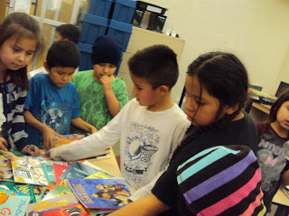
1. Books distributed on 34
occasions in 2 years

Read this list to get ideas about 'points of entry' to distribute books to children and their families.

- "We love books" book distribution day at the school by Bighorn Library, February, 2011

- Bonny Books and Bighorn Public Library gently used books for FNs students, November 21, 2011

Nov 22, 2011, http://abookforeverychildnov22.blogspot.ca/
- Legacy Library (COW Bus) presented to the school principal at the Celebration of Learning, November 22, 2011

- Frontier College donated books for the Family Literacy Day celebration coffeehouse, January 26, 2012

- 100% attendance awards were given book gift vouchers to buy books at the book fair, February 2012.

- Class 3A achieved their AR reading goal and received free books for team goal achievement, March 16, 2012

- Buy 1 Get 1 Free book fair, May 15, 2012 at the library

- Book Bins placed around the community, July-August, 2012

- TDSRC book distribution, Week 1, TDSRC, July 4, 2012

- First Books helps families start their home libraries, Week 2, TDSRC, July 11, 2012

- TDSRC book distribution Week 3, July 18, 2012

- COW Bus gives away books and many literacy play ideas to FNs families, safety alerts for toys marketed as books, stopover at the school library, July 18, Week 3, TDSRC

- Books distributed during Week 4, TDSRC, July 25, 2012

- Community Safety Advocate taking home books for education programs, Week 5, TDSRC, August 15, 2012

- Books given to Maskwacis Outreach school, September 2012

- Reading is an essential skills day celebrated by distributing books, September 21, 2012

- First Books donated books to FNs students to set-up their home libraries, September 2012

- INDIGO’s Adopt a School campaign participation, 310 books given by 125 adopters, October 2012

- Frontier College donated books for FN families, October 2012

- Scholastic Book Fair, October 26, 2012

- Students participated in Intellimedia's Ermineskin Reads and received free books during Libraries Connect month, October 2012

- Books given to Samson High School students for the Halloween Concert on October 30, 2012

- Books given to school students on Halloween Day, Trick or Treat give me something good to read, October 31, 2012

- Diary of Wimpy Kids set of books distributed to Grade 4E students. FNs students voraciously read these books, November 9, 2012

- Class 6S students received curriculum related graphic novels from First Books on November 14, 2012

- Class 3C received books for demonstrating excellent borrowing behaviour on November 14, 2012

- Class 5C achieved their AR reading goals and received books as gifts from First Books on Nov 14, 2012

- National Reading Campaign book distribution to grandparents on November 15, 2012

- IODE's Books and Breakfast Club, DEAR time, and Reading energizers, November 2012

- Diary of a Wimpy Kid - Third Wheel distributed to a Class 4E at the Ermineskin Elementary School, December 19, 2012

- Books distributed at the COW Bus stopover at Samson Bingo for the Family Literacy celebration, January 18, 2013

- Library in a Box Service which is 'bulk reading volume boutique' for everyone launched, May 29, 2013

- Stony Plain Public Library gave away books at the Library Showcase, July 17, 2013

- Books given in the door prize bags of social work students during the orientation and mixer at the
Maskwacis Cultural College Library, September 5, 2013

Next giveaways:
- August 28,2013: Give away books to Montana school and tribal administration office
- September 6,2013: Give away books to college students at the Four Nations student orientation
- September 9,2013: International Literacy Day mixer for Warriors and their families
- September 27,2013: Reading is an Essential Skill Day celebration

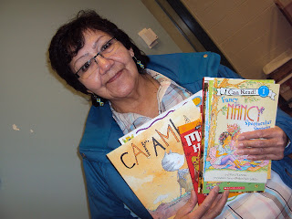
Grandparents read to grandchildren
2. Partners and relationship
development

Sincerely appreciate the support provided by organizations, institutions, public libraries, and individuals to nurture reading as a habit for FNs families.

Grandmother Theresa Thunderchild is proud to read to her children anytime and in particular during the National Reading Campaign, November 15, 2012
Book givers and facilitators
Corporations  TD | Families  Mackinaw  Wildcat, Littlechild, Saddleback, Crier, Yellowbird, Minde | Foundations, book retailers and publishers  First Books Canada  Alberta Book Publishers Association  Canadian Children's Book Centre  INDIGO’s Adopt a School campaign
Businesses  Intellimedia | Book Givers  Bonny Books | Public Library  Bighorn Public Library, Westlock Public Library, Edmonton Public Library, Stony Plain Public Library
Literacy organizations  Centre for Family Literacy's Legacy Library and COW Bus, TDSRC,  LearningLinks | College  Frontier College | Book Fair  Scholastic
Service Clubs  IODE | Individuals  Tymm Zehr | Councillor  Samuel Minde

"Reading preserves the culture for the next generation. It creates a shared connection to the community."
http://nationalreadingcampaign.ca/about-us/the-national-reading-plan/
3. Piggy-back books and reading on community activities

This section has information about how books, print and reading was leveraged during the National Reading Campaign, Bird Migration Day, Books as achievement awards, Welcome Orientations, and Mixers. A quick dipstick research was conducted and people were asked about their favourite books. Pictures of people with the books they are using was were captured using a camera. Then, posters were created and pinned in public places. These book ambassadors served as reading role models and showed the association with print for learning purpose.

National Reading Campaign featuring Henderson Best

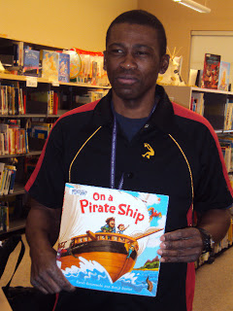

Henderson Best uses, 'On a Pirate Ship' book to teach life skills lessons to his students,
November 2012
"Innovations emerge when there are interconnections and interdependencies, when we work outside the parameters of what has been done before and seek out new possibilities. We all have the ability to connect one idea with another, to find an idea in a different organization, in a different industry or field of activity and connect it with another to solve a problem at hand."
Martins-Rodriquez, and Viedma-Marti, 2006

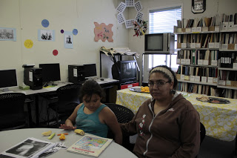
Let's go the library
Mother daughter reading on the occasion of the Bird and Word house event at the Maskwacis Community Library.

May 17, 2013

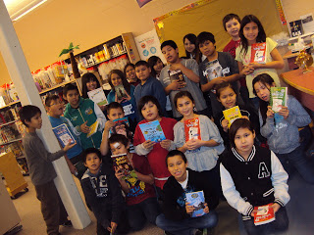
5C class received book from First Books for achieving their reading goals
Mrs. Jessica Chaves was the winner for many students in her class achieved their reading goals. The class is a model for Peer to Peer reading support. This class demonstrates high motivation to read for pleasure. Thank you First Books for giving books on this day of the launch of the National Reading campaign.

October 2012
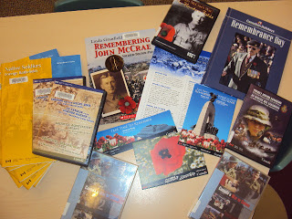
We read everything

Remembrance day resources provided by Veterans Affairs;
Bookmarks, posters, books, DVDs, and information handouts.

November 2012

First Book Canada-TD Bank helps establish home libraries with quality reading resources for FNs students on FNs land

Books were sourced from First Books-TD Bank grant and distributed to a class of Grade 4E students on November 9th, 2012. Their teacher Mr. Frans Erickson (in the picture) was excited and promotes reading for the fun of it. Each student received five copies of the Diary of the Wimpy Kid series.
Interesting and high demand books are given away to children

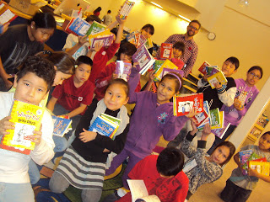

"Early access to joyful reading is the right of all children and in a democracy schools are the place where
such access can be guaranteed"
http://nationalreadingcampaign.ca/about-us/the-national-reading-plan/

Give a child a ball they will play
Give a child a book they will read

Reading Role Model Champion
Wilda Listener, Chair of Social Work

I originally grow up on the Piikani Reserve with my mother and grandmother where I learned from them on how to be an indigenous woman in the modern world. My dad is from the Ermineskin Cree Nation. I moved to the Hobbema area in 1993. One thing that my Elders encouraged to do was to get my education and continue learning. My education took me to Augustana University College with my first taste of university life and I was amazed. My first interest was biology but then I decided to change my major to psychology. I completed my degree in psychology at Augustana. I enter the work force and soon realized that I had much to learn. I was young, inexperienced but had a lot of enthusiasm and heart. I wanted to continue my education journey after taking 5 years away from it. The opportunity came when MCC was host to the University of Calgary, Bachelor of Social Work, and I quickly learned that this was what I meant to do. After completing the program I applied for the Master of Social Work and went to U of C to complete my studies. My path has led me to some interesting jobs such as Director of Ermineskin Social Development and a position at the Ermineskin Women’s Shelter Society. Now at my dream job of MCC, I truly enjoy being a part of other future social workers and doing my best to nourish the minds and hearts of people who want to become helpers. This is my second year at MCC and I truly love being a part of the college and the social work program. The library gave books for the door prize bags for the students during the 'Welcome to College Orientation' in September of 2013 at the Maskwacis Cultural College.

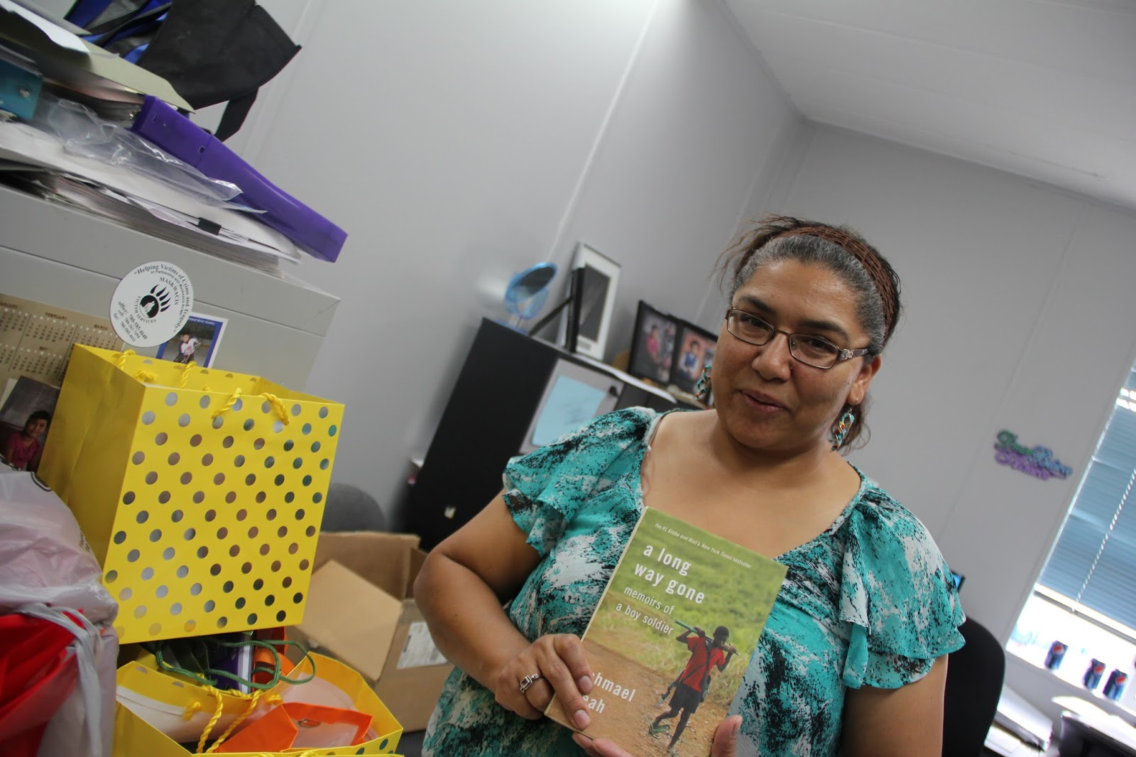

"Who will be involved?
Readers, parents, young people, academics, librarians, educators, publishers of all media, booksellers, literacy organizations, writers, community organizations, business (both large and small), trade unions, elected officials, Aboriginal elders, child-care providers, NGOs/associations, all levels of government, and members of the community who care passionately about the power and pleasure of the written word."

http://nationalreadingcampaign.ca/about-us/the-national-reading-plan/
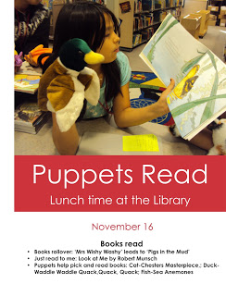
4. Action steps proposed

- Conduct a study about reading interests
- Offer blended events such as Story Reading, Story Bags, Story Maps
- Encourage reading hour
- Make reading visible
- Embed reading and research time in classrooms
- Initiate annual Book Exchanges
- Host author readings and read aloud sessions
- Offer 'Homework Library in a Box' for students and families
- Focus on a 'Book of the day' with some incentives to engage readers
- Offer a paired reading program

[Picture source] http://schoollibraryservices.blogspot.ca/2011/11/puppets-read-at-lunch-at-our-library.html

- Continue accountability progress updates to partners and consolidate relationship

- Continue connecting book contributors with reading consumers at grassroots level

- Organize in partnership 'Reading Literacy' camp and 'How-to' read/access the library workshops

- Run a Reading Role Models and Reading Ambassadors campaign with champions such as elders and parents

- Expand the network of book contributors and look for ways of showing appreciation

- Source eBook subscriptions, start a digital library, and gadgets such as Kobo ereaders

- Explore by storytelling, make a felt story and writing engagements

- Offer reading aids workshop such as making pointers, bookmarks, post- it notes, writing book reviews, I like this book because, and peer to peer recommendations

- Keep FNs communities and associated stakeholders informed about nurturing reading initiatives and resources

Let's all work together to nurture reading.
Useful links
- Collaboration Bulletin for schools: http://manishakhetarpal.blogspot.ca/2012/11/collaboration-bulletin-free-book.html
- Accessing the library lesson plan: http://www.nald.ca/connect/v3i2/db/lesson2.pdf
- Source for the pictures: http://schoollibraryservices.blogspot.ca/2013/05/mother-daughter-reading-together-and.html

http://abookforeverychildnov22.blogspot.ca/

To start a book distribution program in your community contact
Manisha Khetarpal
780 352 1633
librarieshelppeople@gmail.com

Objective: Empowering People, Strengthening Communities, and Creating Sustainability by Nurturing Reading
Output: Access to Books, Read Next
Outcome: Sustainable supply of reading resources and cultivate reading habit

