如何使用Google搜索
How to Search with Google

Google is a great website for searching or looking up something you are interested in. To search on Google:
Google 是一個對於搜索非常有利的網頁。若想在Google上搜索：
- Open your internet browser (e.g. Internet Explorer, Google Chrome, Mozilla Firefox, Safari, etc.)
開啟您的網絡瀏覽器 (例如Internet Explorer, Google Chrome, Mozilla Firefox)。
- Click on the address bar (where the website is) once.
按一下網址欄 (顯示網址的地方)。

- Type google.ca in the address bar, and press ‘Enter’ on your keyboard.
在網址欄輸入google.ca，並且按Enter鍵。

- The Google website will load with a blank search box – it should look like this:
Google的網頁會顯示出一個空白的搜尋欄。

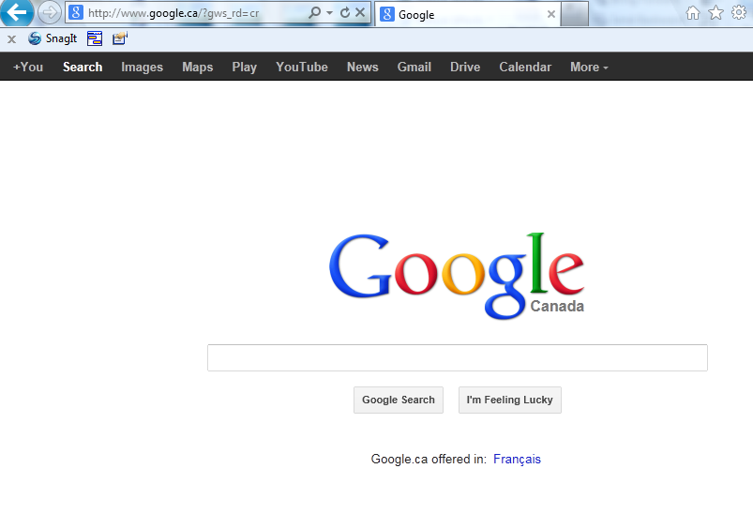
Click on the search bar and type in whatever you want to look for (eg, Canadian Passport Application form)
按一次搜尋欄並且輸入您想找的資訊 (例如, 加拿大護照申請表)。

- In the blank search bar, type in 2 or 3 words describing what you’re looking for in the empty search box. Then click on Google Search or press Enter on your keyboard.
在空白的搜尋欄裡輸入您想找的資訊或形容詞，並且按Google Search或Enter鍵。
For example, you can try the following searches:
您可以輸入類似以下的搜索：
- 素理工作
- 魔戒的評論
- 北溫日式餐廳
- 蛋糕食譜
- Jobs in Surrey
- Lord of the Rings review
- Japanese Restaurants in North Vancouver
- Cake Recipes
- After you click the search button, a list of results matching what you typed in will appear. Generally, the ones which more closely match your words will appear first.
Google會列出搜索結果。比較合您輸入的搜索關鍵詞的網頁會率先列出來。
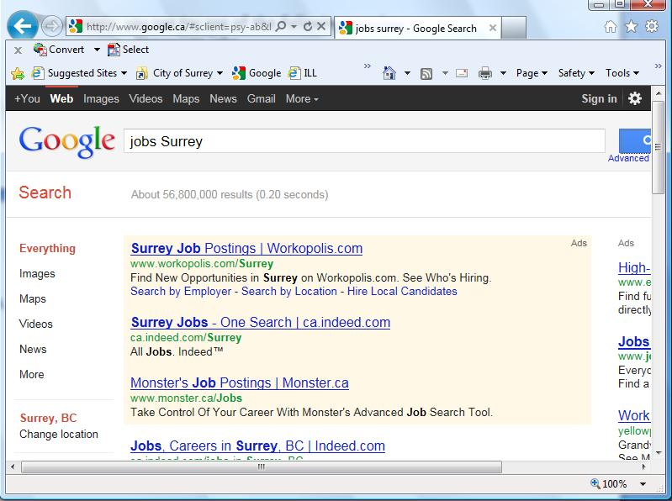
Use these scroll bars to go up and down on the page and view all results
您可以用網頁邊邊的滾動條來觀看所有的搜索結果（網頁下面通常還有更多結果）。

- Read the brief descriptions of the results displayed and if you feel that one of them may contain information relevant to what you searched for, click on the hyperlink of the page
搜索結果下會有簡介。若有看到任何您覺得符合您要找的資訊就按下那結果的超鏈接。
- If none of the pages listed on the first page of results match your criteria, you can scroll down to the bottom and click on Next, or 2 to go to the next page containing results. Many web pages are generated by a general search, but the relevant ones are usually found in the first couple of pages.
若您覺得搜索結果第一頁列出的網頁都不是您所要的，那您可以向下滾動您的網頁並且按下一頁或2來移動到下一個搜索結果的網頁；通常相應您輸入的關鍵詞的網頁會在第一頁。
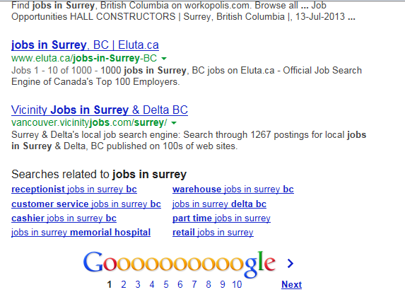
Click here to see more results.
按這就會顯示下一頁的搜索結果。
- If you click on a link and feel it doesn’t satisfy your search criteria, use the back button to go back to the results page to find another page. Or, you can scroll up to the top and try modifying your search by changing some words in the search box and then hitting ‘Google search’, or pressing the ‘Enter’ key again.
若您按了一個鏈接然後發現它不是您想要的，您可以用上一頁的按紐回到搜索結果頁並且再尋找您所想要的網頁。您也可以試著更改搜索欄裡的關鍵詞好修飾您的搜索結果。

