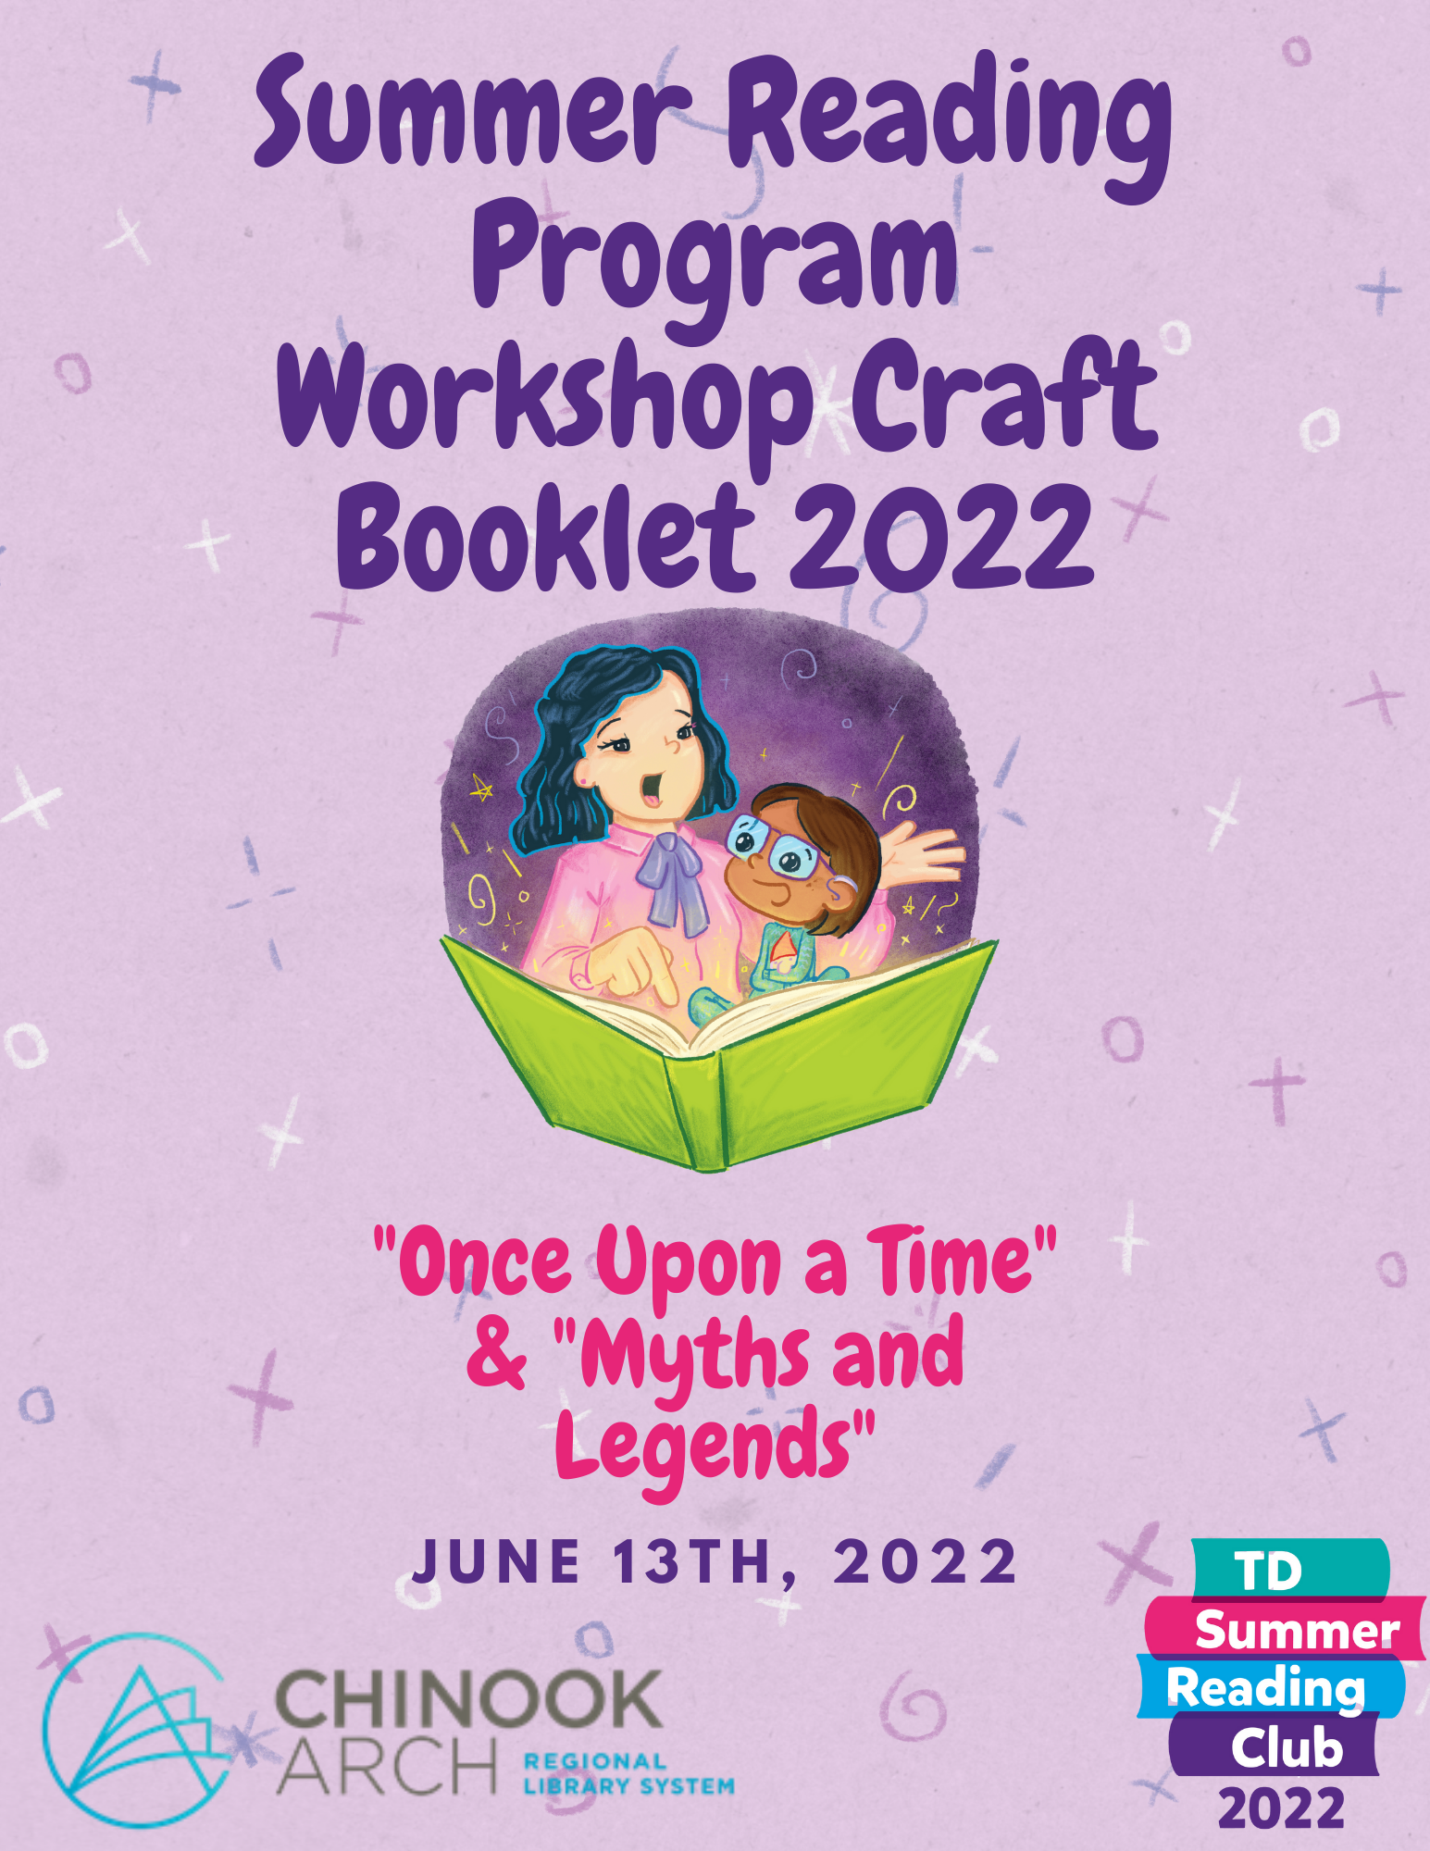
This booklet is full of ideas for your member libraries to use for your programs or to give you inspirations to make your own games, crafts and or activities! Chinook Arch SRP’s won’t be using any of these ideas so there will be no overlapping! We want your reading programs to be full of fun and adventure, which is why we are here to help!!
Games
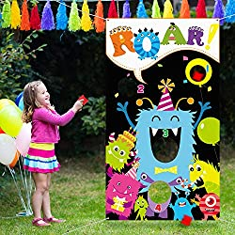
Feed the Monster!
- Feed the monsters is a bean bag toss game! Get cardboard or something sturdier and paint a couple of monsters on it! Cut open the mouths of the monsters and there you have it! You will need bean bags or something else to throw into the monster’s mouth! This game can be fun on its own or in a relay format!
Forbidden Pirate Word
- Choose a pirate word to be the forbidden word of the day. Since kids will be talking like pirates, some ideas for forbidden words include pirate, ship, matey, and arrrrrrrr. For the first 30 minutes, kids simply continue with the party activities as planned, but when one kid catches another saying the forbidden word, the offending player must surrender one of his coins to his captor. When time is up, the pirate with the most coins wins.
Wicked Step Mother vs. Fairy God Mother
- One player is the wicked stepmother. Another is the Fairy Godmother. The rest of the players are all Cinderella heading to the ball. Set a timer. Once the game starts, the wicked stepmother tries to take as many players as she can. When she tags players, they have to freeze in place.
Meanwhile, The Fairy Godmother has to tag the frozen players with her wand to set them free. When time is up, all of the frozen players are “sent to the attic” (out of the game). The rest get to go to the ball. In the end, count how many Cinderellas were sent to the attic and how many made it to the ball. The one with the most tags (Stepmother or Godmother) wins.
Change the players and play a few rounds so everyone gets a turn at being the wicked stepmother or fairy godmother.
Crafts
Paper Cone Monsters
Materials:
- Monster Template (on last page)
- TP Roll/Paper Towel Roll cut in half
- Colouring supplies or coloured paper
- Scissors
- Glue
*You can also use googly eyes, stickers, glitter glue, yarn or any other fun crafting material
How To:
Step One: colour the template, or if you are working on coloured paper already, cut the monster piece3s out and trace them onto the coloured sheet
Step Two: once you have finished colouring all the pieces, it is time to cut them out
Step Three: Take the head part and glue where it says to glue. After you have done that, then take the paper roll and roll the head onto the paper roll, and wait for the glue to dry
Step Four: Glue the horns onto the head, or wherever you want the horns to be
Step Five: Cut out the remaining pieces and roll the body into a cone shape, then glue it together on the glue marker
Step Six: Take the head you made, cut the dotted line so there is a slip, and then add glue to the dotted line. Once you have done that, then quickly attach the head to the body by pushing the body through the slit.

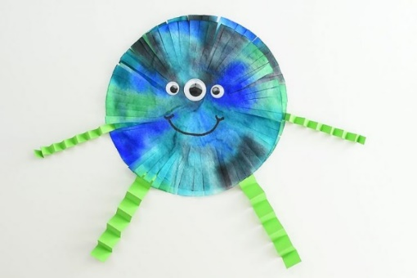
Coffee Filter Monster:
Materials:
- 2 Regular sized Coffee Filters
- Washable Markers (we used Crayola)
- Water
- An Eye Dropper or Spray Bottle
- Googly Eyes (different sizes)
- Crafters tape
- Coloured Construction Paper
- Regular Tape
How To:
Step One: Layer two filters together, one on top of the other. Try to get them as flat as you can.
Step Two: Colour the filters how ever you would like. The patterns can be all different and wild, as no two monsters will look the same.
Step Three: Once you have finished colouring the monsters, you can use an eye dropper or a spray bottle and drip water onto the filters. You want the filters to be wet, but not soaked as it will take forever to dry.
Step Four: Let the filters dry for a few hours by leaving them over night or you can dry them in the oven at a low temperature. 115F for about 30-40 minutes. If you are using an oven, be sure to watch for smoke and do not dry higher than 130F.
Step Five: Once they are dry, it is time to start cutting little slits all around the filter, this creates a fringe look.
Step Six: Time to put a face on your monster friend!
Step Seven: After your face is drawn on, pull the filters apart and rotate the bottom filter slightly so they don’t line up perfectly anymore. Once you rotate, you can use tape or double-sided tape and put them back together. Fluffing the monster gives it more dimension.
Step Eight: Add his arms and legs! Grab some construction paper and cut 4 strips – two thick (for the legs) and two thin (for the arms)
Step Nine: Fold each strip like an accordion, making sure you leave a longer bit at one end so you can tape it to your monster. Once you have folded the legs and arms, tape them on the back, and you are done!!

Monster Handprints
Materials:
- Green Paper (textured is an option)
- Dried Lentils
- Craft Foam (or construction paper)
- Glue
- Scissors
- Pencil
How To:
Step One: Pick out your paper and trace your upper arm and hand!
Step Two: Get a larger paper and glue your witch arm and hand onto it for a bigger surface
Step Three: Cut up pieces of foam or construction paper to look like long finger nails
Step Four: Glue the fingernails onto your witch hand
Step Five: Glue the various lentils and other objects onto your witches hand to make them look like warts! And TADAH! You have witch arms!

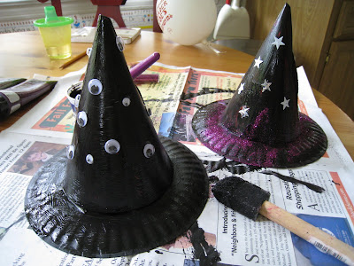
Witches Hats
Materials:
- Paper Plates
- Party Hats
- Paint
- Paint Brushes
- Glitter
- Stickers
How To:
Step One: Take a small paper plate. Make pie shaped cuts in the center circle.
Step Two: Fold up the cuts and tape or glue to inside of hat!
Step Three: Paint your hat whatever colour you want and let it dry! Once dry, have fun decorating with your glitter and stickers!

TP Roll Horses
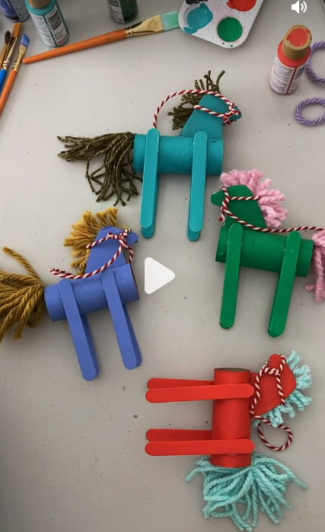
Materials:
- Recycled toilet paper rolls
- Popsicle sticks
- Recycled cardboard
- Yarn scraps
- Paint + paint brush
- Scissors
- Hot glue
- You can add a harness or reigns with bakers twine, but that’s optional!

How To:
Step One: Paint all your pieces and let them dry!
Step Two: Use the cardboard to make two horse head.
Step Three: Cut up your yarn to make the horse mane and tail.
Step Four: Take your tail yarn and glue it to the toilet paper roll.
Step Five: Assemble the head. Take your two head pieces and glue your mane to one side and let it dry. Once it is dried, then go ahead and put the second head on and let that dry.
Step Six: Glue on the legs to the body
Step Seven: Once legs are dry, glue your head on the horse

