How to Use the Mouse and Windows 如何使用滑鼠和Windows
Mouse Buttons and Mouse Pointers 鼠標鍵和鼠標指
When using the mouse, whichever way you move your hand is the way that the mouse pointer will move. If you move your hand left, the mouse pointer will move left on the screen.
當您使用鼠標時，鼠標指會跟著您的手的方向一起移動。若您的手向左，鼠標也會跟著向左。
The mouse is used frequently with Windows Operating Systems. The mouse’s default settings are configured for a right-handed person; however, they can be changed to accommodate left-handed people.
若您的電腦使用Windows操作系統，您經常會用到滑鼠。滑鼠的基本配置是設定給右撇子的使用者；可若您是左撇子那也無須操心，可以更改設定讓滑鼠更適用於左撇子。
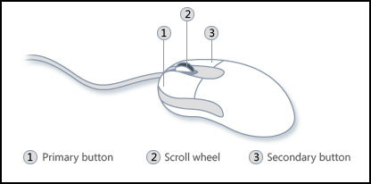
- Left Button: is used for selecting and highlighting and dragging
左鍵: 用來選則，部份明亮，和牽引。
When you are asked to “click”, this always refers to left click; people say “right click” for right clicks
若指示叫您 “按” 或 “按一下”，這是指［按左鍵］；要您按右鍵時會說［按右鍵］。
- Right Button: is used for the Context Menu (Pop Up Menu)
右鍵: 用來按出滑鼠的右鍵選單。

Tips For Using the Left Click and the Right Click 使用滑鼠左右鍵的技巧
Left Click |  | - Double click to open something (按兩次開啟檔案)
(左鍵) |  | - Single click to select something. (按一次選擇檔案)
 |  | - On the internet, single click is used. (當您使用網絡時，按一次就好)
Right Click |  | - Tells you what you can do to a particular item (告訴您可以對這個項目做什麼行動)
(右鍵) |  | - Pops up a hidden menu. (顯示出隱藏選單)
Busy pointer means that Windows is busy and is currently working to finish the last command that was sent. No other commands can be used at this time. You must wait until the Busy pointer has returned to the Normal Select pointer.
忙碌鼠標告訴您Windows操作系統正在忙著完成上一份工作指示。直到忙碌鼠標變回正常鼠標，您無法給於Windows任何其它工作指示。

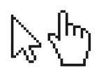
Mouse curser can change: 鼠標會變!
- Arrow (箭頭) – for pointing (用來指點)
- Hand (手) – when it is a link to another webpage (當鼠標在會連接到另一個網頁的自字體上面)
- Capital i (大寫的i )- when it is text (當鼠標在文體上面)

Additional Help 更多指點

- Go to the Surrey Public Library website: www.surreylibraries.ca
前往Surrey Public Library的網站: www.surreylibraries.ca
- Click on Programs & Services Computers & Technology Totally new to Computers series, & more!
按Programs & Services 然後 Computers & Technology再按Totally new to Computers series & more!
- Scroll down and click on “Mousing Matters Class Activities“
按Mousing Matters Class Activities
- Click on any of the links to different websites for practicing mouse skills
按任何一個連接前往新的網站練習如何使用滑鼠

Using Windows 使用Windows
The desktop is the very first screen you see after your computer starts. Desktop consists of various icons. Icons are visual representations of some applications or shortcut keys. These icons allow you to run programs from the desktop rather than going to the “Start” button and selecting from a menu. They are shortcut keys for various program applications on a computer.
當電腦剛開啟時，您會在登入後看到桌面。桌面上有許多圖示。那些圖示代表著電腦上一些程式的捷徑，讓您可以從桌面上開啟程式 (另一個方法是按 “開始” 鍵然後從出現的選單裡找出程式)。

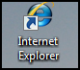
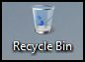
Internet Explorer is a web browser.
It is an icon for surfing the Internet.
Internet Explorer 是一個網頁瀏覽器 好讓您使用來上網。
Recycle Bin is a temporary storage place for deleted files. Windows temporarily stores all these deleted files in the Recycle Bin for restoring purposes.
資源回收桶會暫時存儲被刪除的檔案 (好便您若想恢復檔案)。

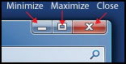

Part II – Managing a Window 如何操持視窗
Minimize (縮小) Click it with the left button to minimize an active window. This button puts a program on hold and places it on the taskbar at the bottom of the screen. To re-open the window from the taskbar, click on the box that represents the program you want.
按一下來縮小視窗。這會把程式擱置在螢幕下方的任務覽。若想打開視窗，按一下在任務覽裡代表程式的小視窗即可。
Maximize (放大) Click it with the left button to maximize an active window in order to fill the entire computer screen. If the active program's window has been maximized, button will contain two small overlapping boxes. This is a restore button. If you click it once with the left mouse button, the window will no longer cover the entire screen. It has been restored to its original size.
按一下來放大視窗。若視窗已放到最大，這鈕會有兩個交疊的匡匡。這是恢復鍵；若您按一下，視窗就不會蓋住整個螢幕了。
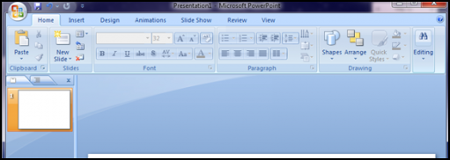
Close (關閉) Click it with the left button to close an active window. 按一下來關閉視窗。
Moving a Window 如何移動視窗
Press and drag the title bar. When you let go that’s where the window will move to.
按下左鍵(別放開喔!)然後牽引標題覽。當您放開，視窗就會移動到您所放開的地點。

