TEMPLATES: Technology Consultation Plan

Phase 1: Initial Consultation
Who do we want to engage? | About what? | How?
Library managers | Knowledge about community  Planned initiatives, priorities  Aspirations, ideas, possibilities  Information gaps | Interviews  Focus groups
Library staff | Knowledge about community  Planned initiatives, priorities  Aspirations, ideas, possibilities | Focus groups
Library Board  Foundation Board  Council | Knowledge about community  Planned initiatives, priorities  Aspirations, ideas, possibilities  Information gaps | Focus groups
District staff | Knowledge about community  Planned initiatives, priorities  Aspirations, ideas, possibilities  Information gaps | Interviews
Other libraries | Successes and mistakes  Lessons learned  Best practices | Literature review  Informal interviews
Community organizations (including schools) | Knowledge about community  Organization and member needs  Partnership opportunities  Other organizations to contact | Interviews
Community businesses with a technology focus | Knowledge about industry  Business and customer needs  Partnership opportunities  Other businesses to contact | Interviews
Other potential partners | Knowledge about community  Interests, ideas | Interviews
Community members  - diversity in language, age, library cardholder status | Needs  Aspirations  Frustrations  Gaps | Surveys  Focus groups  Fair/event/tours  Meetups  Graffiti walls
Library managers | Knowledge about community  Planned initiatives, priorities  Aspirations, ideas, possibilities  Information gaps | Interviews  Focus groups

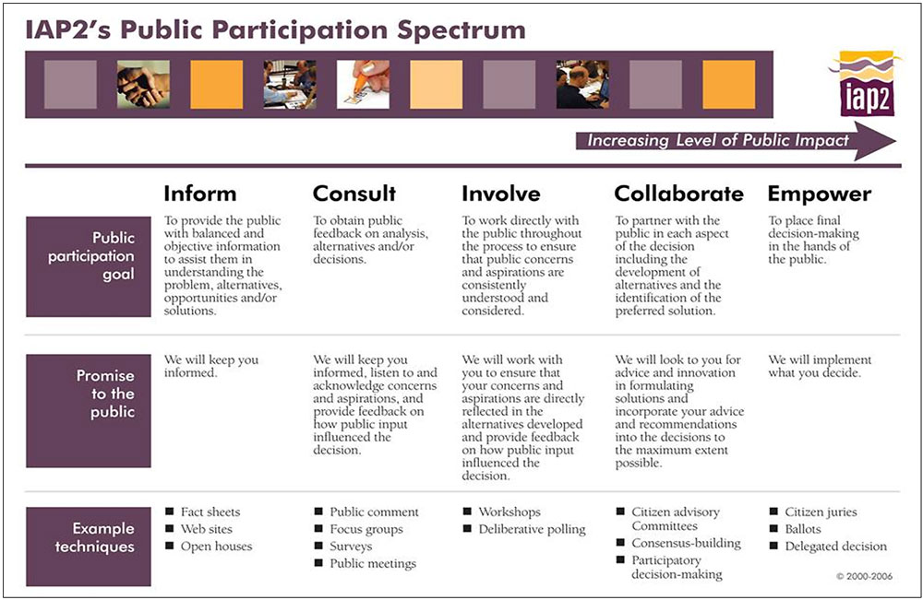

Sample Interview Questions
- What do you know about the community’s technology needs?
- What trends are you seeing in our community?
  - How do people want to get information? Interact? Engage?
  - How is the community changing?
- What does the community value?
- What do you know about other needs, priorities, interests in the community that might help us?
- What expectations do residents have (about services, programs, facilities)?
- What does our community lack? What gaps are you aware of? What frustrates people?
- What assumptions do we make about our community, especially re: technology needs?
- Are there aspects or parts of our community we don’t know (much) about?
- Who else should we talk to in the community as part of this consultation? Organizations? individuals?
- Do you have communications channels that we could potentially use to disseminate information about our project or invite feedback?
- Do you have any thoughts about how the Library can better support the community in its learning, recreation, personal enjoyment and enrichment, community connectedness?
- Does your department have plans or aspirations that library technology might support?
- Are you aware of opportunities, other initiatives, conversations happening in the community that we should be aware of?
- What question(s) should we be asking?

List of People/Groups to Consult with (check it twice!)
Done? | Group Type | Group | Contact
 | Schools | West Van Secondary
Yes | Library | NVCL | Deb Koep
 | Library
 | Internal | Library Champions | Lynn (Library Staff)
 | Stakeholder | Library Board
 | Partner
 | Community | PACs
 | Comm Org | Kinsmen
 | Comm Org | Vancouver Maker Faire Society
 | Business | Gluu Technology Society

Public Consultation Plan
[what, how, and why]

Timeline | Consultation Activity | In person or digital? | Possible consultation questions/techniques
 | Graffiti wall  - one week per question | In person | What technology frustrates you?  How does technology make us better?  How does technology make us worse?  How does technology help you?  When does technology get in your/our way?  How is technology changing our community?  How can technology make our community better?
 | Focus Groups  - | In person
 | Technology Fair | In person | Exit survey  - what inspired you?  - what concerned you?  - did anything surprise you?  - is anything missing here today?  Card sorting station  - sort technologies into green (yes!), yellow (maybe), red (no)  Staff observation  - where were people getting excited? why?  - words people used?  - what did people try?  - what tables attracted the most/least visitors/widest age group?
 | Survey | In person  Digital

Survey Questions:
- Which of the following statements BEST describes your skills, knowledge and ability when it comes to technology? [choose one]
  - I have little or no technology skill or knowledge
  - I can use technology to do some thing, but I have a lot to learn
  - I can use technology to do many things, but it’s hard to keep up with new features and tools
  - I can use technology with confidence and adapt to new things as they come along
  - I am highly skilled with technology and can make technology work for me
- Which of the following statements about technology are true for you? [choose all that apply]
  - I feel frustrated by technology
  - I enjoy learning about new apps and technology tools
  - It is important to know about technology and stay current
  - It is hard to keep up with all the new things when it comes to technology
  - Technology can help us to solve important problems in our community and globally
- Please rank the importance of each of the following role(s) the library might play when it comes to technology

 | Not interested | Curious and I’d like to learn more | Interested and I have some ideas about how I might use it | Bring it on! I’ve been waiting for this | Don’t know
Applying artificial intelligence to solve complex problems
Blogging, self-publishing
Building or operating robots and drones
Coding and programming
Developing websites
Digitizing, preserving and converting historical materials (e.g. photos, videotapes, etc.)
Exploring real and imagined places in virtual reality
Making products or prototyping with 3D printing
Recording and editing sound (e.g. music, oral histories, podcasts)
Telling stories using video and photos
Using smart technology to improve everyday life (e.g. wearables, smart house)

- Please rank the importance of each of the following role(s) the library might play when it comes to technology
 | Not at all important | Somewhat unimportant | Neutral/ no opinion | Somewhat important | Very important
Helping people learn how to use technology and keep technology skills up to date (ex. Computer literacy programs, coding classes)
Keeping the community informed about changing and emerging technology (ex. Technology demos and talks)
Providing equipment that is impractical or expensive for people to have at home (ex. Digitization equipment, 3D printers)
Bringing people together to solve community problems with technology (ex. Mapping community data, hackathons)
Using technology to improve library services (ex. Personalized reading recommendations, improved ebook access)

- What technology, equipment or tools would you like to have access to but wouldn’t buy yourself?
- What projects or pursuits would you like to do if you had the right technology and knew how to use it?
- What are you interested in or learning about these days? What’s on your mind or igniting your passion? (This can be anything, not necessarily technology)
- Gender:
  - Male
  - Female
  - Prefer not to say
- Age:
  - 13 – 19
  - 20 – 29
  - 30 – 39
  - 40 – 49
  - 50 – 59
  - 60 – 69
  - 70 – 79
  - 80 – 89
  - 90+
  - Prefer not to say

