Help for OverDrive Media Console app for Windows 8
Compatible Formats: EPUB, OEPUB, MP3
Options for Windows 8
There are two different varieties of Windows 8. Which version you have on your device will affect how you access library audiobooks.
Windows 8 RT | Found on many tablets and phones, including Microsoft Surface tablets.  Follow the instructions below.
Windows 8/  Windows 8 Pro | Found on all computers and laptops running Windows 8, as well as the Microsoft Surface Pro  You can follow the instructions below to access EPUB ebooks and MP3 audiobooks. If you want to also use WMA e-audiobooks and/or PDF e-books, see our Windows 8 handout for more information:  http://www.sclibrary.ab.ca/docs/ebooks/windows8.pdf

How to install OverDrive Media Console for Windows 8
1 | 2
Install OverDrive Media Console app | - Authorize the app with an Adobe ID

- Install OverDrive Media Console app.
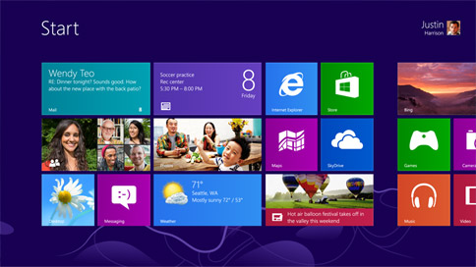 | Turn on your computer or tablet. You will see the Start screen, shown at left.  Look for the “Store” tile on your Start screen. It should look something like this: 
To search, open the Charm Bar (shown at right):  - With a mouse, move to the top right or bottom right corner of the screen. (Shortcut: Or type Windows Key + Q)  - With a touchscreen, swipe from the right edge of the screen to the left (toward the middle of the screen).  Then click or tap on the magnifying glass to bring up the search tool.  Ensure that “Store” is selected as what is being searched (at the top). Search for “OverDrive”.  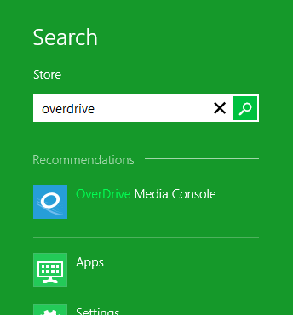 |  | 
When you find it, select it:
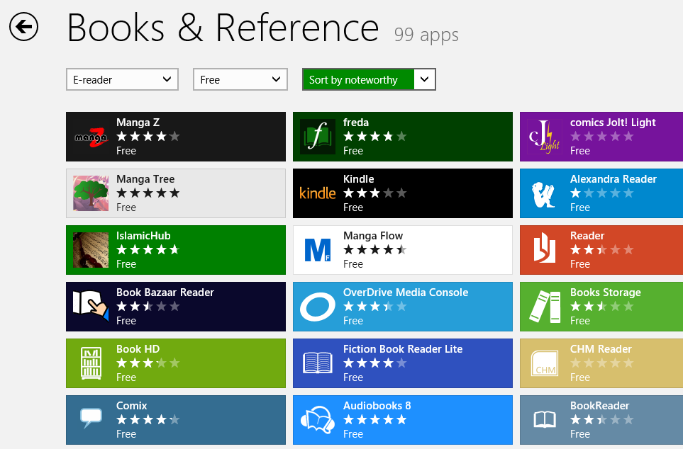
Then tap or click the “Install” button.
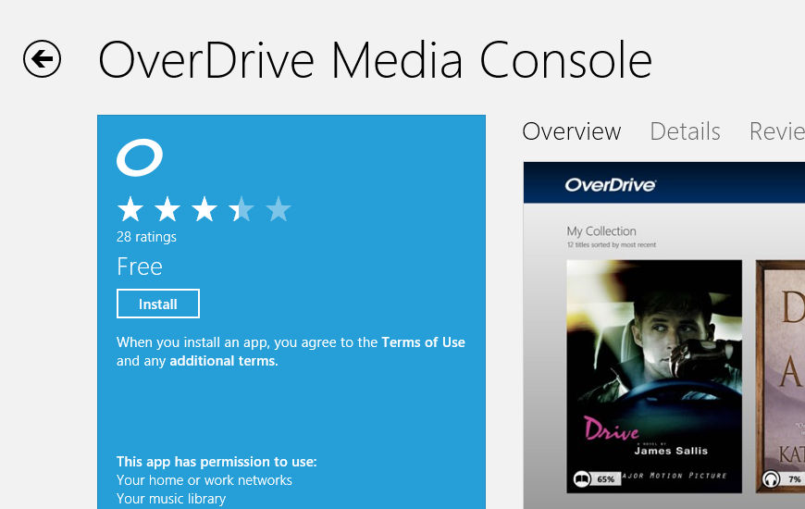
Note: If you are running Internet Explorer 10 on your device you can also install the app directly from this link.
A message will appear briefly on the top right-hand portion of your screen indicating the progress of your installation. It will notify you once OverDrive Media Console is installed successfully.
- Authorize your app with an Adobe ID. Your Adobe ID is like a key that unlocks library e-books. It also lets you use the same digital account on multiple devices.
Open OverDrive from the tile on your start screen: 
Open the Charm Bar and go to Settings. Under “Accounts,” you will see the place to enter your Adobe authorization information. If you have not set up an Adobe account already, tap or click on “Get a free Adobe ID.”
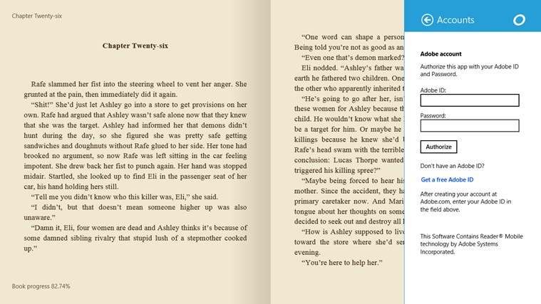
You may want to record your Adobe ID here in case you need it again in the future.
Adobe ID (email):
Password:

How to add items to your Collection
Anytime you are ready to download new books and audiobooks, you can do so directly on your device.
1 | 2 | 3 | 4 | 5
Open the OMC app on your device | - Go to “Get Books” and select your library | - Search or Browse for a title that interests you & Add To Cart | - Proceed to Checkout > Login with your library card information | - Download. As long as your OMC is authorized, your title will appear in your Library automatically.

- Open the OverDrive Media Console app on your device. (If you have not installed the app yet, see the first page). Tap on Find a Library.
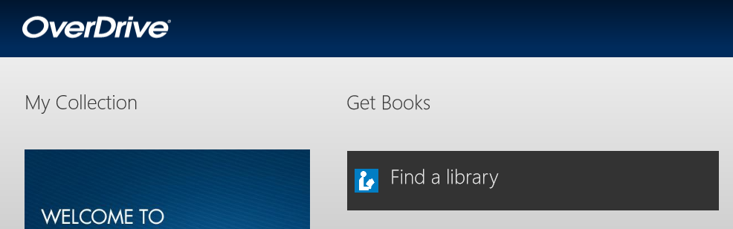
- Open the Charm Bar.
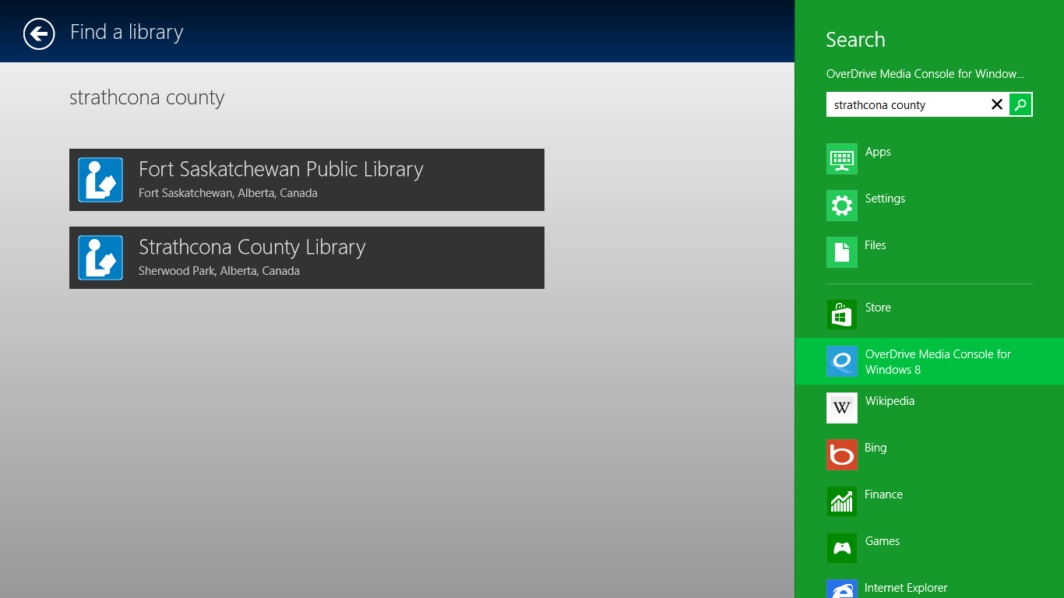 | Search for “Strathcona County” and then select it from the results list.
- You will see SCL’s Digital Downloads page, with items from our collection. Search or Browse for a title that interests you and Add it to your Cart.
- Proceed to Checkout. Login with your library card information.
- Download. As long as your OverDrive Media Console is authorized (see first page), your title will appear in your Library. Some items may take several minutes to download, especially e-audiobooks.
Once you have an item checked out and you select “Download,” you may see a popup window like this one:
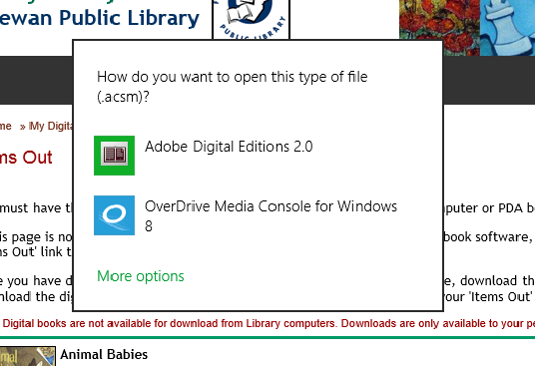
If you do get a message like this, select “OverDrive Media Console” as the program to open the file.
If you are prompted whether to Open or Save the file, always choose Open.
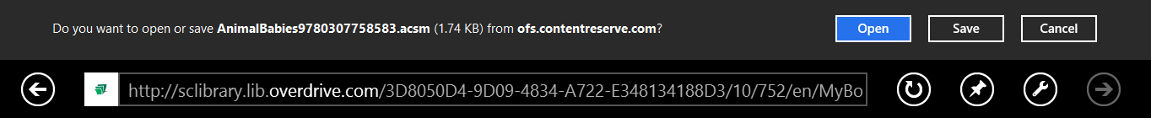
The book will now load in your app. You are ready to read or listen!
Reading and Listening
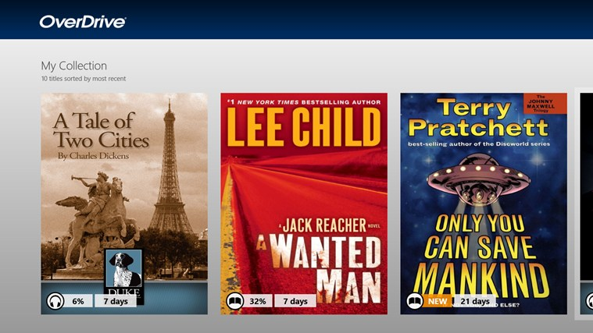 | Once an item downloads to your Collection, you will see its cover on the main screen of the app.  Tap a cover to read or listen.
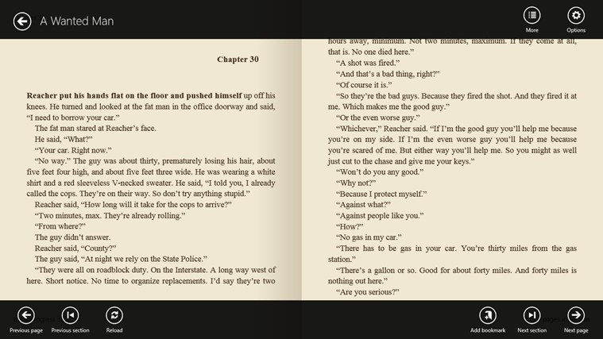 | When you have a book loaded in reading mode, tap the centre of the screen to see the top and bottom menus. These will give you options to resize text and adjust contrast, add or navigate between bookmarks, and turn pages or navigate in the text.  Tap the centre of the screen again to hide the menus and show more of the text.

More Help
The Help function within the OverDrive app also provides great help information.
This app also uses extensive keyboard shortcuts. If you have a device with a keyboard (computer/laptop) you may find these useful. You can find the full list of shortcuts here: http://help.overdrive.com/article/0351/

Thanks to the Fort Saskatchewan Public for their help in developing this handout.
http://www.fspl.ca/
If you have any questions, please feel free to contact us:
Phone: 780.410-8601 | Email: info@sclibrary.ab.ca | or stop by one of our Information Desks
Last updated: January, 2013

