CHECKLIST FOR iPad Mini BRANCH STAFF TRAINING

The iPad Mini runs on the iOS system by Apple, similarly to the larger version of the iPad, iPod touch, and iPhone.
TABLET PARTS:
- Physical parts of the iPad Mini:
  - Speakers on the bottom of the device
  - Button at the top – On/Off: Hold the button for a few seconds, Sleep/Wake: Press the button once
  - Home button located on the front (circle with square) – press once to return to home screen
  - On the right side: side switch (switch down to mute iPad, switch up to unmute)
  - Volume control on right side – upper button to increase, lower button to decrease sound level
  - Cameras: Front facing and back
  - Lightning charging/USB port on the bottom
  - Headphone jack on top left of the device
  - To take a screenshot: press the home button + the sleep/wake button at the same time – screen shots will be found in Photos app

SCREEN MOVEMENT:
- Movement: To unlock the lock screen, simply tap and hold the and gently swipe across

TRY THIS
- Press the sleep/wake button or the home button when the iPad screen is off, tap and hold the
button and gently swipe it to the right to unlock the screen.
- Swipe down from top of screen to view notifications

WIFI HOTSPOTS
- Tap on the Settings app
- Tap on Wi-Fi
- Select Surrey Libraries network to login – once it’s connected, a check mark will appear
- Press the Home button
- Tap on the Safari app
- Tap on the address bar, type in a website and tap on Enter, it will load the Terms and Connection page (Data valet)
- Tap on the empty box to accept the Terms, and tap on Connect
- This opens the browser to the Surrey Libraries homepage

BROWSER (Safari)
The default Internet browser on the iPad mini is the Safari app.

TRY THIS
- Back/Forward buttons, bookmark button, other options (share via Mail/Twitter/Facebook, Printing, Copy, Add to Home Screen, Bookmark, or Add to Reading List)
- To open a new tab, tap on the + on the top right
- Type in surreylibraries.ca and tap ‘Go’
- Tap on this icon
- Tap on Bookmark, name the bookmark (E.g. Surrey Libraries)
- Tap on Save
- It will now be found in the bookmarks section (book icon next to address bar)

APP STORE
This icon on the main home screen will connect to the iPad App store where you can find many free and paid apps to download onto the iPad.

TRY THIS
- Tap on App Store
- Browse through apps displayed on main App store page, or type in the name of an app/program in the search bar (top left)
- Tap on an app
- Tap on FREE if it’s a free app (tap on the price if it’s a paid app)
- Tap on INSTALL APP
- An Apple ID window will pop up, type in the Apple ID password and tap OK
- The app will start downloading and can be found on the home screen

Sometimes a red number/notification will appear on the App Store app, this means there are some apps installed on your iPad that need to be updated.
- To update apps installed on your iPad, tap on App Store
- Tap on Updates (found on bottom right)
- You can choose to update specific apps, or tap on Update All
A red notification means that there are apps on the iPad that need to be updated.
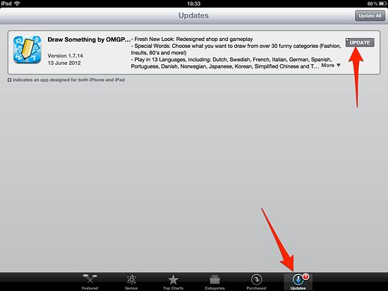
To update the apps, tap on ‘Updates’, and then tap on the Update button for each app, or tap on ‘Update All’.

OVERDRIVE
The Overdrive app is already downloaded on your branch device.
** The Overdrive app must be authorized on a mobile device using an Adobe ID before it will accept a downloaded eBook and this step is hidden from the process.

TRY THIS
- Press the Home button to go to the home screen to find the Overdrive app, tap on the app to open
- Tap the Home Menu button (located in the top left corner) to expose settings, libraries and more
  - Notice under Settings, your branch Gmail account is noted in the Adobe Authorization ID field.
    - If this isn’t activated with a current email account ID, Overdrive will not be allowed to download any eBooks/audiobooks

- To download eBooks and Audiobooks onto the iPad, tap on the Home Menu icon
- Select ‘Surrey eLibrary’
- Find a book/audiobook that is available and check it out using your personal library card number and change the loan period to 7 days (Tap on Borrow > Tap on Download)
- The book will begin downloading to your device (can be found under Files)
- Once it’s finished, it will appear in your Bookshelf (tap on Home Menu > Bookshelf)
  - To share, delete or return a title, go to the bookshelf and press and hold the title you want to delete or return.
  - To access the Book Menu, tap on the Book Menu Icon (located in the top right corner) , from here you can view the Overview, Table of Contents, and any Bookmarks created.

iBooks APP
This is an app for the Apple eBook store, but you can also read PDF files, or ePUB files in iBooks. This app has already been downloaded to your branch device.

TRY THIS
- Tap on the iBooks app to open
- Tap on Store – this will lead you to the iBooks store with free and paid eBooks
- Once you have found a book, tap on FREE, tap on GET BOOK
- An Apple ID window will pop up – type in the password
- Tap on Library to view the bookshelf
- Tap on a book to open and read, you can also adjust the settings (text size, theme, font, etc.)

CAMERA/VIDEO & EMAIL
The iPad mini has a front facing and back facing camera – the front facing is used for taking pictures or FaceTime video calling, as well as in other similar applications.

TRY THIS
- Tap on the Camera app
- Take a picture by tapping on the Camera icon (middle right) – you can also rotate the iPad to landscape format
- Press the Home button
- Tap on the Photos app
- All of your pictures will be found there, tap on a picture that you want to send
- Tap on the options icon (located top right)
- Tap on the Mail app
- It will lead you to your main email account and opens a new message with the picture attached.
- Type in a the branch’s gmail address
- Tap on Send when you are done
- Check the email inbox for the message

CC eBook Gmail Account Info:

CC BRANCH iPad Mini Log-In:
Apple ID:

