Freading & OpenLibrary
Help for your Android phone or tablet
Compatible Formats: EPUB, OEPUB, MP3, PDF (depending on app)
Note for OverDrive Media Console users: If you have downloaded library e-books before using OverDrive Media Console, and you already have it installed on your device, you can use it to access OpenLibrary and Freading in addition to OverDrive. (However, you won’t be able to read PDF ebooks.) You don’t need to install another app. Skip ahead to the section called “How to Add Items To Your Library.”

How to set up an app on your Android phone or tablet:
In order to use library e-books on your tablet, you will need to add an app that can open them. You can download the OverDrive Media Console app, the Freading app, or both. Other apps that support Adobe DRM ebooks (such as Bluefire) will also work.
You only need to do this once. You will need to be connected to the Internet.
1 | 2 | 3 | 4 | 5
Confirm requirements | - Open the Google Play store or the Android Market | - Search for OverDrive Media Console or Freading | - Install one, or both, apps on your device | Authorize your app with a free Adobe ID
See below for details on these steps.
- Confirm requirements. Check that your device complies with the Android version requirement shown below. If you are not sure about your Android version, go into the Settings menu for your device, and then select “About phone/About tablet” (or sometimes “Software Information”).
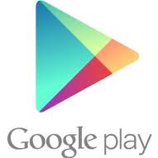 | - Open the Google Play Store or the Android Market on your device. You will see one of the icons at left indicating the market/store for your device.  - Search for one of the apps shown below:
 |  | OverDrive Media Console (Requires Android v1.5 or higher)  File formats: EPUB, OEPUB, MP3  Return items early: Yes  More info - Google Play store
 |  | Freading (Requires Android v2.2 or higher)  File formats: EPUB, PDF  Return items early: No  More info – Google Play store
- Install one (or both) of these apps on your device.
- Authorize your app with a free Adobe ID. This lets you use the same digital account on multiple devices. You may be prompted to authorize your device the first time you use the app.
Many people find it easier to set up an Adobe ID using a computer rather than on a smartphone or tablet. Go to http://www.adobe.com/cfusion/membership/index.cfm to set up an Adobe ID.
To enter an Adobe ID manually, or to change your Adobe ID at any time, proceed as follows:
OverDrive Media Console | Find the button for additional options – often this will resemble ,  or 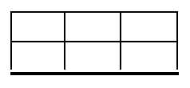 . Click on “App Settings.” Scroll down to the “Adobe ID” area under “eBook options.” Enter your Adobe ID and then tap “Authorize.”
Freading | Find the button for additional options – often this will resemble , or . Click on “Account.” Enter your Adobe ID and then tap “Authorize.”

How to add items to your Library:
Anytime you are ready to download new books and audiobooks, you can do so directly on your device.
1 | 2 | 3 | 4 | 5
Visit the library’s downloads page at http://www.sc  library.ab.ca/  download.htm | - Choose an e-book service – OverDrive, Freading or OpenLibrary | - Search or Browse for a title that interests you. | - Proceed to Checkout. Login with your library card information if requested to do so | - Download.
See below for details on these steps.
- Using the browser on your device, visit the library’s downloads page at http://www.sclibrary.ab.ca/download.htm . This is SCL’s portal for all e-book services, help information and other resources.
- Choose an e-book service – OverDrive, Freading or OpenLibrary. These services offer different things, which are outlined on this page. You can download items from all 3, if you like. Click on the link for the appropriate service.
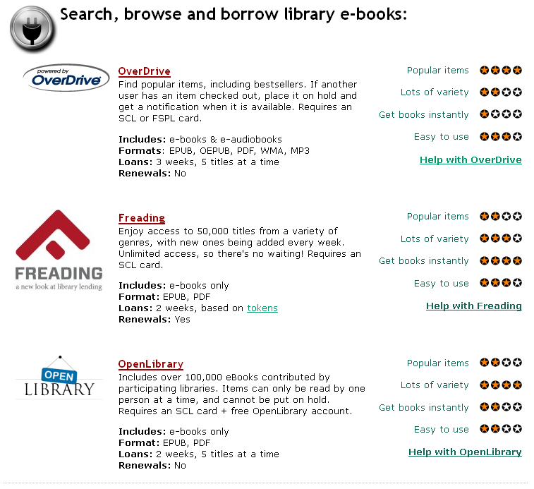 | Click on the name or the logo  of the service you want to  search or browse.
- Search or Browse for a title that interests you. For more information on how to use these services, see Help for OverDrive | Help for OpenLibrary | Help for Freading.
- Check the book out, if required (Freading does not require a checkout).
- Download. As long as your OverDrive Media Console is authorized (see step 5 on the previous page), your title will appear in your library. Some items may take several minutes to download, especially e-audiobooks.
Note: If you click to download a book and get a jumbled error screen with text that begins “urn:uuid…” then there is a problem with your browser. Switch to another browser such as Dolphin or Opera and try again.

Expiring Titles
When your titles expire, you will be prompted to delete them. For Freading books, you can redownload them from your account. For OverDrive books, you can check the title out again or request it if it is not available. For OpenLibrary books, you can find the book again and check it out if it is available.
How to Return Items Early
Items can be returned early in the OverDrive Media Console app but not in the Freading app.
In OverDrive Media Console:
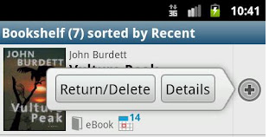 | 1. On the Library screen, tap the small plus sign that appears to the right of the item you want to delete. You will see options for that item including “Return/Delete” and “Details.”  2. Tap “Return/Delete” to return the item. Select either “Delete” or “Return and delete.” If you want to keep the book checked out, for example because you want to continue reading it on another device, you can delete it without returning it. Otherwise, you can return the item so the next user can borrow it.

If you have any questions, please feel free to contact us:
Phone: 780.410-8601 | Email: info@sclibrary.ab.ca | or stop by one of our Information Desks
Last updated: August, 2012

