getting started with instagram!

Logins
Instagram account: vpldigitalplayground / tpi4plgI (Username and Name = vpldigitalplayground)
Email associated with Instagram account: plgvpl@yahoo.ca / tpi4plgY

before class check for bookings etc:
- Terry McBride (for sound bleed)
- Helpstar: iPad Air 1 (has Instagram app)+ short HDMI cable + Lightning HDMI adapter + vpl-presentation wifi
- Charge iPad (L6 locker)
- Check drawer for scripts to see if a package for your session has been prepared already or…
- Print out the registration list from the Hub: http://hub.vpl.ca/content/44498
- Evaluation forms can be found in the drawers by the sign-in book or printed from the Hub: http://hub.vpl.ca/content/52923
- Create & print signage for stanchions: in VanDocs “Inspiration Lab Workshop Sign”
- Print out Getting Started with Instagramhandout from the Hub: http://hub.vpl.ca/content/1758
- Login to public wifi 21383026295464 / 2013
- From storage room get music stand for materials & remote for presentation screen
- Use presentation touchscreen to select source (i.e. HDMI). If you get “no signal” on screen – reverse the plug (text facing you)
- Using remote under audio set balance to +10. Use touchscreen to set level to 23
- Put up signs on stanchions

OPTION – use Brio instead of directly connecting the iPad to screen
- Get key for L3 storage from program assistant or our workroom: get music stand for your notes/iPad & get the remote for the presentation screen
- Power on presentation screen (bottom left button). A menu should appear – wait for VPL logo. If VPL logo does not appear or message “no signal” appears, push the power button again, and push INPUT for a menu – choose DISPLAY PORT.
- Log iPad on to wifi: Settings > select network “VPL-Presentation” The iPad should remember and automatically log you onto wifi. (psd: vplInspiration) call Systems if you have trouble.
- Open Safari. Go to bookmark for cil-brio.vpl.ca (or type as seen here into address bar)
- Swipe up from bottom of iPad screen: tap AIRPLAY, select BRIO, turn Mirroring on.

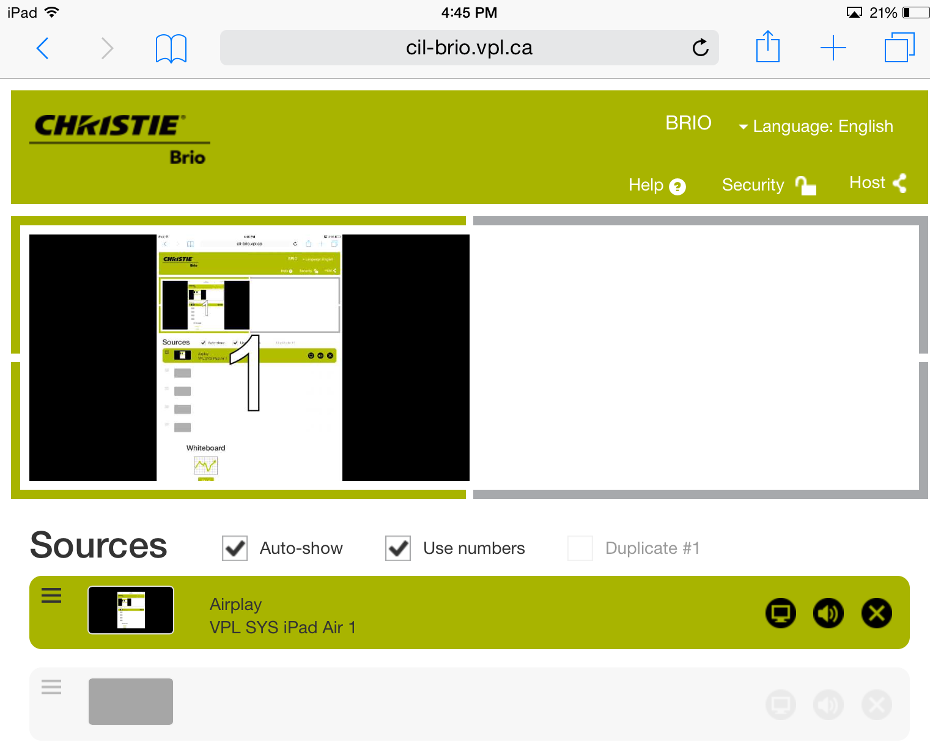
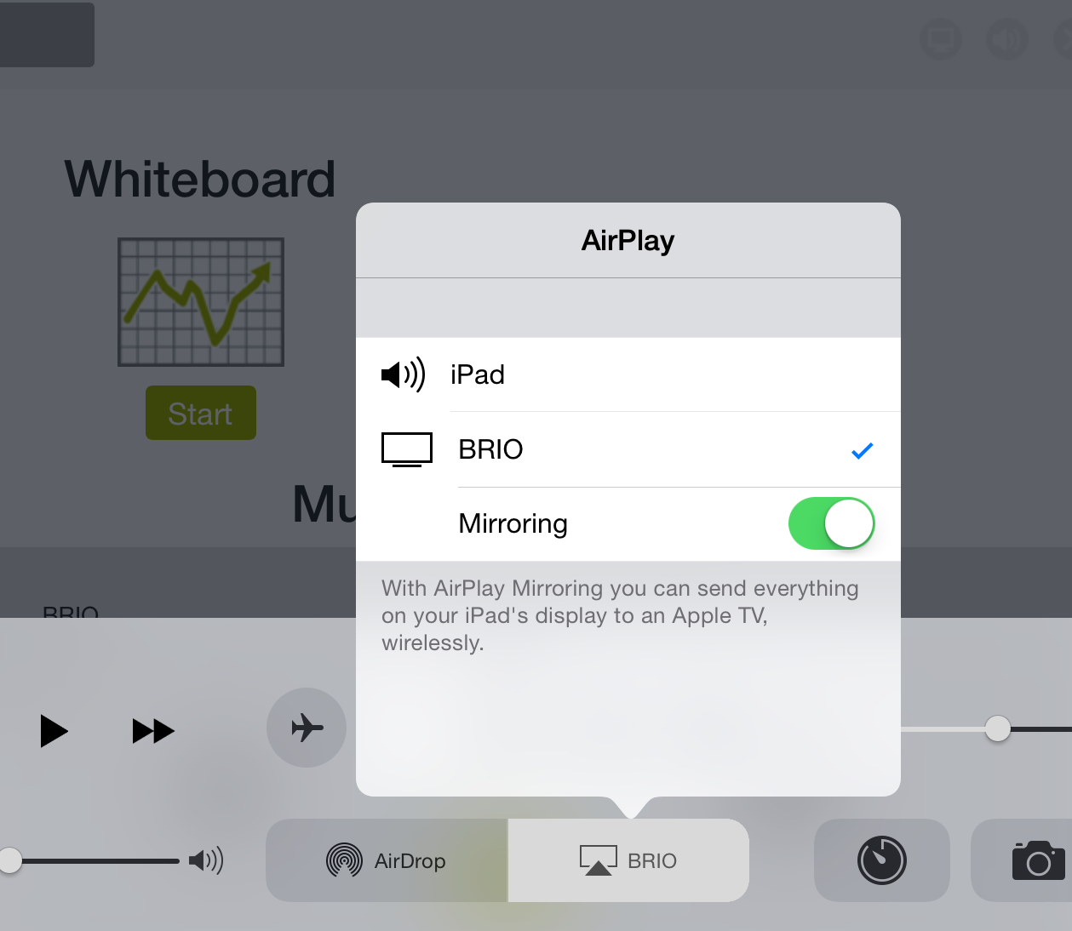
- Tap iPad’s HOME button. You should see iPad in Brio’s SOURCE list & your screen will now show on the presentation screen (make sure to select TV icon on right).

- Tap iPad HOME button > PHOTOs icon > Camera Roll: Use 9 screenshots to demo sign up
- After this, close PHOTOS and open the Instagram app to finish script. App remembers log in.
Tips for a better signal/presentation:
The wireless AP is located above the 4 TV display wall -the closer the device the better.
Don’t block signal with pillar/body/moving around during presentation

course objectives

- What is Instagram? What is the Summer of Learning? Show Summer of Learning booklet & webpage http://www.vancouverlearningcity.ca/summeroflearning/, explain challenges and prizes.
- Demonstrate Instagram: signing up & navigation features
- Demonstrate editing profile & privacy settings
- Demonstrate posting and tagging a photo to enter the Summer of Learning challenges

what is Instagram
Welcome! My name is… Give out handouts etc.
What is Instagram?

Instagram is like a visual version of Twitter for photos: users take & share photos with friends and family with only a few taps on the device – all you need is an internet connection and the app. You can even take a short video (15 seconds) and share it with friends!

Because Instagram is owned by Facebook some of the features and functions will be familiar to you. You can link to Facebook (or other social media accounts) if you want to share your photos beyond Instagram.

You can also share a photo saved to your device from an earlier time - this is useful if you want to visually edit your photo before sharing or strip the data (photos can store information about where and when it was taken, the type of camera/device, and more).

Things to note about Instagram:

Data Usage Because you will be using data to load your photos you will want to be aware of how much your service provider allows for free so that you don’t end up with hidden fees charged on your bill. You can always log on to a shared network but remember to be careful as the information you send or receive can be intercepted on a shared network (i.e. passwords).

Location tracking & Metadata Instagram can pinpoint a photo’s location by reading a photo’s metadata (time, location, device, etc.). You can disable your location settings as it is not necessary for uploading photos. There is freeware for computers with Windows, Mac and Linux that will strip the metadata from files (if you sync photos from your computer to your device).

Deleting account is irreversible – you won’t be able to retrieve your photos or sign up for the same username /use same email once you’ve deleted your account
- Log into instagram.com from a mobile browser or computer. You can't delete your account from within the Instagram app.
- Click your username in the top right and then select Edit Profile.
- Click I'd like to delete my account in the bottom right.

the sign up process demo (9 screenshots in photo icon on IPAD)
The sign-up will walk through a number of steps and requires a valid email address, a username, your name (anything you choose), and a password. You can change any of this information later. Usernames are unique so you need to create one that no one else is using. Do not use spaces for the username. You have the option of skipping steps to add Friends, Contacts, Follow People and notifications.
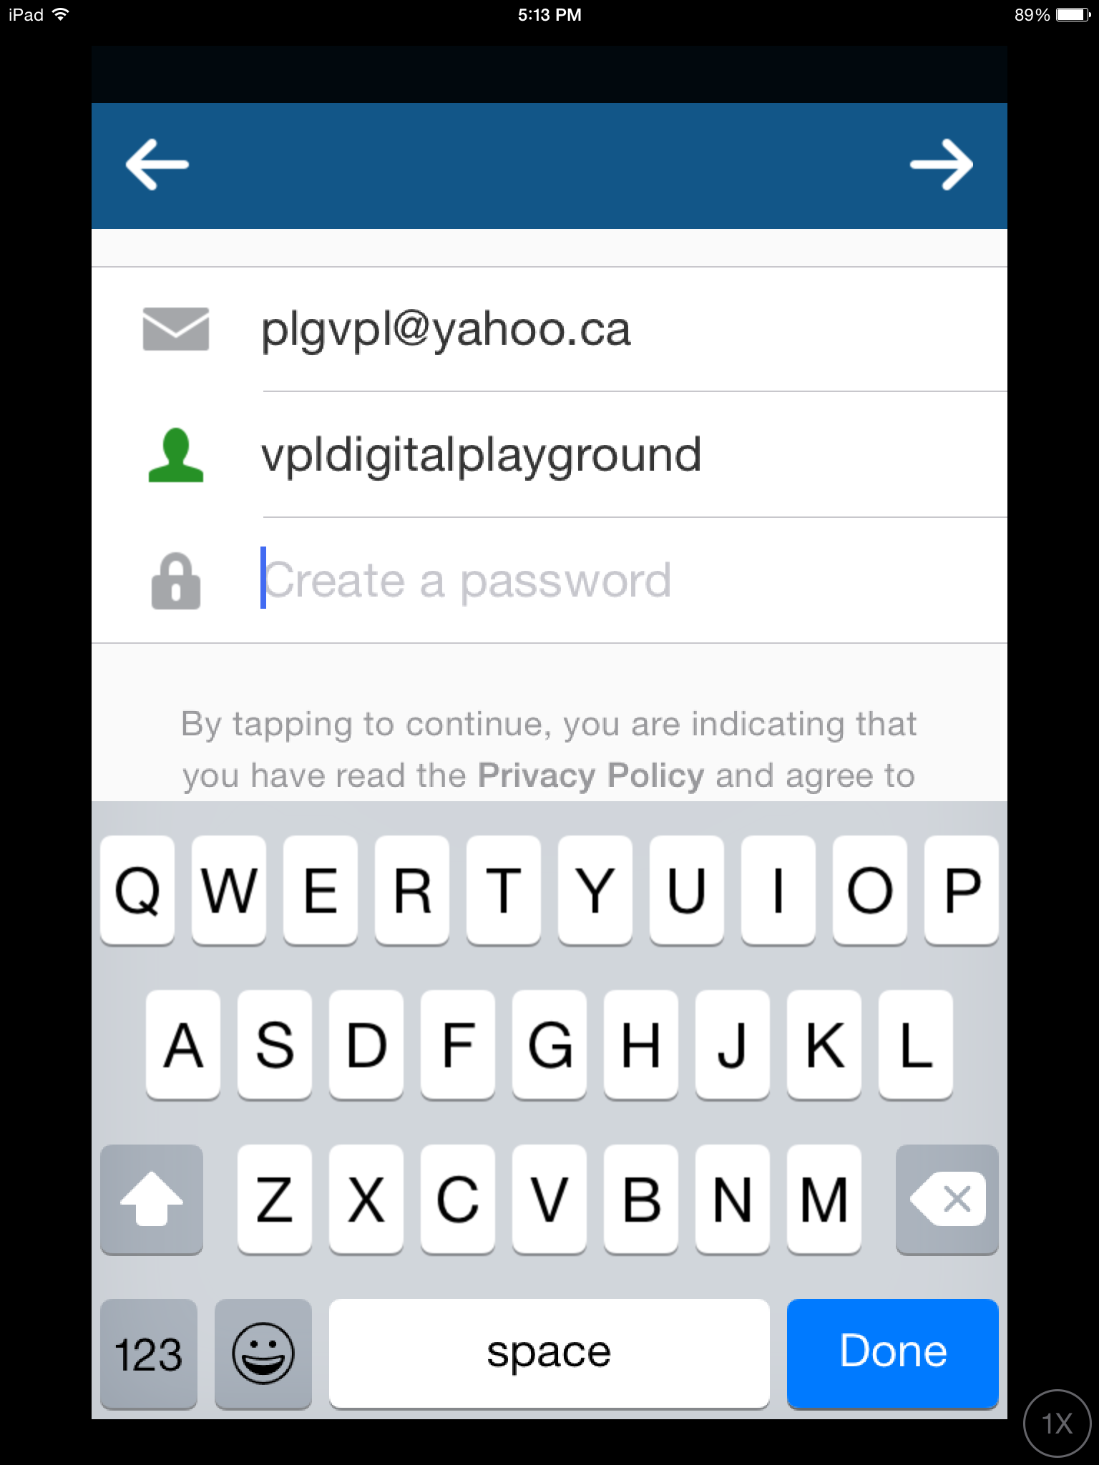
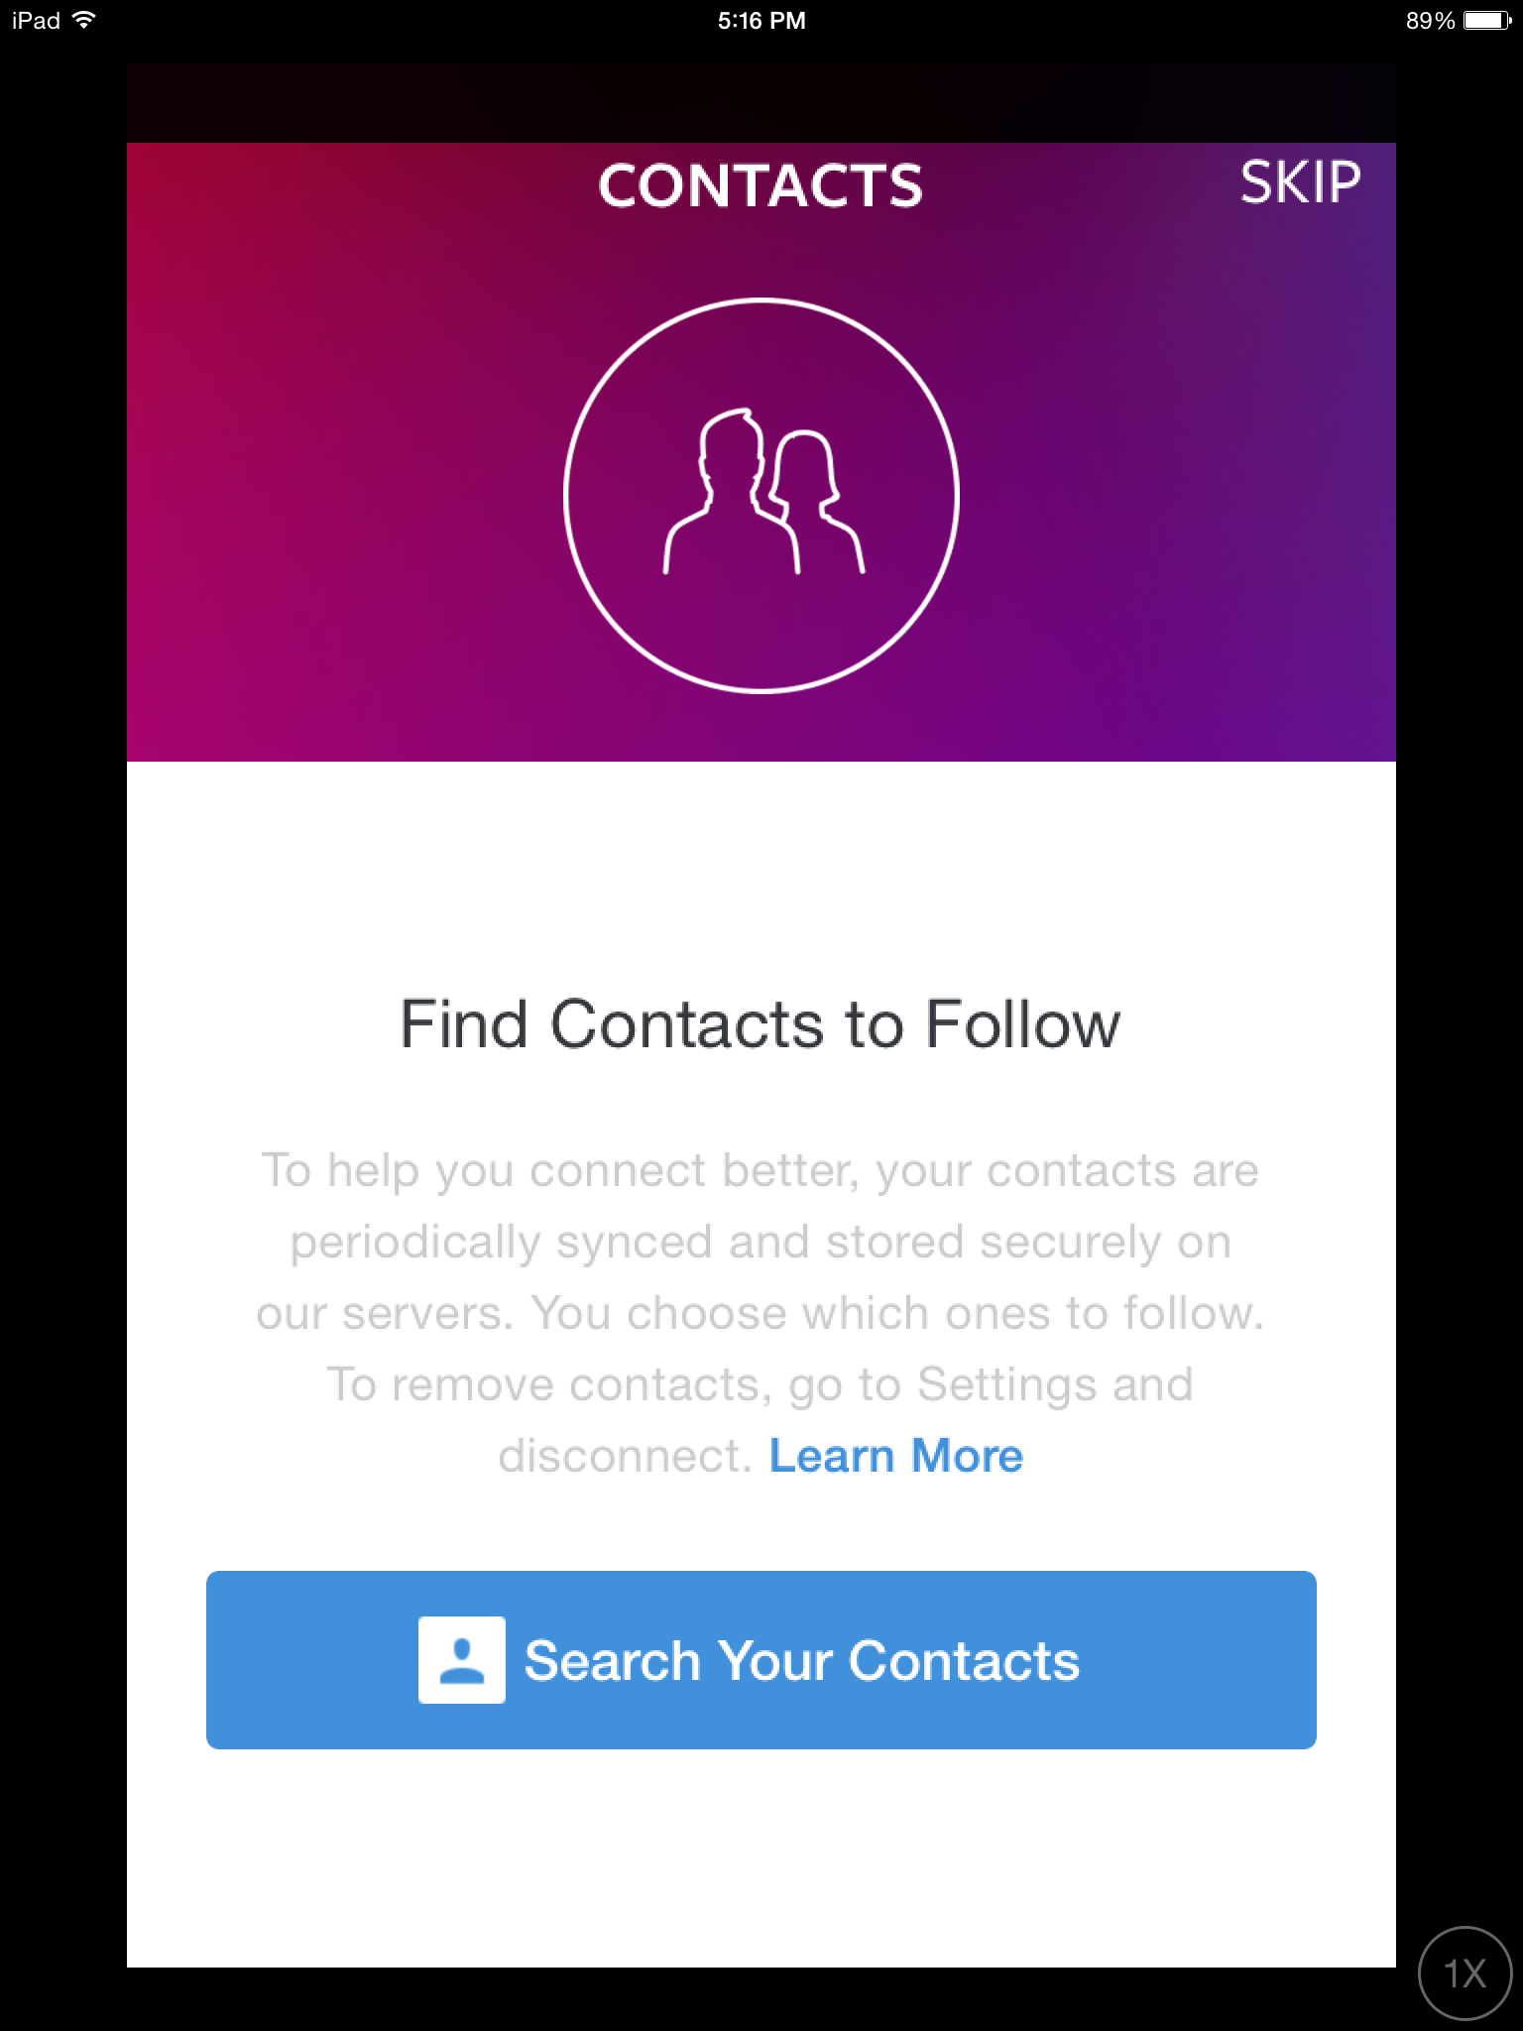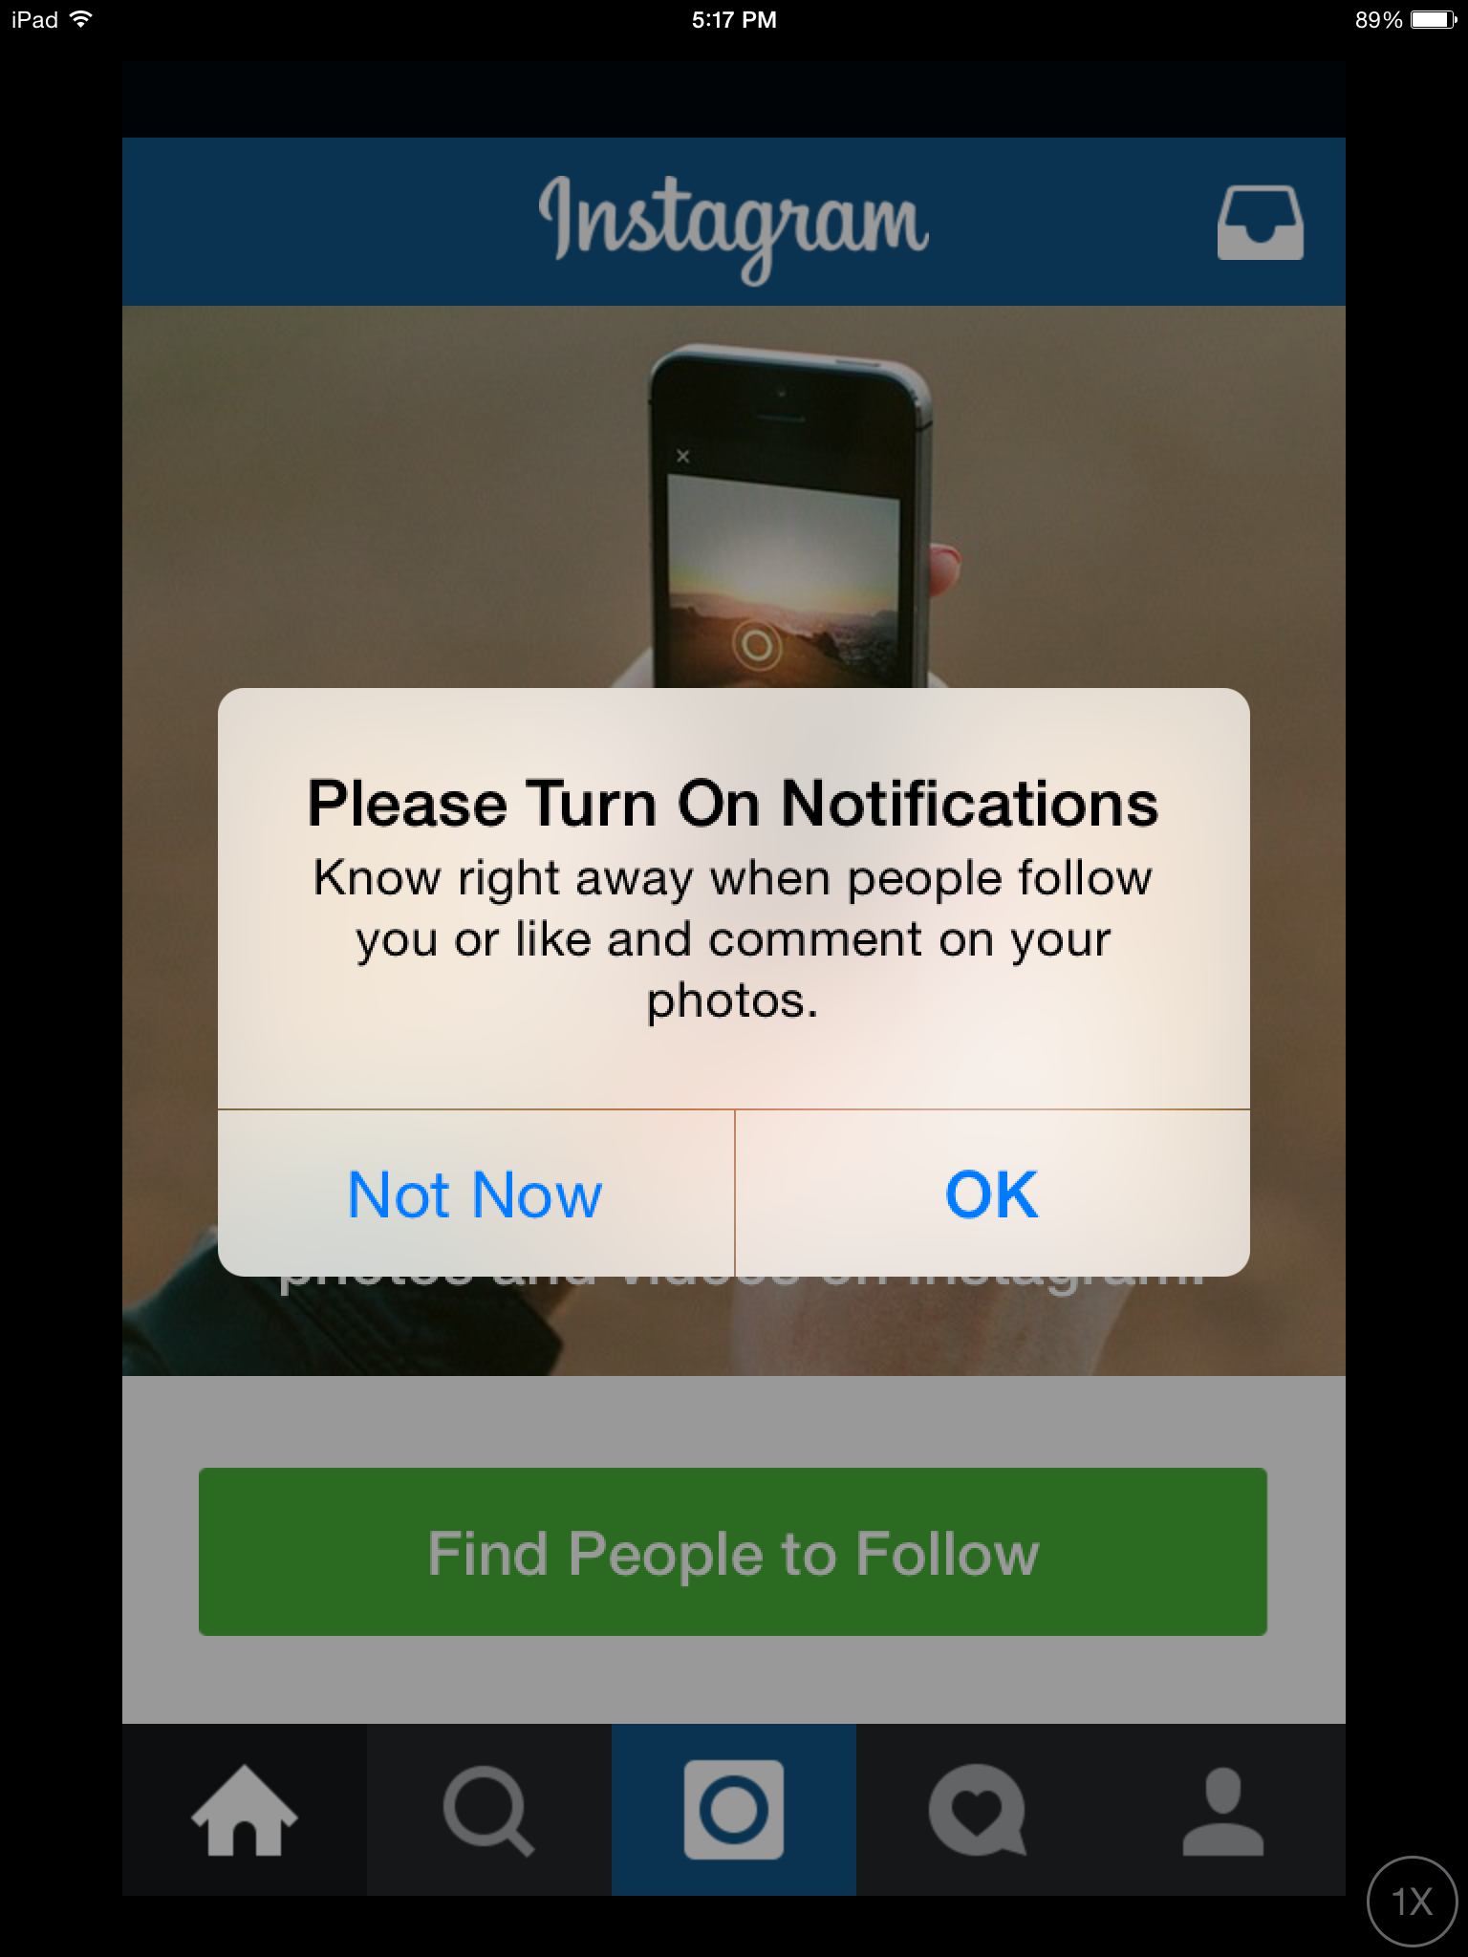
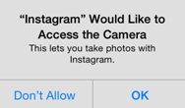
You may come across the following pop up messages as you start:

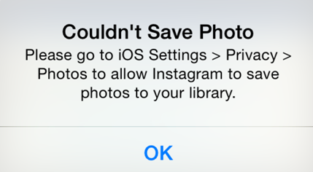
This is normal for the app to ask your permission to access the camera in order to take photos for uploading. If you don’t allow access, you won’t be able to use the app. Say OK.
This means the app is trying to save a copy to your device but this is not necessary for using the app.

Don’t forget to confirm your account by checking your email inbox & following their link to activate!

DEMONSTRATE navigation features
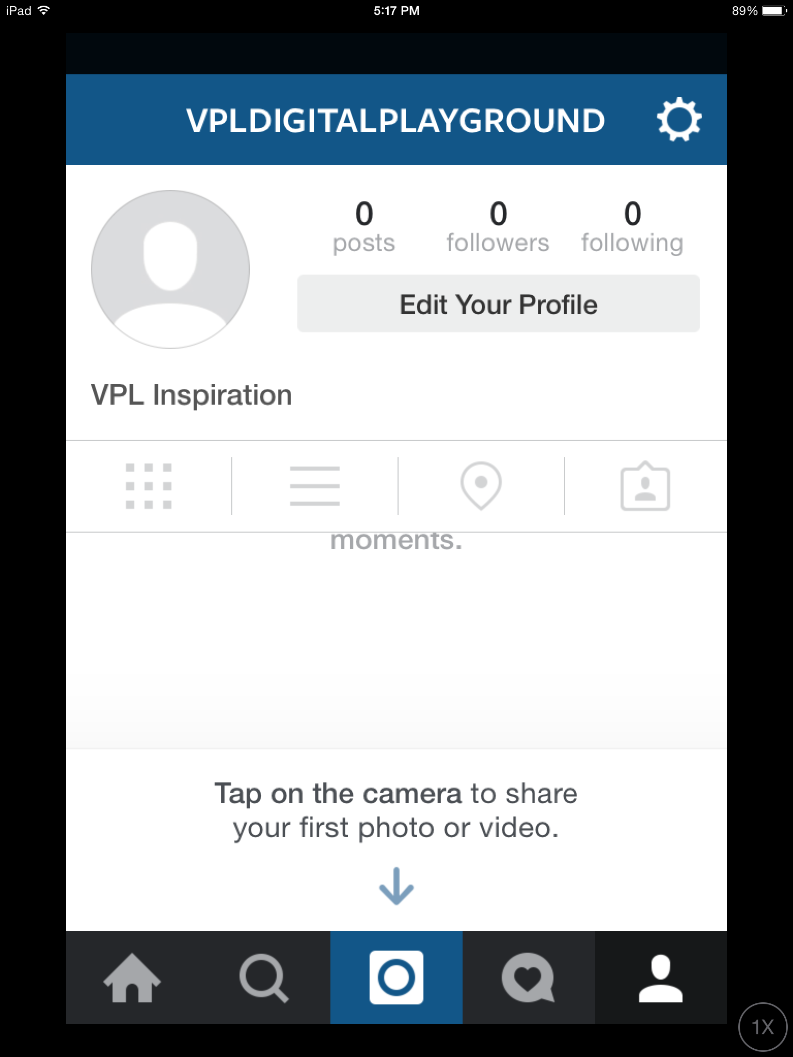

Open the Instagram app on iPad and project to screen as you walk through the following sections.

For Navigation, walk through each icon & explain…the camera/search icons will be explored more in the last 2 sections of script.

NOTE: Icons may be different on different (older) versions of Instagram.

 Tap on the Home icon. This shows photos from the people you are following (like Facebook newsfeed). This is typically the screen Instagram will open up on when you open the app.
 Instagram Direct icon on your Home page allows you to share a photo privately to any of your friends (up to 15 followers). Tap the icon & take a photo, apply filters (optional), then write a caption and add recipients from your follower list. Tap “send to” when done. This photo is now shared privately to the chosen recipients only.

 Tap on the Search icon. Search on VanSummerLearning. Note that Instagram will offer suggestions as you type. Different versions of Instagram may show different icons/options.

 The Camera icon allows you to take a photo/video and upload it to your account

 Tap on the Profile icon. It shows your name, how many posts (photos) you’ve uploaded, how many followers you have, and how many people you are following. View your photos as a grid or lines, see your location map for photos you’ve shared, and see who you’ve tagged.
 Tap on the Activity icon. This will highlight any activity related to your account, such as when someone starts following you, leaves a comment or likes a photo you’ve shared.

DEMONSTRATE profile and privacy settings
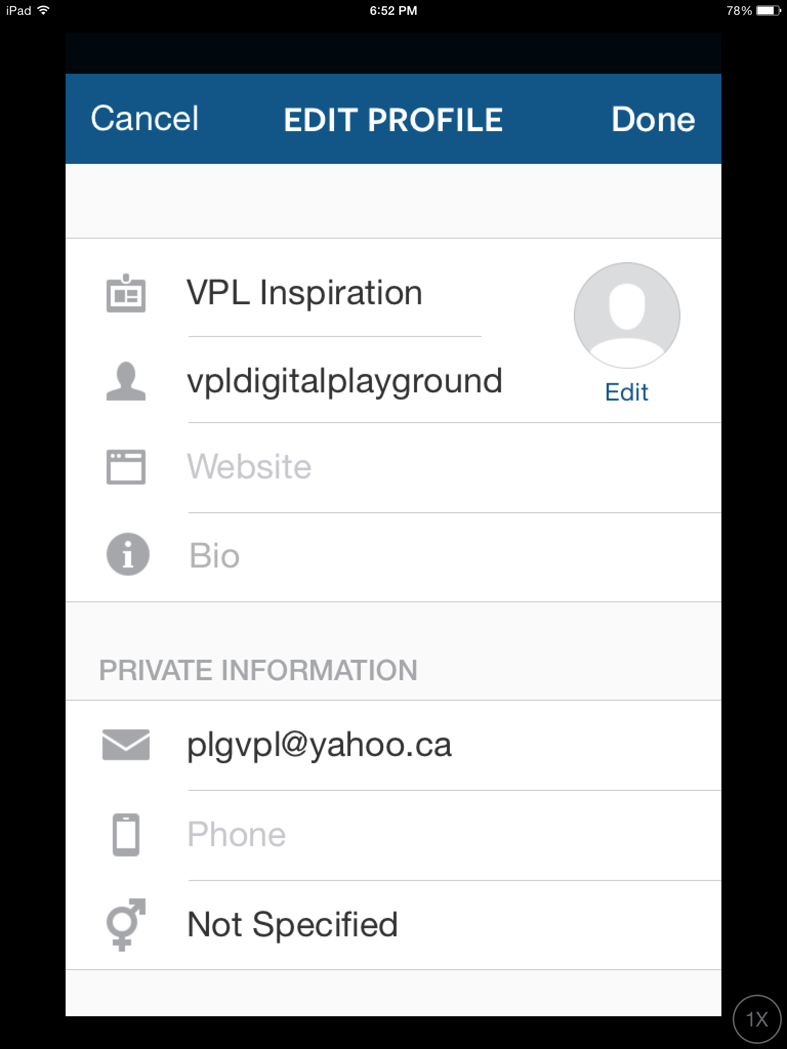
Tap on the Profile icon. If you tap Edit Your Profile, you can change your username (as long as no one else has it), name, email and more. Tap Done when finished editing.

 When you are on your Profile page tap the Settings icon in the top right. Options include:

Account:
- Edit profile (same as above)
- Change password
- Posts You’ve Liked
- Private Account – your photos are only shared with those users you’ve approved (they send you a request to follow you like Facebook Friend requests)
NOTE: Your account must be public for everyone to see the photos you contribute to Summer of Learning.

Settings: Linked accounts like Facebook or Twitter, notifications, data use, save original photos
Support: Help Center, Report a Problem
Note to trainer: Instagram accounts will be indexed on the web regardless of privacy setting, but search engines aren’t allowed to index photos
About: Ads, Blog, Privacy Policy, +
Clear Search History
Log Out
To Block a user/follower: go to their profile page > … > Block
They will not be notified that you have blocked them.

Demonstrate posting & tagging a photo for summer of learning

Follow the steps on the handout to demonstrate taking a photo and tagging it for the Summer of Learning (#VanSummerLearning)

TRAINER NOTES – OTHER FIELDS:

Captions can be edited at any time. You can include hashtags at this point by typing # followed by keywords without spaces. Instagram remembers tags you’ve used before and will show these as you type. Once tagged, these will appear as links that will give a list of other photos with the same tag.

Why tag? So people can find your photos and admire your creative brilliance! Remember that you make your account Private so only your friends (followers) can see you photos.

Tag People – choose from your friends (followers) - the app will search for “faces” to tag
Add to the Photo Map – this shows the location when you uploaded the photo (not necessarily where the photo was taken, for example, a photo taken earlier stored on your device)
Name This Location – this allows you to give a location from the Instagram suggestions.
For Photo Map/Name this Location you’ll be asked to turn on location services (GPS). Say no/cancel.
Share to other social media (Facebook, Twitter, etc.)

Closure & Evaluation
Thank you for attending! Please remember to fill out your evaluation form – it is very helpful for our Programming & Learning team to determine the types of course you would find most useful!

