**Planning, Sharing & Promoting**

**Your Podcast**

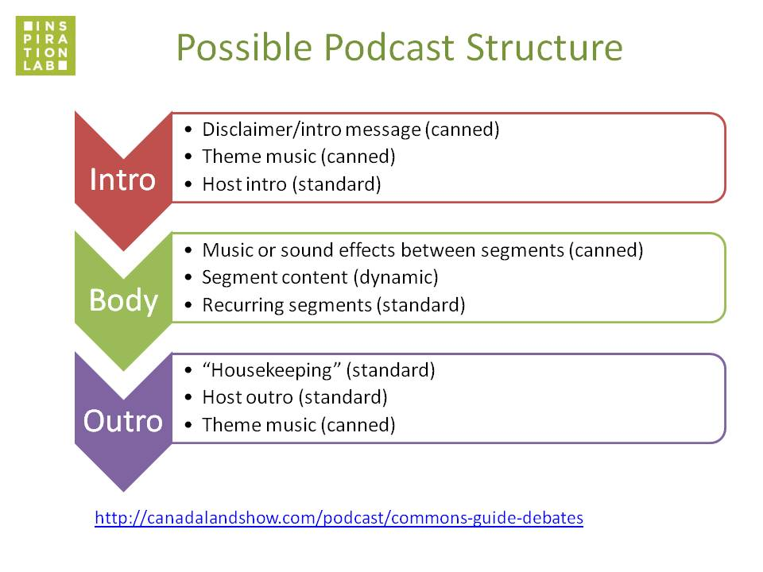

**RESOURCES**

Website & Audio Hosting:

* SquareSpace
* WordPress
* Weebly
* Wix
* LibSyn
* SoundCloud

Useful Google searches:

“website builders”

“audio hosting”

“podcast hosting”

Copyright + Creative Commons:

* *search.creativecommons.org*
* *creativecommons.org/licenses*
* en.wikipedia.org/wiki/Creative_Commons_license

Local Podcasts We Mentioned:

* The Story and the Story
* Rain City Chronicles
* S.S. Librarianship
* The One Project
* Stop Podcasting Yourself
* Vancouver Special

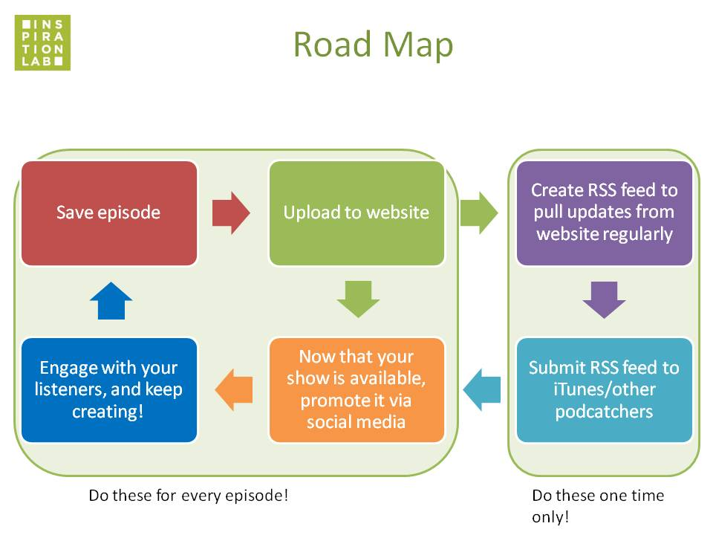

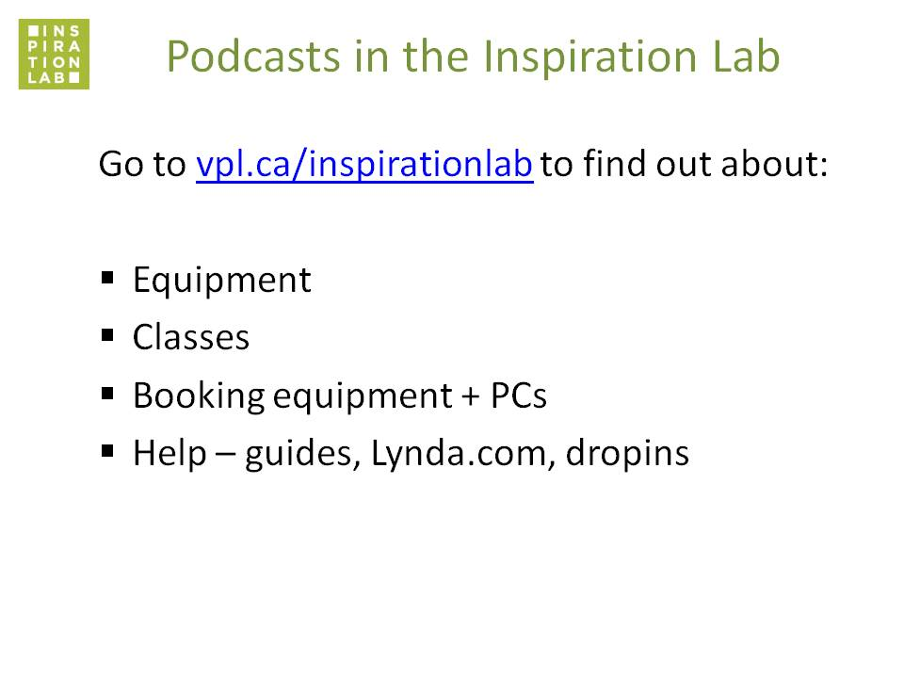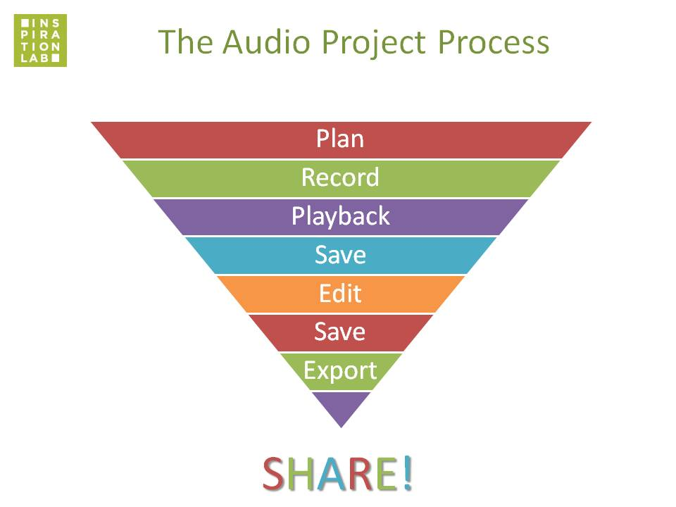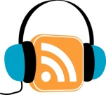

**Your Notes**