Let’s Talk about Participating online

Description
Explore safe social networking and Internet privacy and learn how to manage your digital identity when you engage with others online. Basic ability to use a computer and mouse is required. Register here for other classes in the Social Media Essentials series. Each class must be registered for separately.

Learning Goals > LEARNING outcomes
Digital Proficiency > Secure > Secure digital devices and services
- Recognize and report digital crimes.
Digital Proficiency > Secure > Secure private information
- Identify and interpret rights under service provider agreements to understand how service providers can and cannot use your data.
Digital Proficiency > Secure > Understand and shape online identity
- Examine and assess the consequences of sharing data online.
- Identify responsibilities agreed to under service provider agreements.
- Identify and criticize their own online persona and its components and interpret the online personas of others.
- Find, manage and monitor information about themselves on the web and in public databases.
- Manage personalization settings in online accounts to present the personal and professional identity they wish to project.

Preparation

Equipment Needed: | - Computers for learners  - Projector/laptop  - Internet access  - Sound
Materials Needed: | - PowerPoint on usb  - Handouts/evaluation forms for learners  - Blank certificates + date stamp
Setup Procedures: | - Review the “Adult Teaching & Learning at VPL” teaching philosophy: http://hub.vpl.ca/content/85898  - Review the lesson materials  - Confirm that all necessary space and equipment has been booked
Background Reading | See slides – reading included as topics are introduced
# of Staff Required | - 1-5 learners: 1 instructor  - 6-12 learners: 2 instructors  - For branch meeting room capacities, please see: http://hub.vpl.ca/content/64490

Opening
- Write your name and contact info (optional) somewhere visible
- Distribute handouts, evaluation forms
- Test internet & speakers

Lesson

LEARNING ACTIVITIES |  |  |  | LEARNING OUTCOMES
Slideshow and/or Demo | Time | Trainer Does | Learners Do
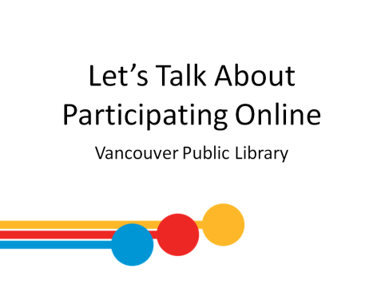 | 2 min | Participating Online  - Welcome  - Remind learners of washroom locations; turn off cell phones; emergency evacuation procedures; etc.  - Ask: What brings you here? What are you hoping to learn? | - Listen to instructor  - Respond to instructor’s questions
 | 5 min | Before we get started…  - This is one of many learning opportunities at the library.  - Today’s class is meant to be an introduction to the topic – there are lots more ways to delve deeper.  - Today will be the final class in this series: for those who’ve attended each class Congratulations! Please pick up your certificate of completion at the end of this lesson! | - Listen to instructor  - Ask questions
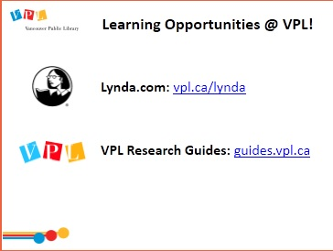 |  | Online learning at your own pace…  - Lynda.com  - vpl.ca/lynda  - videos; various tech topics; basic to advanced  - VPL Research Guides  - guides.vpl.ca  - Wide variety of topics; collected books & online resources | - Listen to instructor  - Ask questions
 |  | - Drop in to any branch  - Tech Café at Central | - Listen to instructor  - Ask questions
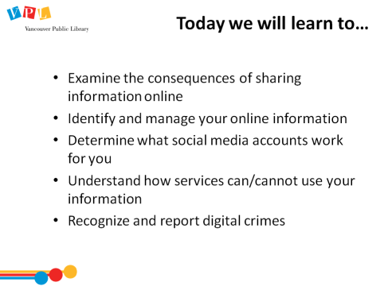 | 3 min | Today we will learn how to  - Review the description and outcomes on slide  - Ask:  - Do you have any social media accounts?  - How do you engage online? Work? Socialize?  - Are you comfortable engaging online?  - Do you have any specific questions or concerns? | - Listen to instructor  - Respond to instructor’s questions  - Ask questions
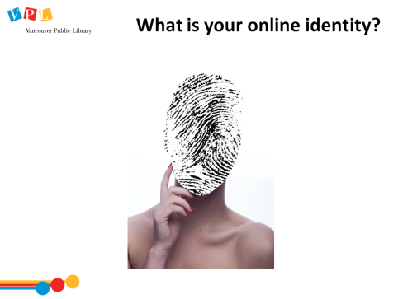 | 2 min | Background reading  https://www.gcflearnfree.org/jobsearchandnetworking/personal-branding-101/1/ *on handout  - Discuss: What do you think is meant by online identity? How would this identity be created?  - “A social identity that an Internet user establishes in online communities and websites.” (Wikipedia)  - Discuss: How is this identity created?  - Determined by what you share and what others share about you  - Determined by your relationships with other individuals or groups  - You have the power to limit what you share (e.g. use pseudonyms to maintain privacy) | - Listen to instructor  - Respond to instructor’s questions  - Ask questions | - Examine and assess the consequences of sharing data online
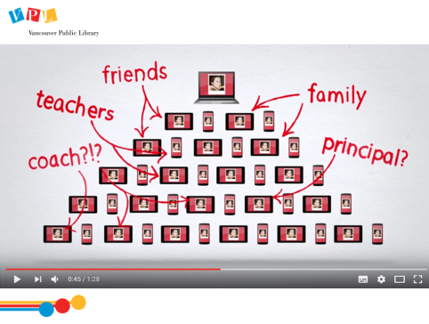 | 5 min | - Watch video linked in slide: Think Before You Share by Google https://www.youtube.com/watch?v=BcdZm3WAF4A (1:28) *on handout  - Highlights how online sharing can impact you  - NOTE: Target audience is for young adults but principles are applicable to everyone | - Watch video | - See previous
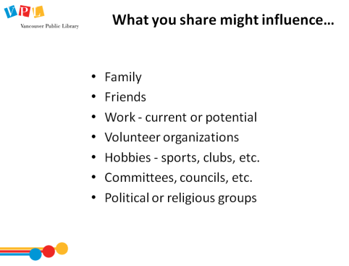 | 5 min | What you share might influence…  Background stories  http://www.bbc.com/news/stories-41851771  http://www.dailymail.co.uk/news/article-2175053/Burger-King-worker-posted-pictures-standing-bins-lettuce-fired.html  - Recap video  - You can’t control information once it’s out in the world. Shared info can spread quickly. What you post/send can be forwarded, copied, found by strangers  - You are what you share. What you share online can influence your real world reputation. Impressions can change based on what you share/post. Consider its impacts, positive and negative  - Ask (Write answers on whiteboard):  - Are there any agencies or individuals outside your immediate friends and family who might see your information?  - What other instances can you think of that could be impacted by what you share?  - Compare responses to slide | - Listen and respond to instructor’s questions  - Ask questions | - See previous
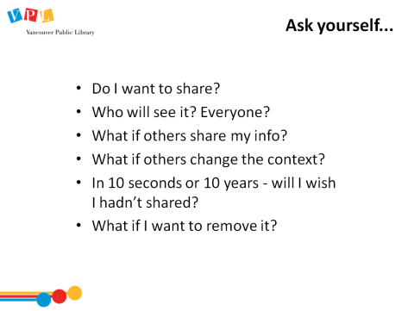 | 5 min | Background reading  https://www.serene-risc.ca/en/cybersecurity-tips/social-media *on handout  - Review slide and discuss | - Listen to instructor | - See previous
 | 5 min | - Watch video linked in slide: Infographic: Social Media is Changing Recruitment by CIPHR https://www.youtube.com/watch?v=w6rGe-XBi9w (2:00) Example of how social media can impact on your employability  - Ask:  - Were you surprised at how employers used data to accept or reject applicants?  - Does it make you more aware about your own presence online?  - Will you review your accounts to remove any unflattering information?  - Mention: Facebook and Linkedin classes | - Watch video  - Respond to instructor’s questions  - Ask questions | - See previous
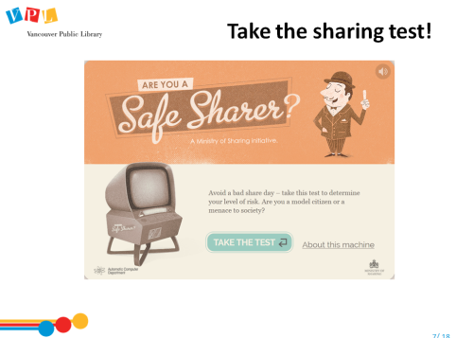 | 10-15 min | - Visit site & walk through test with group (ask for input)  http://www2.open.ac.uk/openlearn/ministry-of-sharing/ *on handout  OR…..  - Refer to handout pg. 3 for activity  - Divide learners into groups/partners (at discretion of trainer)  - Tell learners to review and describe fictional online profiles of people. Pick three adjectives or phrases they might choose to describe those people  - Discuss answers; reiterate key points:  - We draw conclusions about people from their posts  - People willingly share a lot of personal information online  You are what you share. Be sure that the way you would want someone to describe you matches the actions you take online | - Follow along with instructor  - Listen to instructor  - Participate in activity  - Ask questions | - Examine and assess the consequences of sharing data online  - Identify and criticize their own online persona and its components and interpret the online personas of others
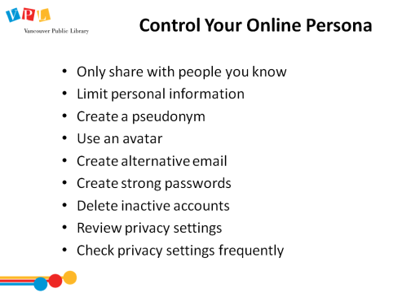 | 10 min | Background reading  https://www.priv.gc.ca/en/privacy-topics/technology-and-privacy/online-privacy/ *on handout  http://www.victimsinfo.ca/en/services/fraud-and-identity-theft  - Discuss: Once you share, there is no way to be sure if it has been shared or copied  - Review tips that will protect information online:  - Only share with people you know or who your friends, family, coworkers, etc. can vouch for  - Limit the sharing of personal information that could lead to identity theft (e.g. phone, address, birth date, ID numbers)  - Create a pseudonym. Be aware of terms of service. Some sites may block/delete your account if discovered you are using false information  - Profile pictures do not need to an image of you. You can use an avatar to represent you  - Create an alternative email for online purchases and social media accounts  - Create strong passwords. Hackers easily access accounts with simple passwords, like pet names or birthdays  - Delete inactive accounts. This will reduce the risks if there are ever any security breaches. More later  - Review your privacy settings. All social networking sites have privacy settings that allow you to control who you share with  - Check your privacy settings frequently. Sites may reorganize or change their privacy policy. Review your settings to make sure they are set the way you want them to be  - What type of public image you want to project?  - Mention: Let’s Talk About Online Privacy class | - Listen to instructor  - Ask questions | - Examine and assess the consequences of sharing data online  - Find, manage and monitor information about themselves on the web and in public databases  - Manage personalization settings in online accounts to present the personal and professional identity they wish to project
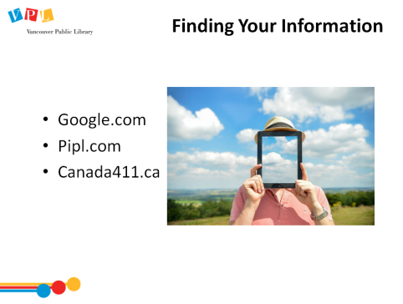 | 10 min | Background reading  https://techboomers.com/t/finding-your-information-online *on handout  - Activity: Perform search/s based on sites in slide.  - Discuss results:  - Is there anything you found that surprised you?  - Is there anything you would prefer was private?  - Was it accurate?  - Search yourself yearly and review results | - Perform searches  - Listen to instructor  - Ask questions | - Identify and criticize their own online persona and its components and interpret the online personas of others  - Find, manage and monitor information about themselves on the web and in public databases
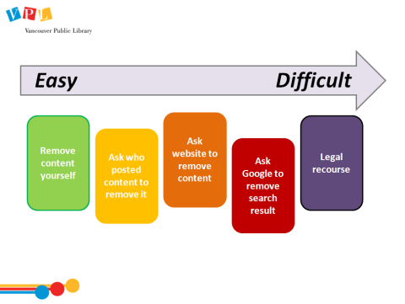 | 5 min | - Discuss the steps available to remove content  - We may forget what we’ve posted, we change our opinions, or we just decide to be more private  - Good practice to periodically review the information about you online and remove it if necessary  - This can be easy or difficult  - Review options on slide. Click slide (each example will appear individually):  - Remove it yourself if you own the account. By changing your privacy settings (e.g. Facebook), you can prevent others from seeing your information  - Ask who posted it content to remove it  - Ask website. Use the contact on the site to request the content be removed  - Ask Google. Google will remove search results for content shared without your consent (not from the source site itself) – such as bank account numbers or sexually explicit photos https://support.google.com/websearch/troubleshooter/3111061?hl=en *on handout  - Legal recourse is the final, but potentially expensive and long, process for extreme cases. | - Listen to instructor  - Ask questions | - Find, manage and monitor information about themselves on the web and in public databases
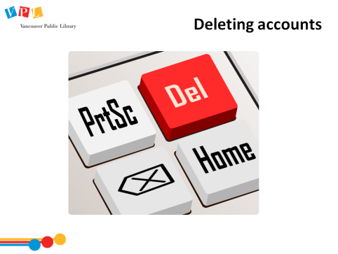 | 5 min | Background reading  http://www.wikihow.com/Delete-Yourself-from-the-Internet *on handout  http://www.telegraph.co.uk/technology/2016/11/25/delete-internet-website/  - Discuss deleting inactive accounts:  - Unused or forgotten accounts still contain your private information  - Before deleting, download or save your info, such as pictures or messages  - Some sites do not allow for complete deletion of account information (read Terms of Service). In this case, replace your real contact information to something fake  - “Deleting” may not mean complete destruction/erasure of data already collected by any given site/platform  - Explore websites:  http://backgroundchecks.org/justdeleteme/ *on handout  - Contains direct links to social media accounts to delete your account  - Gives a quick summary and rates the process from easy to hard  https://www.deseat.me/ *on handout  - Get a list of all the websites and services you've signed up for and provides instructions on how to delete them or unsubscribe  - Limited to those who have a Google or Outlook account  - Mention: Let’s Talk About Online Privacy class | - Listen to instructor  - Ask questions | - See previous
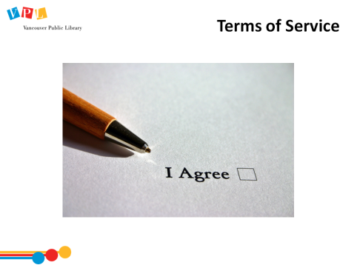 | 3 min | Terms of Service  - Discuss. Terms of service (or Terms and conditions) are rules by which one must agree to abide in order to use a service  - Ask:  - Have you read the terms of service that accompany services that you sign up for?  - Have you reviewed those terms since signing up?  - What are you really agreeing to? | - Listen to instructor  - Respond to instructor’s questions  - Ask questions | - Identify and interpret rights under service provider agreements to understand how service providers can and cannot use your data  - Identify responsibilities agreed to under service provider agreements
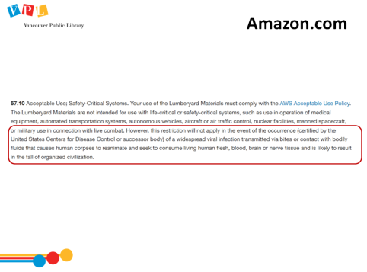 | 5 min | Terms of Service example: Amazon.com  - Read aloud circled section on slide: “However, this restriction will not apply in the event of the occurrence (certified by the United States Centers for Disease Control or successor body) of a widespread viral infection transmitted via bites or contact with bodily fluids that causes human corpses to reanimate and seek to consume living human flesh, blood, brain or nerve tissue and is likely to result in the fall of organized civilization.”  - Ask: Anything unusual?  - Demo more examples (if time): http://www.businessinsider.com/tumblrs-new-terms-of-service-is-inspiring-and-funny-2014-1 | - Listen to instructor  - Respond to instructor’s questions  - Ask questions | - See previous
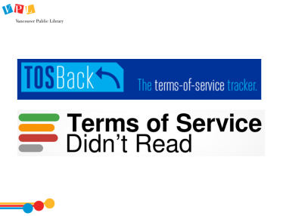 | 5 min | - Demo following websites (they help interpret terms):  - https://tosback.org/ (on handout) – tracks any policy changes  - https://tosdr.org/ (on handout) – analyzes and grades the terms of service | - Listen to instructor  - Ask questions | - See previous
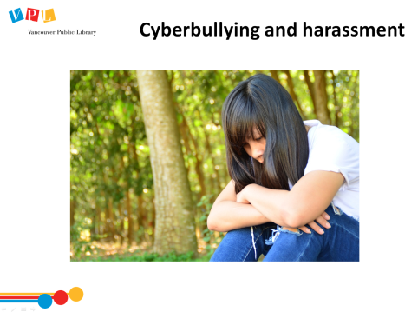 | 5 min | Background reading *on handout  https://www.cbabc.org/For-the-Public/Dial-A-Law/Scripts/Criminal-Law/206  https://cybertip.ca  - Discuss: What is cyberbullying?  - The use of social media, blogs, texts, instant messages, etc. to deliberately to harm, embarrass, or slander someone.  - Discuss: What can you do if someone is stalking, harassing, or cyberbullying you?  - Tell the person to stop. Do not engage in any other discussion. Make it clear their communication is unwanted.  - Call the police and report it.  - Record details of every incident (time, date, place, who was involved, and what was said and done). Keep letters, notes, voicemail messages, emails, texts, instant messages, and social media and internet posts.  - If the harassment happens at school, report it to the school authorities, as well as to the police. If it happens at work, report it to your boss (or a co-worker, especially if the boss is the one harassing you), plus the police.  - Report it to your internet or cell phone company. Most companies have policies on acceptable use of their services, and can cancel the service of a customer who violates those policies. The company can also help police find a cyberbully who is using their network.  - If you get a harassing phone call on a landline, dial *57 immediately when the call ends. The phone company will record the phone number that made the call, so the police can get it. If you receive harassing calls on your cell phone, call the phone company for help in tracking the calls.  - If you find anything that exploits or harms children, or the possible harm of people or property, report it! | - Listen to instructor  - Ask questions | - Recognize and report digital crimes
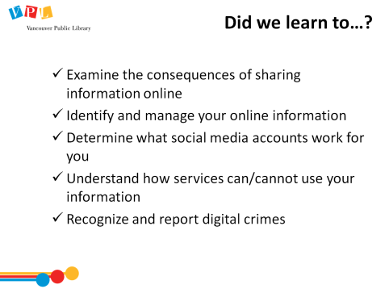 | 1 min | Did we learn how to…?  - Ask: Did we meet all of our goals today? Was there anything we didn’t cover? Do you have any other questions and/or comments  - Hand out Certificates of Completion: ask who has completed the series, fill name in + date stamp  - Refer learners to resources on the handout  - Review how to search for more classes | - Listen to instructor  - Ask questions
 | 25 apx. | Time for practice, questions, etc.

Closing
- Thank learners for coming
- Ask them to take some time to fill out the evaluation form

