Get to know file management

Description

Do you need to organize the documents on your computer? This hands-on, introductory class covers the basics of file management including creating, renaming, transferring, and deleting files and folders. Basic ability to use a computer and mouse is required. Register by phone for this or other classes in the Computer Essentials series. Each class must be registered for separately.
Learning GOALS>OUTCOMES

Digital Proficiency > Operate > Operate Digital Devices
Learners will be able to . . .
- Recognize the major components of computers and mobile devices
- Prepare devices for use by connecting components and charging (2016: cords and cables, adapters, wireless charging mats, power bars)
- Operate computer user interfaces effectively (2016: Keyboard, mouse)
- Locate and use common computer operating system features (2016: desktop, program icons, applications menu, Windows Explorer/Finder, Control Panel/Settings, Taskbar/Dock, etc.)
- Locate, organize and label files and folders on a computer

Digital Proficiency > Operate > Operate programs and Apps
Learners will be able to . . .
- Recognize common features of programs, and generalize knowledge from familiar to unfamiliar programs (2016: menus, toolbars, word processing, image and video, edit, delete, etc.)
- Identify and use features for saving and exporting files and information

Preparation

Equipment Needed: | - Computers for learners  - Projector/laptop  - Internet access  - Sound
Materials Needed: | - USBs for learners (PLG locker)  - PowerPoint on usb  - Handouts/evaluation forms for learners  - Blank certificates + date stamp
Setup Procedures: | - Review the “Adult Teaching & Learning at VPL”  - Review the lesson materials  - Confirm that all necessary space and equipment has been booked  - Read/use the Digital Literacy Setup and Closing Procedures Checklist  - Install the Practice Folder on all learners and instructor computers
Background Reading | - GCF File management basics https://edu.gcfglobal.org/en/windowsbasics/working-with-files/1/
# of Staff Required and/or Staff:Learner Ratio | - 1-5 learners: 1 instructor  - 6-12 learners: 2 instructors  - For branch meeting room capacities, please see: http://hub.vpl.ca/content/64490

Opening
Before doors open:
- Write your name and programs@vpl.ca on the whiteboard (include phone number 604-331-3603 for more basic digital literacy classes)
- Distribute handouts, evaluation forms (if applicable)
- Test internet & speakers
- Turn the computers for learners on before class starts
- Open any relevant websites needed for lesson.

As learners enter
- Welcome learners

Lesson

LEARNING ACTIVITIES |  |  |  | LEARNING OUTCOMES
Slideshow and/or Demo | Time | Trainer Does | Learners Do
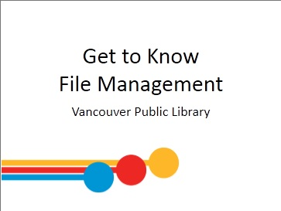 | 2 min | INTRODUCTION  Welcome students; introduce yourself; introduce the class and series  Remind learners of washroom locations; turn off cell phones; etc.  Ask if everyone can hear you. | - Respond to instructor’s questions and prompts
 | 5 min | LEARNING OPPORTUNITIES AT VPL  - This is one of several Digital Essentials series offered for free here at the library.  Click on the link in slide to navigate to vpl.ca Digital Essentials page and show learners other classes.  - You can work toward a certificate for each series. If you attend all classes in the series, you will receive a certificate in the last class in the series.  - Come and talk with me at the end of class if you have attended this series for the past three weeks so I can get you your certificate. | - Listen to instructor  - Respond to prompts  - Ask questions
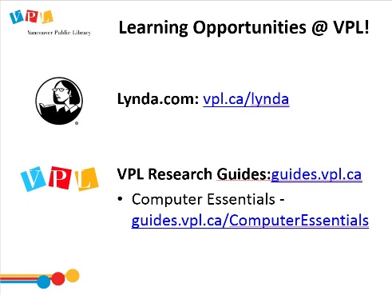 |  | LEARNING OPPORTUNITIES AT VPL  - There are several ways you can learn more about this topic. One way is through online learning at your own pace.  Lynda.com  - vpl.ca/lynda  - videos; various tech topics; basic to advanced  Navigate to Lynda.com via the VPL website.  Show them how to login and access Lynda.  Show them where to find the relevant Mobile Device class on Lynda.  VPL Research Guides  - guides.vpl.ca  - Wide variety of topics; collected books & online resources  Show them how to find the Research Guides from the VPL website and how to navigate to the relevant Research Guide. | - Listen to instructor  - Respond to prompts  - Ask questions
 |  | LEARNING OPPORTUNITIES AT VPL  - This is one of the many learning opportunities at the library.  - Today’s class is meant to be an introduction to the topic – there are lots more ways to delve deeper.  - There are many other ways to learn and get help on this and other topics at the library.  - Drop-in to any branch  - Tech Café at Central  - Call or email the library | - Listen to instructor  - Respond to prompts  - Ask questions
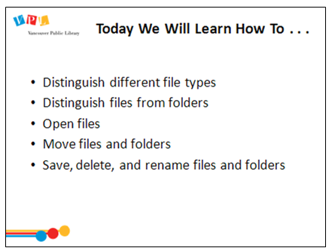 | 2 min | LEARNING OBJECTIVES  Review slide and read learning outcomes listed on slide  Ask: Any comments or questions about what we will be covering today?  Lead a round where people introduce themselves and answer this question:  - Please share your name and what brings you here today. What are you hoping to learn from this class?  - Explain that this will be a mixture of informational and hands on learning – with lots of practical application | - Respond to instructor’s questions/prompts | - Operate computer user interfaces effectively  - Locate and use common computer operating system features  - Locate, organize and label files and folders on a computer  - Recognize common features of programs, and generalize knowledge from familiar to unfamiliar programs
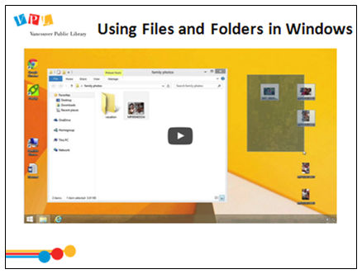 |  | - Play video: Using Files and Folder in Windows by GCF https://youtu.be/wFv_mIozZYs (2:32) | - Learners watch video | - See previous
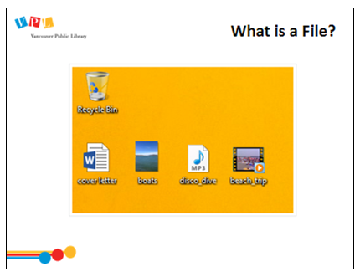 |  | WHAT IS A FILE?  - Explain to learners that files include:  - Documents  - Photos  - Music  - Videos  - Explain that files are digital versions of real-world things  - Explain that you can view, create, or edit files  - Show learners examples on slide | - Learners listen and ask questions | - See previous
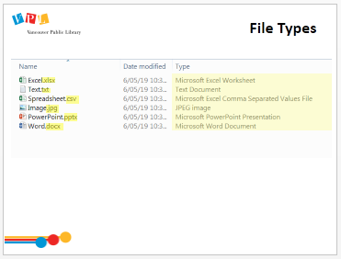 |  | TYPES OF FILES  - There are different types of files, and they have different formats. These formats are denoted through a “file extension”  - Files have an extension that tells your computer what program it should use to open that file  - The extension is the suffix at the end of the file name, after the decimal point  Click to highlight the file extensions  - If there are multiple decimals, only the suffix after the last one counts  - You don’t have to know what the file extensions mean to use them, but you’ll probably start to see the same ones over and over again  - If you want to know what type of file it is, there should be additional information, depending on the view, or you can right click and select “Properties”  Click to highlight Type | - Learners listen and ask questions | - Locate, organize and label files and folders on a computer  - Identify and use features for saving and exporting files and information
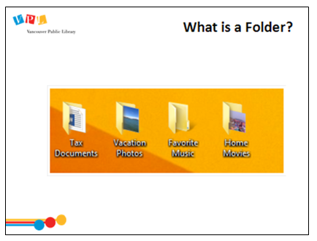 |  | WHAT IS A FOLDER?  Explain to learners that Windows uses folders to help organize files just like in the real world  Explain that folders can be used in many different programs (eg: email)  Show learners examples on slide  Explain that folders can store both files and folders (or subfolders) | - Learners listen and ask questions | - Operate computer user interfaces effectively  - Locate and use common computer operating system features  - Locate, organize and label files and folders on a computer  - Recognize common features of programs, and generalize knowledge from familiar to unfamiliar programs previous
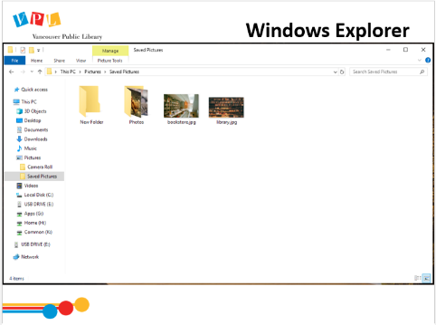 |  | WHAT IS WINDOWS/FILE EXPLORER?  Explain to learners that you can view and organize files and folders using a built-in application known as Windows Explorer (Windows 7 and earlier, File explorer for later versions) or My Computer  Explain to learners that you can open Explorer by clicking on the computer icon OR via the start menu  Demo the two methods of accessing Windows Explorer (Computer Icon and Start Menu)  Instruct learners to practice opening and closing Windows Explorer using the two methods | - Learners listen, practice and ask questions | - Operate computer user interfaces effectively  - Locate and use common computer operating system features  - Locate, organize and label files and folders on a computer  - Recognize common features of programs, and generalize knowledge from familiar to unfamiliar programs
No Slide – Demo live |  | Make sure everyone has Windows Explorer open.  Demo how to change the view to “detail view”, Learners follow  Describe what they are seeing:  - Drives – Instruct learners to click on different drives – explain changes  - Name  - Size  - Item type  - Date modified  Show how they can sort by all these fields. Ask:  - Can you think of a scenario where it would be good to sort your files alphabetically? How about by type? Or most recently changed? Or size?  Show learners how to expand sections to see more  Instruct learners to click on: Libraries > Pictures > Sample Pictures  Point out the address bar at top shows the location of the file or folders  Explain, to open a file they need to double click on it. Have learners practice | - Follow along  - Ask questions | - See previous
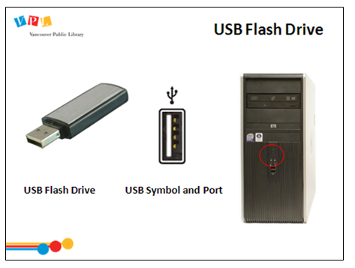 | 5 min | USB FLASH DRIVE (UNIVERSAL SERIAL BUS)  Refer learners to “Let’s Talk About File Management Handout” page 1  - A flash drive is a small, removable hard drive that plugs into a USB port on your computer. You can purchase a flash drive for less than $20 at just about any retail store with an electronics department, and even at some grocery stores and pharmacies. Flash drives are a convenient way to bring your files with you and open them on a different computer. You could also use a flash drive to back up important documents and other files  How to Use a USB Flash Drive:  - Insert the flash drive into a USB port on your computer. You should find a USB port on the front, back, or side of your computer (the location may vary depending on whether you have a desktop or a laptop)  - Tips/Tricks: The USB will only fit in one way (if it isn’t fitting in try turning the USB stick around)  Assist: learners to plug USB Flash Drives into lab computers  Tell learners this is only one type of storage they should check out Let’s Talk About Digital Storage to learn more about backing up & transferring files. | Learners practice:  - Practice plugging USB Flash Drives into lab computers | - Recognize the major components of computers and mobile devices  - Prepare devices for use by connecting components and charging
No Slide – Demo live | 5 min | CREATING NEW FILES AND FOLDERS  Refer learners to Handout page 2 – 6  Instruct learners to open Word, type “I love the library” and walk learners through the steps to save:  - Click the Office Button  - Click Save  - Click Desktop (explain importance of selecting the drive before saving)  - Click file name and name it Practice (explain the importance of file names and that some programs will not open file names that have a space – best practice is to use an _ between words or use “camel case”.  - Click “Save as type” and explain the different types files can be saved as. Let learners know that .doc is proprietary to Word and patrons using Open Office in the library may have problems when editing/saving. The universal format is .rtf  - Click save  Have learners close the document. Show how the file is now on their desktop  Demo “Save As”. Have learners practice and create 4 – 5 files all saved to the desktop  Demo how to create new folders on the Desktop using the right click menu  Have learners practice and create 4 more folders  Demo how to rename folders using the right click menu  Have learners practice renaming their folders | - Learners practice: Creating new folders on the Desktop | - Operate computer user interfaces effectively  - Locate and use common computer operating system features  - Locate, organize and label files and folders on a computer  - Recognize common features of programs, and generalize knowledge from familiar to unfamiliar programs
No Slide – Demo live | 5 min | MOVING FILES AND FOLDERS  Refer learners to “Let’s Talk About File Management Handout” page 6 – 9  Demonstrate (and have learners practice):  - How to drag a file into a folder.  - How to drag a folder into a folder.  - How to drag a file from the Desktop and drop it onto the USB drive.  - How to drag a folder from the Desktop and drop it onto the USB drive.  Tip: Share with learners that nothing can ever be dragged and dropped into a file | Learners practice:  - Moving a file into a folder  - Moving a folder into a folder  - Moving a file onto the USB drive  - Moving a folder onto the USB drive | - See previous
No Slide – Demo live | 5 min | DELETING A FILE OR FOLDER  Refer learners to “Let’s Talk About File Management Handout” page 10  Demonstrate how to delete a file or folder. Have learners practice  - Tip: Share with learners that not everything that is deleted ends up in Recycle Bin. Items deleted from the USB Memory Stick will always be permanently deleted. Delete a file or folder from the Desktop, open the Recycle Bin and demonstrate how to move the file/folder back to the desktop. | Learners practice:  - Moving a file/folder from the Recycle Bin back to the Desktop  - Deleting all the files and folders they created from the Desktop and USB drive | - See previous
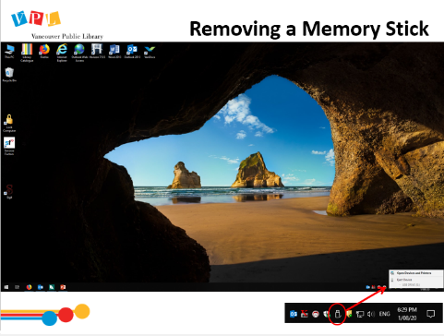 | - min | Demonstrate ejecting/Removing a USB Memory Stick  Explain why it is important not to just pull out the USB Memory Stick  Have learners practice | - Learners practice:  - Ejecting/removing a USB stick | - See previous
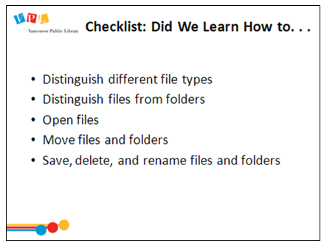 | - min | DID WE LEARN HOW TO…?  - Ask: Did we meet all of our goals today?  - Was there anything we didn’t cover?  - Do you have any other questions and/or comments  Refer learners to resources on the handout  Review how to search for more classes | - Respond to instructor’s questions/prompts
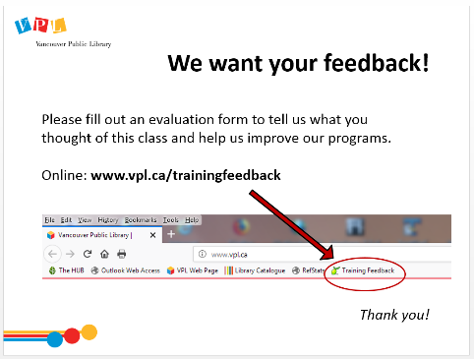 |  | EVALUATION FORMS  Ask them to take some time to fill out the evaluation form. If possible, have them fill out the form online. If not, provide them with the paper forms:  - We would like your feedback! Please take some time to fill out an evaluation form to let us know what you enjoyed and what could be improved.  - There is a bookmark link to the form on all computers.  - You can also access the link by going to http://www.vpl.ca/trainingfeedback
 | 30 min | Time for practice, questions, etc.  Rove around and assist learners as needed

Closing
- Thank learners for coming
- Ask them to take some time to fill out the evaluation form

