Let’s Talk About File Management Handout
USB Stick/Flash Drive
A flash drive is a small, removable hard drive that plugs into a USB port on your computer. Flash drives are a convenient way to bring your files with you and open them on a different computer. You could also use a flash drive to back up important documents and other files

How to Use a USB Flash Drive
- Insert the flash drive into a USB port on your computer. You should find a USB port on the front, back, or side of your computer (the location may vary depending on whether you have a desktop or a laptop)
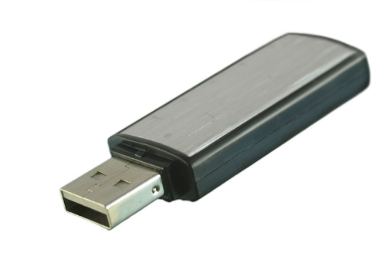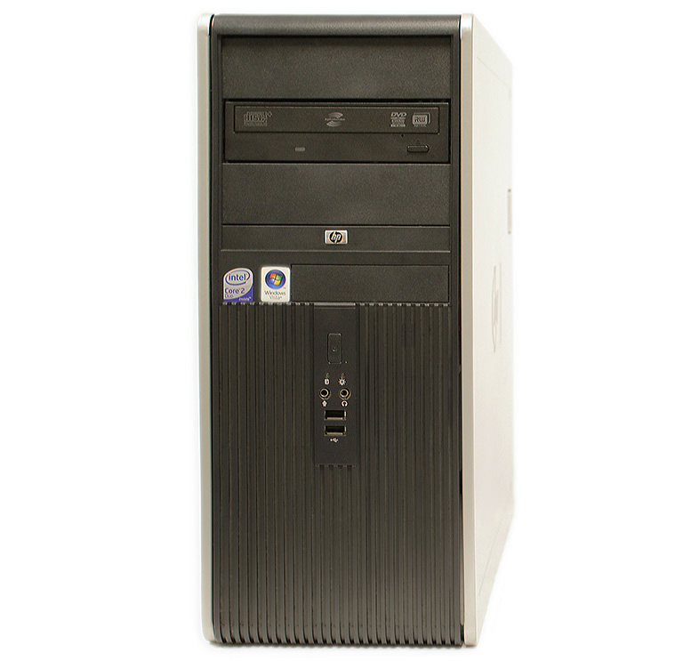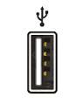
USB Port
USB Stick/Flash Drive
USB Symbol
USB Ports

Note: if a flash drive pop-up window/dialog box appears, just click the button to close it)

How to Eject a USB Flash Drive
Click icon (bottom right of screen), click eject and pull out when “safe to remove hardware” appears
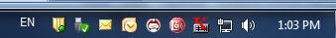
How to Save a Document
- Left-click the Office button on the top left hand side of the screen
File Menu

- Left-click “Save”

Save
Saves your changes and overwrites the original file

Save As
Creates a new file under a new name and avoids overwriting the original file

- Left-click on the “Desktop”

- Change the “File name” to whatever you would like the document to be called

- Left-click the “Save” button

How to Create New Folders

- Click the “Start” button and click on “Computer” to locate the flash drive

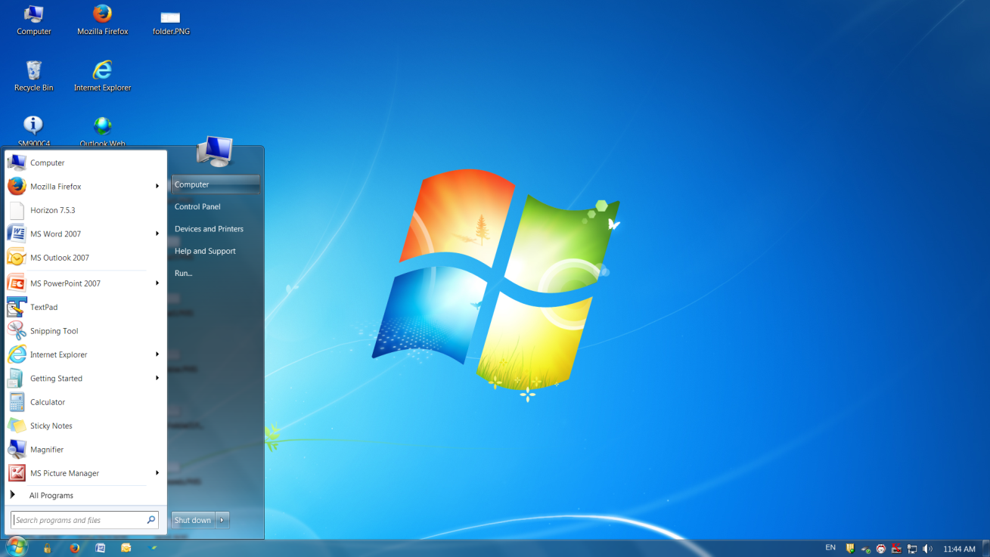
- Double-click on the Desktop drive to open
- Left-click “New Folder”
- Rename the New Folder

How to Move Files and Folders
- Moving a document into a folder:
  - Left-click the document/file you would like to move
  - Drag and drop the document/file into the desired folder

How to Explore Files and Folders
- Insert the flash drive into a USB port on your computer. Depending on how your computer is set up, a window/pop-up dialog box may appear. If it does, select “Open folder to view files”

- If a dialog box does not appear, or if the Flash Drive is already plugged in to your computer, click the “Start” button and click on “Computer” to locate and select the flash drive

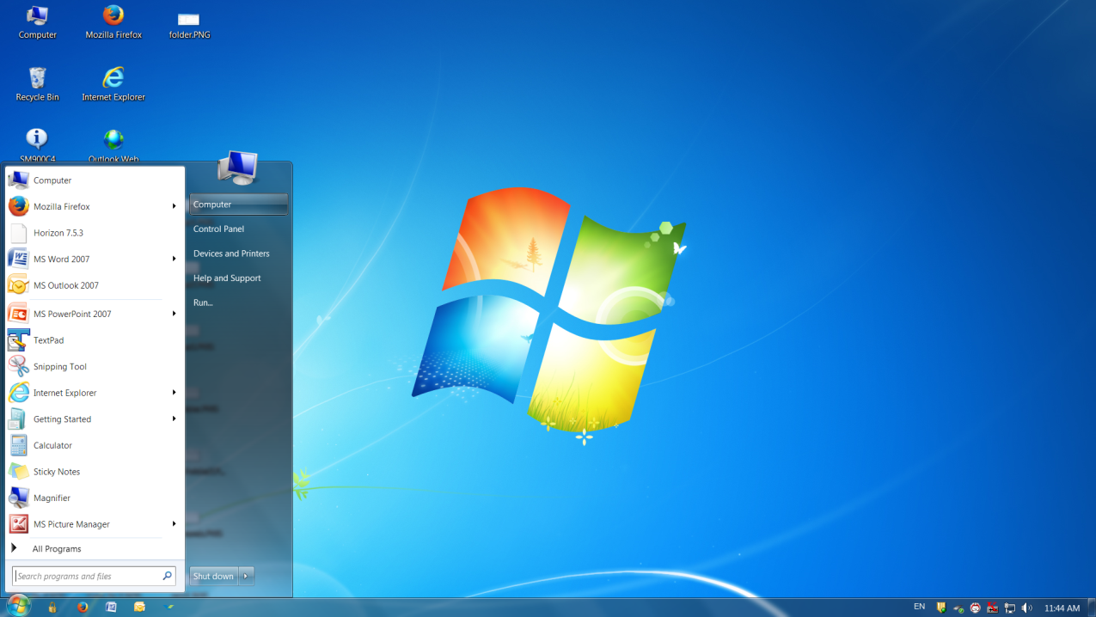

- Double Click on the Desktop drive to open

- Double-click on the folder to open and view the files inside

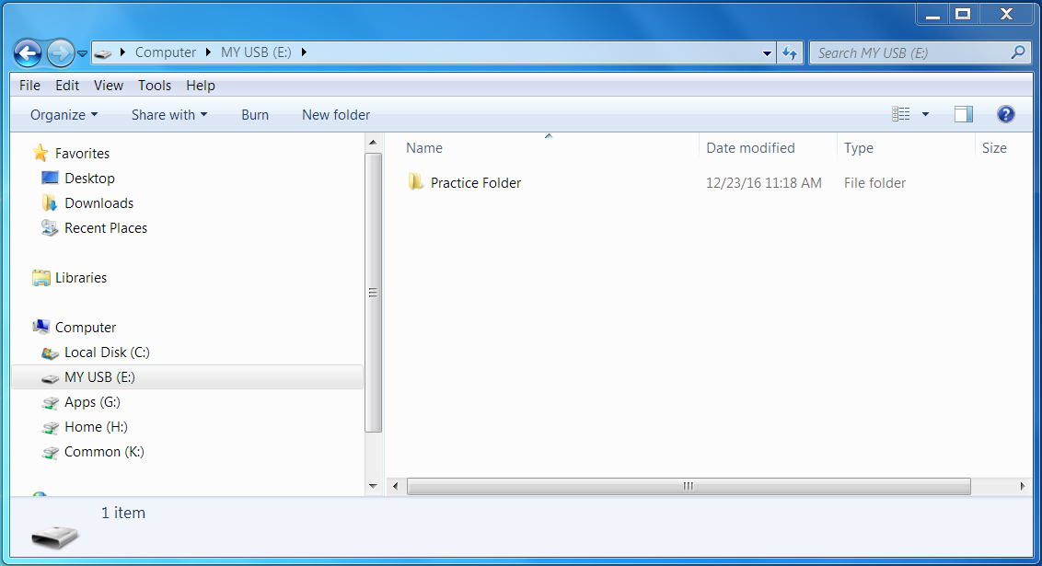

- Double click on the document to open, view and/or edit
Tips/Tricks: The breadcrumb trail will allow you to keep track of your location

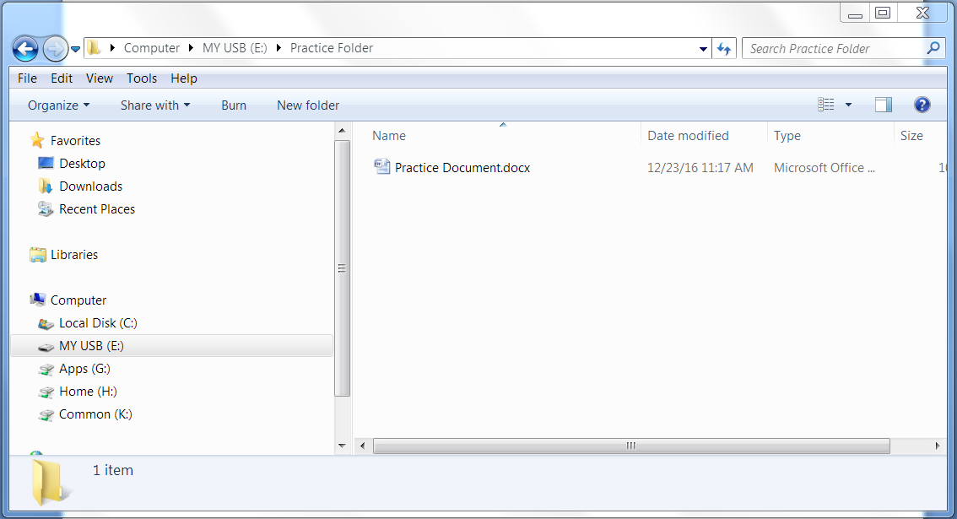

How to Delete a File or Folder

If you want to remove a file from your flash drive, click and drag the file to the Recycle Bin on a PC or the Trash can on a Mac. A dialog box may appear. If it does, click Yes to confirm that you want to permanently delete the file

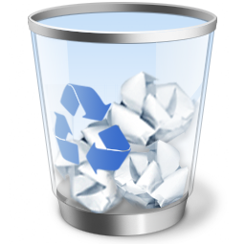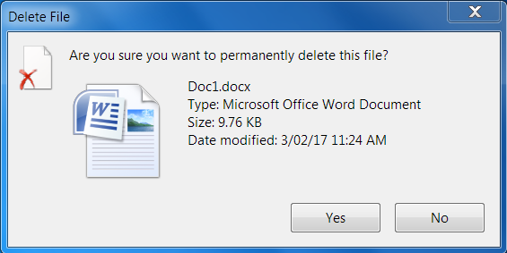

Note: If a dialog box does not appear, you may need to empty the Trash can to permanently delete the file

Another option to delete a file or folder is to right-click on the file or folder to bring up the menu. Select Delete from the menu. A dialog box may appear. If it does, click Yes to confirm that you want to permanently delete the file

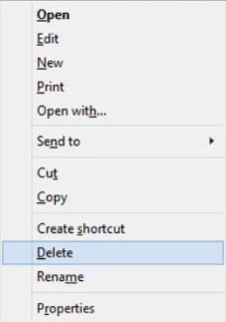

LEARN MORE

- Computer and Technology Help (vpl.bibliocommons.com/events)
Drop in to practice your computer and technology skills and get help from VPL staff. For days, times and locations, check out the “Computer & Technology” category in our Events Calendar

- Computer Essentials Research Guide (guides.vpl.ca/ComputerEssentials)
Outline of the Computer Essentials Series including handouts and practice activities

- GCFLearnFree.org tutorials (gcflearnfree.org)
Free tutorials for learning the essential skills you need to live and work in the 21st century

- We are here to help!
Talk to VPL staff in person, by phone (604-331-3603) or by email (info@vpl.ca)

