TYPING GUIDE 打字指南
- Click in the address bar, on top of the existing website
在地址栏上按一下现有的网址
- Type/输入 sense-lang.org/typing/
- Press/按 ‘ENTER’ on your keyboard
To practice typing online, go to www.sense-lang.org/typing/
要在网络上练习打字，请至：www.sense-lang.org/typing/
- Click on/按Tutorials
- Click on/按Lesson
- Click on the lesson you wish to complete
选择您想要复习的课
Use this button to erase text to the left of your cursor. (Your cursor is the flashing black line that appears when you are typing)
用这个按钮删除在光标左边的字（光标是在打字时一闪一闪的黑直线）

- Type the letters that you see above
打出屏幕上显示的字母
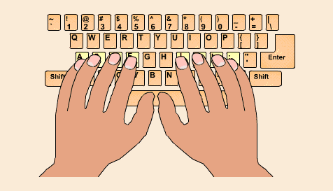How to place your fingers on the keyboard (键盘上该如何摆手指):
This set of keys is called your Home Row. This is where your fingers rest.
Your pointer fingers should rest on F and J.
这些按键是您的“母排”。当您没有在打字时或者是要刚开始打，手指都应该先到这个位置上。左手从小指至食指摆在A至F键。左手从食指至小指摆在J至；键上。
。
Backspace

For the keys that have two characters on them such as the numbers (or to type capital letters), you must keep the Shift button held down and press the other key once. Most people use their pinky for Shift.
若想按特别符号（同在数字键上的符号），要按住Shift键和那符号的按键。
*小提示：使用小指按Shift会比较简单。
Example: For typing @, hold down Shift and press 2 once, and then let go of the keys.
例如：想要打出@，按住Shift键并按一下2。

LEFT HAND左手  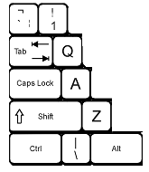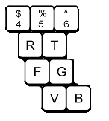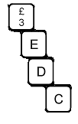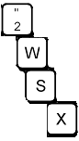  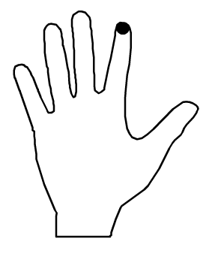  Use your thumbs to press the Spacebar  用您的大拇指按空白键 | RIGHT HAND右手  