Colour in a star for every 30 minutes you read. Each completed row of stars on this page is a check stop and you can come in for a prize. Once all of the stars are filled in come in for a prize as well as an entry in our draw for a grand prize!

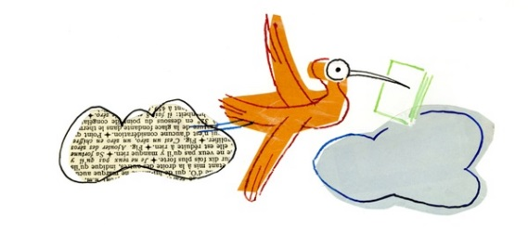

[](http://www.sgpl.ca/)

Colour in a star for every 30 minutes you read. Each completed row of stars on this page is a check stop and you can come in for a prize. Once all of the stars are filled in come in for a prize as well as an entry in our draw for a grand prize!

