PlayStation 4 Virtual Reality Maker Space Kit Contents Sheet
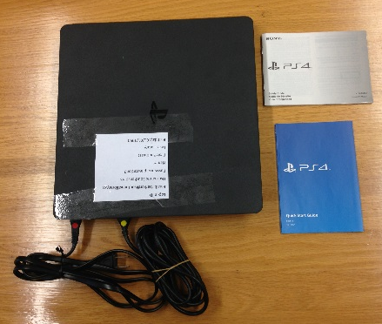
Bag 1 (PlayStation 4)
- (1)PlayStation 4 Console
- (1) HDMI Cable Yellow/Blank
- (1) PS4 AC Power Cord Bright Red
- (1)PS4 Quick start Guide
Bag 2 (Game Controllers)
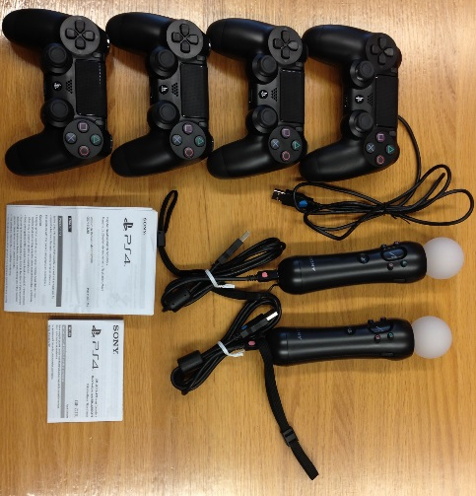
- (4) Dual Shock 4 Wireless Controllers Bright Green
- (1) Dual Shock Charging Cable Bright Green/Blue
- (2) Move Motion Controllers Pink/Blue
- (2) Move Motion Charging Cables Pink/Blue
- (1) Dual Shock 4 Wireless Controller Instruction Manual
- (1) Move Motion Controller Instruction Manual
Bag 3 (Camera)
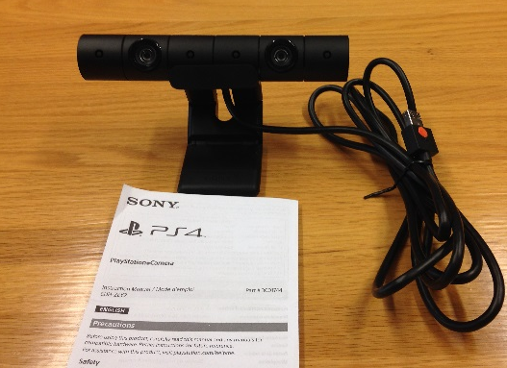
- (1) Camera Stand
- (1) Camera Cable Orange
- (1) PlayStation Camera Instruction Manual
- (1) PS4 Camera

Bag 4 (VR Headset Cables)
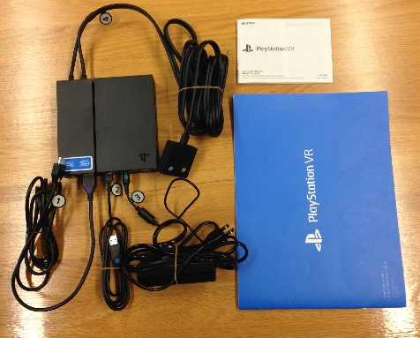
- (1) PlayStation VR Instruction Manual
- (1) PlayStation VR Quick Start Guide
All Cables Are Numbered for Easy Set up Using Quick Start Guide
- (1) HDMI Cable #1 Purple/Pale Yellow
- (1) HDMI Adapter Converter (Yellow/white M) (no photo)
- (1) USB Cable #2 Dark Red/ Blue
- (1)AC adapter #3 Teal Green
- (1) VR Headset Connection Cable #4 Light Blue/Fuchsia, Silver/Gold
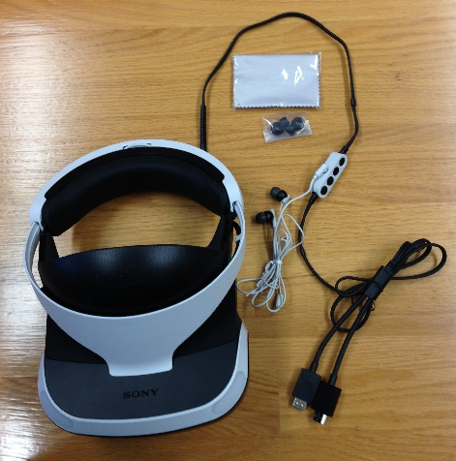
- (1) Processor Unit
Grey Box (VR Headset)
- (1) VR Headset #5 Silver/Gold
- (1)Stereo headphones + Earbuds replacements
- (1)Lens Cleaning Cloth
Games
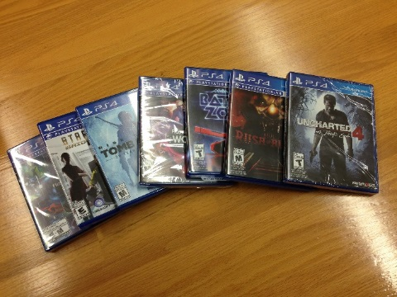
- (1) Uncharted 4 (No VR Capabilities)
- (1) PlayStation VR Demo Disc
- (1) PlayStation VR Worlds
- (1) Eagle Flight
- (1) Battle Zone
- (1) Robinson The Journey
- (1) Eve Valkyrie

