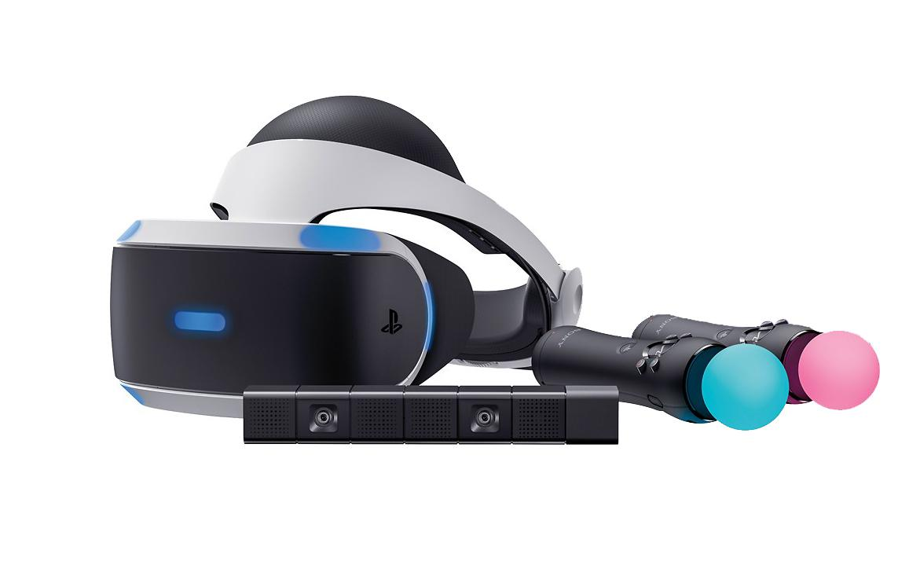

PS4 Virtual Reality Gaming

Mobile Gaming Station
Teen Programming

Prepared by Southeast Regional Library adapted from work done by Jeff Demitor for George Bothwell Public Library Branch, RPL

Background
Virtual reality is a new immersive gaming experience that can also be used to provide educational and training opportunities. The newly released PlayStation VR (PSVR) offers a relatively simply entry point that most patrons can use.
Southeast Regional Library has created 5 makerspace kits utilizing the PlayStation Virtual Reality System. (PSVR) Three of the kits will be circulated throughout the region as well as PSVR Systems in Weyburn and Estevan Library Branches.

Audience
The target audience for any programming with the PlayStation VR should be teens or adults. *PSVR is not recommended for children under the age of 12 due to health concerns around eye muscle development. Prolonged use of near screen activity could produce excessive eye strain on developing eyes, but there appears to be no scientific proof that VR headsets are specifically harmful to kids and it is believed that manufacturers are merely being very cautious in the absence of any conclusive data. A “better to be safe than sorry” approach to launching new technology.
However, as a public services provider, Southeast Regional Library will honour those health and safety use recommendations by limiting access to younger patrons to 15 minute supervised sessions.

Programming:
The PSVR will be new to many people in your community. This is a great opportunity to attract people into the library to try out the Virtual Reality System. Since use is limited to children under 12, this would be a great opportunity to promote the program to Family’s.
There is only 1 Headset with each system. Therefore only one person at a time may use the PSVR. (Of course others find it fun and amusing to watch while another plays the game)
You may like to set up time slots and promote the opportunity to book a Virtual Reality Gaming session at your local library over the duration of the makerspace being at your branch.

PSVR Use: 12 years and older
- As a public entity we must do our best to protect our patrons from potential health and safety risks. Staff will do their best to determine the child’s age. If staff is in doubt, they have the option of denying access to the VR headset and recommending the child:
  - Obtain parent or caregiver permission to use the Virtual Reality System
    - See the Parent permission form
Or
  - Return with a parent or caregiver who can monitor/facilitate their usage.

- Whenever a child or adult requests access to the VR headset staff will highlight the safety risks to the eye development of younger children.

*Key Messaging to review with ALL patrons who borrow the VR headset:
  - PSVR is not recommended for children under the age of 12 due to health concerns around eye muscle development.
  - Prolonged use of near screen activity could produce excessive eye strain on developing eyes.
  - It is believed the age recommendation is the manufacturer’s way of being cautious in the absence of any conclusive data.
  - Some people may experience motion sickness, nausea, disorientation, blurred vision or other discomfort while viewing the contents of the virtual reality. If you experience any of these symptoms, stop use immediately and remove the VR headset.
  - After use, the Headset must be returned to the librarian. The replacement cost, if the headset goes missing or is damaged, is $700.

- Patrons must wait their turn if others are using the PSVR.

- Provide VR Headset, games and controllers to the patron in the gaming area to help them get started – e.g. assistance with TV and receiver setup, console login etc.

- When patron is finished, make sure all related gaming items are kept with the PSVR system.

- Place controllers on charging station so ready for next use.

PSVR use: Under 12 years old
- Patrons who do not meet the age requirement will not be able to use the VR Headset unless accompanied by an adult.
- Recommend the child return with an adult who can monitor their usage and / or sign the permission form allowing them to staff supervised use of the system.
- Children under 12 may be allowed on the PSVR system for 5-15 minute periods of time only due to health concerns.
- Follow the guidelines as per PSVR use: 12 years and older.
- Staff should remain present for the entire time and monitor the behaviour of the patron or any clear symptoms of disorientation, motion sickness, etc. as defined in the Sony Health & Safety message and terminate/restrict access as appropriate based on their assessment of the situation.
- Staff can also authorize limited facilitated access (as described above) to younger children they believe to be 12 years of age or older but cannot provide proof of age or parental/guardian consent – but extra care and attention should be provisioned by staff to ensure the safety of the child. This practice should also be limited to 5-15 minutes and not occur on a regular basis, especially if customer’s age is questionably below the 12 year old minimum age guidelines of the manufacturer.

*Note: A laminated warning card is included with each system. Please show patrons before playing.

PERMISSION FORM for child under 12
PLAYSTATION 4 VIRTUAL REALITY
__________________Public Library Branch currently has a PS4 Virtual Reality System available for in library use only to the public. Adults and children are welcome to come into the library and play with this system. Due to manufacturers warnings use of the VR system is restricted.
  - PSVR is not recommended for children under the age of 12 due to health concerns around eye muscle development.
  - Prolonged use of near screen activity could produce excessive eye strain on developing eyes.
  - It is believed the age recommendation is the manufacturer’s way of being cautious in the absence of any conclusive data.
  - Some people may experience motion sickness, nausea, disorientation, blurred vision or other discomfort while viewing the contents of the virtual reality. If you experience any of these symptoms, stop use immediately and remove the VR headset.
  - After use, the Headset must be returned to the librarian. The replacement cost, if the headset goes missing or is damaged, is $700.

It is recommended that Children under the age of 12 be limited to 5-15 minutes. Your consent is required for a library facilitated experience with Virtual Reality. Your signature of this form indicates that you consent to a facilitated session of no more than 15 minutes on the PS4 Virtual Reality System at ___________________Public Library Branch.

Child’s Name: Birthdate:

Parent/Caregivers Signature Date

If you would like to bring your family in to the library to experience this gaming system, your presence is considered as consent and this form is then, not required.
PLAYSTATION 4 VIRTUAL REALITY MAKERSPACE INSTRUCTIONS:
This system is colour coded and the instructions here are laid out to assist with ease of assembly and disassembly. Match the coloured Dots.
ASSEMBLY: SECTION 1
QUICK START GUIDE:
This system is colour coded for ease of assembly.
Simply match the coloured dots.
Note:
- Match the Red end with Red outlet and plug the power cord to an outlet
- For TV Connection
  - The HDMI cable (Yellow) should be plugged into the processor unit (Yellow) port. (Note: uncoloured end should be connected to the TV HDMI input port)
- For Computer Monitor Connection
  - Take the HDMI Adapter Converter with Cable (Pale Yellow) and connect to the Pale Yellow port on the PS4 Console
  - Connect the end with the White ‘M’ into your computer Monitor
- Make certain the video camera is not faced at a light source i.e. uncovered window. You may need to adjust the location of the Video Camera to get it to work.
- Continue matching coloured ends to coloured ports until all wires are connected.
- When all cords are connected Go to Power up your PSVR and continue with instructions.

If you are having trouble and require more detailed instructions, see the next sections of this booklet.
Power up your PSVR
- Turn on your TV or monitor.
- Press the power button on your PS4 console
- Press the power button located on the VR headset cord
- Follow the on-screen instructions on your TV for setup information and guidance on how to put on your VR headset.
LET’S SET UP:
X is your enter button on the Dual Shock 4 wireless controller
First:
- Click on the smiley face User Icon
- Click on settings (Toobox Icon)
- Click on Network
- Click on setup internet connections
- Click on use Wifi
- Insert password
- Test internet Connection
Next:
Check for updates
Return to Home Screen (to return to Home Press the (PS) button on the Dual Shock 4 wireless controller
- Click on settings
- Click on system software update
- Follow screen instructions if update is required
- Return to home screen

LET’S PLAY
- Insert Disc
- Allow game to update
- Update headset if required following screen instructions
- On home screen click on desired game icon
- Follow screen instructions to play
GAME’S OVER
- To end the game press the (PS) button
- Select close application
- Eject the disc and replace in Disc cover

PACKING UP THE PLAYSTATION 4 VIRTUAL REALITY MAKERSPACE KIT:
Box
- Disconnect the VR Headset #5 from the VR headset connect cable #5. Silver and Gold connections
- Place VR Headset in Box
Bag #4
- Leave the VR headset Connect cable #4 connected: Light Blue and Fuchsia
- Unplug the power cord and leave the Teal Green end on cable #3 connected to the VR processor unit
- Disconnect the Blue end of the USB cable #2 from the PS4 unit. Leave the Dark Red end connected to the VR processor unit
- Disconnect the Pale Yellow end of the HDMI cable #1, from the PS4 console. Leave the Purple end connected.
- For Computer Monitor Connection
  - Disconnect the HDMI Adapter Converter with Cable from the monitor white ‘M’. Leave the Pale Yellow end connected to the PS4 Console
- Remove the HDMI cable (Yellow) from the VR processor unit and plug into the Yellow port on the PSR console
- Place console with connected cords into Bag #4
Bag #3
- Disconnect the VR Camera cable (Orange) from the PS4 Console
- Place camera, cord and stand in Bag #3

Bag #2
- Connect the cable (Green) to the Dual Shock 4 wireless controller (Green) and place in Bag #2 (if the cable end (Blue) is connected to PS4 console, disconnect first)
- Connect the cable (Pink) to the Move Motion Controllers (Pink) and place in Bag #2. (if cable end (Blue) is connected to the PS4 console, disconnect first)
Bag #1
- Disconnect HDMI cable from the TV. Leave Yellow end connected to the PS4
- Unplug the power cord and leave the Red end connected to the PS4
- Place into Bag #1.
Check MakerSpace Kit Content Sheet and make certain all parts and instruction booklets are put into the correct bags.
Collect all of the Games, check that all discs are replaced in their covers.
Place everything in the Red Bins.

