Getting Started with Twitter

What is Twitter?

Created in 2006, Twitter is a social media network that features short posts or “tweets” of 140 characters or less. Public tweets can be seen by anyone. Twitter has 645 million users and there are 58 million tweets per day. It is used as a platform to share news, have conversations, and keep on top of current events.

What is a Tweet?
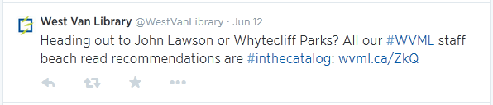 | A tweet is a short 140 character message. It can just contain text, images, and links to articles, websites, or videos.

Terminology

Retweet (RT) | Retweeting is a way to share another users’ message (tweet) by replicating their tweet to your followers and on your timeline.
#Hashtag | The # followed by words is used to mark keywords in a tweet.
Favourite | The favourite is used to mark a tweet that you might want to look at again later, or show your approval of.
@ - Replies and Mentions | The @ symbol followed by a username is a way to reply to users. It also creates a link to that user’s profile. They are notified when you use the @ and their username.

Learn more with the Twitter glossary: http://wvml.ca/Zkd

What is my Timeline?

Your Timeline is a list of all of the tweets from people that you follow with the most recent appearing first. As new tweets appear, they push the old ones down. | 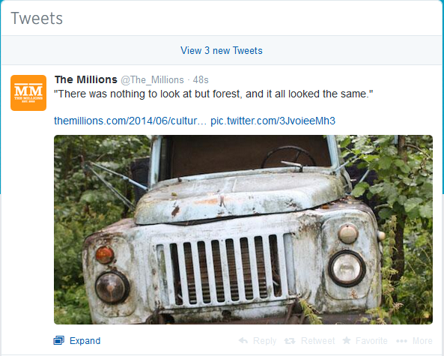
How do I Tweet?

- Click on the Compose button

- Enter in your message. | 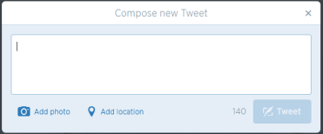
- Click Tweet

Follow Accounts

Keep track of people and your favourite topics by following accounts.  Just click on the Follow button and their tweets will be added to your timeline. | 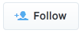

For More Information

Official Twitter Help: https://support.twitter.com/
Books and ebooks from the library: http://wvml.ca/ZkP

Create an Account

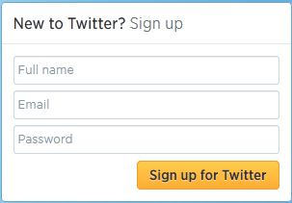 | 1. Click on Sign up For Twitter
2. Fill in the fields | 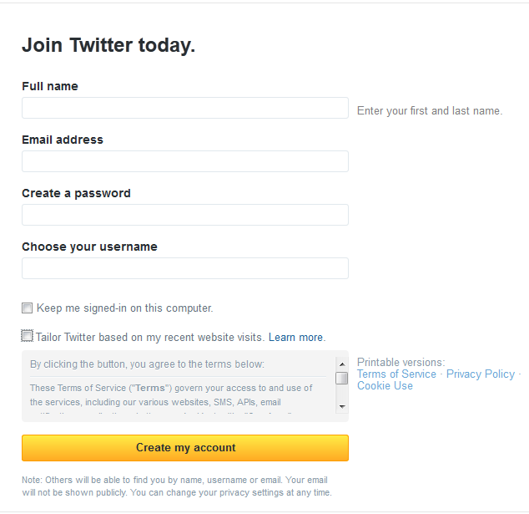
 | 3. Click on Create my account.

