MinecraftEDU Controls:
Player Movement:
To control your movements, use the “w”, “a”, “s” and “d” keys. “w” and “s” will make you go forward and backwards while the “a” and “d” keys control your left and right lateral movement.
Player Point of View Movement:
To control where you are looking simply direct your mouse cursor in the direction you would like to look.
Action keys:
Use the space bar jump and the shift key to crouch. When you are in creative mode you can activate the flight mode by tapping the space bar twice. You will then be able to increase your altitude by pressing the space bar by decreasing your altitude with the shift key.
Mouse buttons:
These are the buttons you use to create your projects in minecraft.
Left mouse button: use selected hotbar item (use this button to remove terrain)
Right mouse button: place selected object (use this button to place your blocks and build your structure)
Here is a keyboard map for the buttons used in Minecraft. For more information visit: http://www.minecraftwiki.net/wiki/Controls
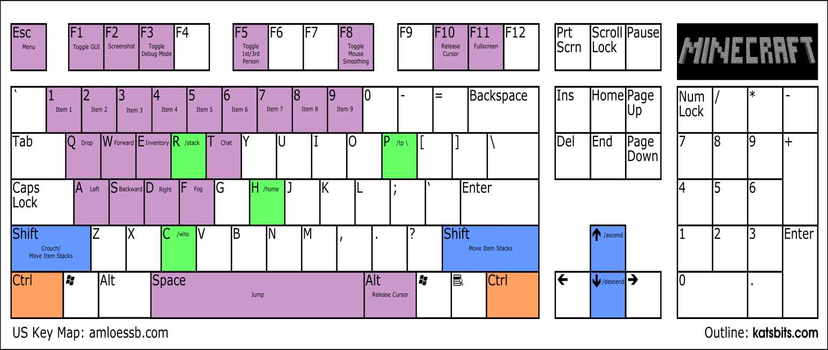

Inventory Management (Creative Mode):
While in Creative mode in MinecraftEdu you already have unlimited access to all of the resources found within Minecraft (normally you would have to mine and craft these).
To access all of your resources press the “e” key on your keyboard. This will bring up your inventory: 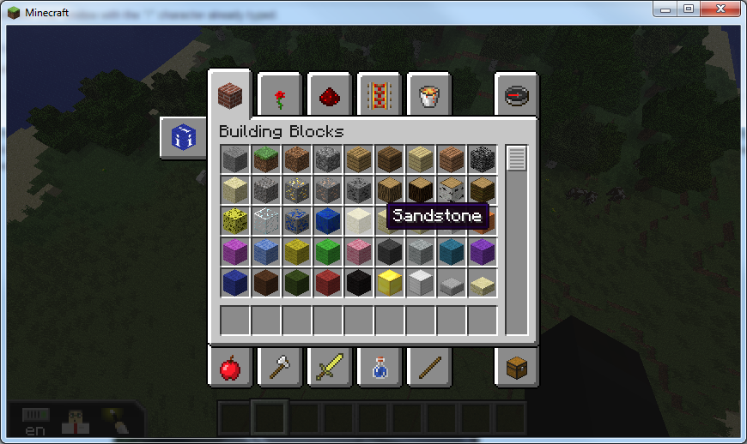
There are different categories for your resources, on the top you have your world building items such as “building blocks”, “redstone” and “decoration blocks.” On the bottom you will find items such as “tools”, “food” and “weapons.” (you can keyword search items by clicking on the top right compass)
Players can click and drag these times into the qucikslots where they can easily be accessed in the world either by their related number key. :
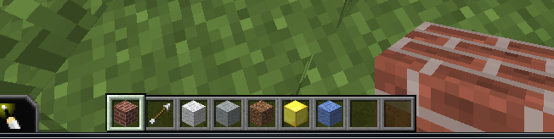
For more information visit this page: http://www.minecraftwiki.net/wiki/Inventory
Some useful tips while playing MinecraftEdu:
If you do not have access to natural light, you will have to place torches in order to create more light. (you can find these in the “Decoration Blocks” section of your inventory).
In creative mode, you are able to place and destroy blocks a few spaces away from where you are looking.

