**Reading Becomes Fun When We Add Wichitowin**

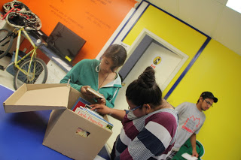

[Picture left] Youth at Jim Rattlesnake building peeking at contents of the box, July 9, 2013

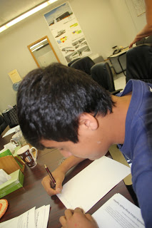

[Picture Centre] Josh Swampy sharing his views and vision about library service, July 26, 2013

**Stay informed.**

**Join the conversation.**

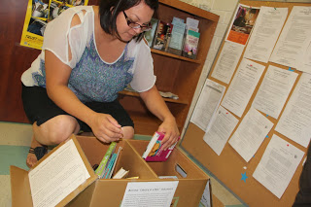**Borrow “Library in a Box” Boutique**

**Maskwacis**

**Library in a Box Service for Everyone** [Above] Christina from Maskwacis Employment Centre hosting library box**, August 15, 2013**

**Service Based Community Consultations by C-EPIC team (College - Employees Participate in Communities)   
August 2013, February 2014 Compiled by Manisha Khetarpal (Draft document. Work in progress.)**

[Creative Commons License](http://creativecommons.org/licenses/by/4.0/)Library in a Box Service for Everyone: 2014 by [Manisha Khetarpal](http://libraryinaboxservice.blogspot.ca/) is licensed under a [Creative Commons Attribution 4.0 International License](http://creativecommons.org/licenses/by/4.0/).

So, What is “Library in a Box?”

[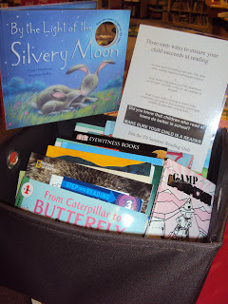](http://3.bp.blogspot.com/-RHRhqTUL9L8/UJyGlBpOC3I/AAAAAAAADCA/EbjKP00K0DQ/s1600/DSC02257.JPG)

* Vision
* Goals
* Service development
* No fees, No memberships, No fines

***Library Box contains books and activity materials for children and families in the age group of 1 to 101+ years.***

**Foundation**

**Vision**: Library service all sorts and for all people

**Mission**: Read more with "Library in a Box" boutique

**Key goal**: Integrated library service based on participation equity which includes

* lending/bulk borrowing,
* programming/storytime/reading circles,
* nurturing reading, and
* volunteering opportunity/capacity for FNs communities.

**Goal for agencies and institutions**: Strengthen reading capacity of youth and children’s service providers and families by providing resources for reading circles and storytime.

* Call us to make a box for you on a theme or come and make our own box
* Can be used for reading circles or for children browse on their own as it facilitates print awareness and motivation
* Program idea box for summer programs, daycares, day homes, Headstarts , classrooms or families
* Remember to contribute your ideas and tell us how you used the box
* Reading becomes fun if we add Wicihtowin.

**Current users and service points**

* Young Spirits Winds Society
* Ermineskin Daycare
* Maskwacis Employment Centre
* Many families with children such as Mom Rebecca

**First client story: May 23: Library in a Box program books picked up by Young Spirit Winds Society**

Program Coordinator Trudy Whitebear selected books to build a, ‘Library in a Box’ for her participants on May 23, 3:30 pm. She picked up 22 books. She also picked up a sign out sheet to track who is borrowing items.  What's next? She would like to bring her group to the library to create word houses and a research camp. Maskwacis Young Spirit Winds Society serves youth in the age group of 12 to 17 years who are in need of treatment for substance abuse.

**Library in a Box service development timeline**

**May 23**: Library in a Box launched in partnership with Maskwacis Young Spirits Trudy Whitebear <http://setuppubliclibrarywithfncommunity.blogspot.ca/2013/05/library-in-box-program-books-picked-up.html> [Library in a Box 1 delivery–Family Wellness Centre]

**May 29**: Let’s Talk About Libraries Information Forum libraries and literacy coordinators spoke about the barriers, benefits and ways in which the service could be offered. [Communication-service development]

**June 24**: Interagency committee meeting attended at the Family Wellness Centre in Maskwacis and progress update presented. Come and host a book sorting party. Check-in for the library in the Box at the Family Wellness Centre [Communication for needs assessment]

**July 9:** Library in a Box borrowed by Ermineskin Daycare. Josie and her friends are excited about the resources and they want more resources for the children in their rooms. Also, they are supporting ATCO's $1 BBQ for the community library. [Library in a Box 2 –Ermineskin Daycare]

**July 9**: Library in a Box borrowed by Youth program at Jim Rattlesnake building Michael Ward and his summer students are enjoying the books.

<http://communicationsprogress.blogspot.ca/2013/07/library-in-box-for-youth.html>

[Library in a Box 3 - Summer Youth Program]

**July 11**: Library in a Box for soup kitchens prepared [Communication-new segment needs assessment]

Please note soup kitchens usually are places to giveaway free books. This is a channel to distribute surplus collection directly for home libraries of Maskwais community members

**July 22**: Theme boxes focusing on beach, pow wow, camping and summer is over requested by Ermineskin Daycare. Theme boxes were created and delivered. They have requested for music for toddlers and nursery rhyme CDs. [Picture below] Josie from Ermineskin Daycare is receiving the books. [Service growth and demand]

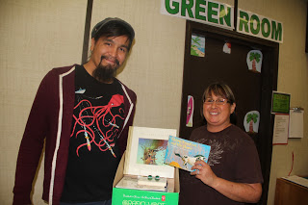

**July 23**: Michele from Ermineskin Daycare came again to borrow books for her daycare along with her friends. She browsed and picked up books she wanted for the children in her care. [Service brings clients to the Maskwacis Community College]

**July 24**: Promote to expand the reach by targeting families with a condition to conduct reading circles [Service Development and Expansion with Reading+ Program Capacity development]

**July 25**: Invited to attend the Head start meeting in August. Headstart is always looking for resources and partnerships. They are also looking for ways to help children improve in speech and language skills [Communicating-Headstarts network]

*“****Library in a Box*** *will bring knowledge and most important access to books to children and families who need help most with speech and language development. It is an asset to the   
Headstart program.”*

***Headstart Coordinator Laurreen Ermineskin, July 25, 2013***

**July 26**: We are in the process of designing fee based educational library service box kits. These will have history, indigenous hands on crafts, Cree syllabics, communicating with FNs protocol, books and many resources. [Expanding via a new product line-fee based for corporate and institutions. Indigenizing library service]

**July 31**: Tai family borrowed a Library in a Box.

[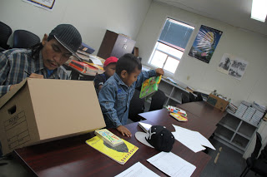](http://4.bp.blogspot.com/-eFHd2bJ6bnE/Uflff7y4zZI/AAAAAAAAEbc/_FSvj_SRyo4/s1600/IMG_6599.JPG)

[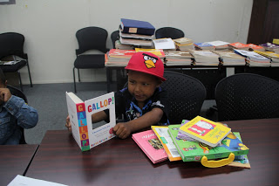](http://2.bp.blogspot.com/-msfuCPb6emE/Uflfmzxd29I/AAAAAAAAEbk/HCn-LJO3kaw/s1600/IMG_6600.JPG)

Tai's children Wayne and Zoran are enjoying board books. Print awareness and motivation at an early stage.

**August 1**: Meeting with Trudy Whitebear from Maskwacis Young Spirits to look at various ways such as posters endorsed by current volunteers and users, radio, pow-wow etc. discussed. Target segments such as teachers, daycares and themes listed. Volunteers need to be reimbursed in some way. Where will the money come from? People cannot work for free. They need gas and food. Recognition is not important.

**August 1**: Trudy Whitbear suggested the following to promote, "Library in a Box". No fees, no memberships, no fines, easy access and comfortable for my lifestyle and in Maskwacis.

**August 2**: Check-in on the Community Library is Everyone’s Project report. People have read the report and are talking about it.

**August 1-11**: Community consultations about embedding bulk/high volume circulation/lending with promoting reading and programs “Library in a Box” volunteer job description released

**August 12**: “Library in a Box” information package circulated to stakeholders

**August 13**: “Library in a Box” borrowing volunteer job description released

**August 13**: “Library in a Box” exhibited at the Maskwacis Youth Career Expo 2013 at the Four Nations Arena and distributed information to the participants. Also, distributed the reading program information.

**Aug 14**: Wilda Listener chair of Social Work program will present the Library in a Box idea to her students. She reviewed the job description and suggested extending the date from September 10 to 20.

**Aug 14**: New books ‘Library in a Box-Reading Circle’ delivered to Josie at Ermineskin Daycare for the blue and green room. These rooms have children in the age group of 3 to 6 years. [Library in a Box-Consolidating Relationship]

**Aug 14**: Library in a Box progress report distributed and posted on the boards in the Ermineskin Mall and to the Maskwacis college library staff. [Library in a Box-Communicating with the community]

**Aug 14**: Meeting with Christina at the Maskwacis Employment Centre to check if they are interested in hosting a ‘Library in a Box.’ They are interested in receiving books for walk-in clients on Thursdays. [Library in a Box 4-Expand Reach-New institutional client]

**Aug 14**: ‘Library in a Box’ borrowed by Mom Rebecca for her son Daleem Thomas [Library in a Box 5-Expand Reach-New family client]

**Aug 14**: TDSRC Summer reading stickers dropped off at Dr. Deb Crowfoots Dentist clinic at the health centre. The materials were received by Micha Crowfoot and Sheri Davidson. Christine Roasting picked up some materials for her children Niley Roan, Calissa Omeasso and Cadence Omeasso. Nicole Belcourt picked up some activity books for Ayisha Buffalo. They would like to receive Library in a Box. [Library in a Box-Potential Client]

**Aug 15**: A partnership to receive books from First Books for FNs students to start their own home libraries initiated.

**Aug 15**: “Library in a Box” report emailed to Trudy Whitebear and she circulated it to the interagency list.

**Aug 15**: Library in a Box placed at the Maskwacis Employment Centre. A check-in visit will be done within a week or periodically.

**Aug 15**: Janet Wallace toured the library in development at 11 am. She shared her family story. Janet came to Edmonton in 1976. She adopted Sheila Mari Rattlesnake, a five year old girl from Ermineskin. She contributed some paperbacks. She is planning to bring apples from her garden to Maskwacis. She came to Canada from New Zealand. [Library in a Box-Ambassador]

**Aug 15**: Nancy Friday from Alphaplus shared links to resources such as a new literacy book for Aboriginal literacy students. Coordinated by a former AlphaPlus colleague, Nancy Cooper, and is called **Journeys of the Spriti IV**. <http://www.firstnationliteracy.com/j4-interviews/>

 You can download the PDF for free here:  <http://www.firstnationliteracy.com/portfolio/journeys-of-the-spirit-iv-teachers-guide/> It is the latest in a series of books produced by Ningwakwe Learning Press.  **Journeys of the Spriti III** can also be downloaded for free here:  <http://www.firstnationliteracy.com/downloads/> [Library in a Box-Resource for Literacy. Reports or Report Link cards can be added to the Library in a Box]

**Aug 15**: Visited Ermineskin Daycare’s Reading Circle and Tessa Headman in the Blue room was enjoying reading books to her group with Grizzly in her lap. [Library in a Box-Service use Check-in-Program Delivery using Library in a Box. Reading Circles.]

**Aug 15**: Sorting of Treaties and history books. These books will be used by the history class assignment in the fall. The assignment is about treaties, chiefs and leaders. [Library in a Box-History class-Output can be used for Treaty Awareness Week during the third week of September.]

**Aug 22**: A list of themes as requested by the daycares and teachers for the Library in a Box was compiled

**Aug 26**: Trudy Whitebear borrowed a Library in a Box for her family. She came with her daughter and her friend Krista Okeymow. Her son is 13 years old and she borrowed many youth books for her son. [Repeat client and network expansion]

**Aug 28**: Meeting with Montana School principal about the date for the field trip and 'Homework Library in a Box.'

**Sept 3**: Louise was a teacher for the Cree Teachers Instructor Training Program at the Maskwacis Cultural College during the summer of 2013. Librarian did a quick puppet making tips session for her class. Now, (September 2013) Louise is a student at the Canadian University College in Lacombe and she is taking the Children's Literature course. Louise made a Library in a Box for herself which included pop-up books, Zoe Hall's fall theme books, How to make pioneer craft books, and children's games books. <http://libraryinaboxservice.blogspot.ca/2013/09/canadian-uuniversity-college-student.html> [Service Connection - Repeat client - Strengthen relationship]

**Sept 3**: 'Library in a Box' news release posted on NALD site. Library in a Box service for families, employment centers, health centers and anyone interested in nurturing reading. <http://www.nald.ca/sites/default/files/library_in_a_box.pdf>

**Sept 5**: Library in a Box was requested by Michelle from Ermneskin Daycare. The themes were fall, back to school, dinosaurs, shapes & numbers, and grandparents. We need more books about grandparents. A box was made and delivered. [Repeat client]  
  
**Sept 5**: James Reindeer borrowed a Library in a Box for his family. He liked Indian bunnies, Why the eagle has sharp eyes books, etc. [Clients help in marketing library service. Family directed him to this service]

**Sept 5**: A student used the computers to learn about storytelling techniques and peeked at the Story Library in a Box.

**Sept 5**: Created a Treaty Library in a Box and circulated it to schools.

**Sept 5**: Grandmother Shirley brought her grandchild Essa from Calgary to visit the library and enjoyed Library ina Box

**Sept 6**: Library in a Box big poster made by taking a few pages from the service progress report. We laminated the six pages and made it like a big poster. [Communication]  
  
**Sept 6**: "I am using the Library" outcome campaign discussed [Communication]  
  
**Sept 6**: Karen Lightening, Councillor Samson Cree Nation is interested in knowing more information about this project.  
  
**Sept 6**: A quick meeting with Brian Wildcat Superintendent Ermineskin schools and he reviewed the Library in a Box and thought it was a great project. He would like to meet again.  
  
  
**Sept 10**: Gave Wilda Listener Chair of Social Work a copy of the Community Library is Everyone's project and Library in a Box report [Library Champions and WOM Word-of-mouth distribution channel via social work students]

**Sept 17**: Louise came to borrow award winning books such as Caldecott, Newberry, etc [Repeat client]

**Sept 26**: Presented a proposal to the Ministry of Advanced Education to provide grants for shelving, TV, trolley, and chairs.

**Sept 28**: Culture Days celebration visitors from the Edmonton Public Library liked the Library in a Box borrowing volunteers job description.

**September-November**: Advanced Computer studies student input and poster creation for the Library in a Box service.

**[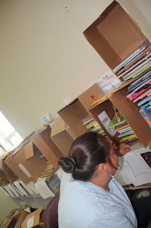](http://4.bp.blogspot.com/-1JO7Ut98iv8/Ue7jbEKdXqI/AAAAAAAAEXM/z9AZwup66oU/s1600/IMG_6562.JPG)Oct 7**: Check-in visit about the Library in a Box service at the Ermineskin Daycare. We brought some books back and got a list of themes such as Fire safety, Thanksgiving, Dinosaurs, Halloween, and Halloween safety

Michele and her friend browsing and making their own Library in a Box. (picture) http://communicationsprogress.blogspot.ca/2013/07/library-in-box-borrowed-by-daycare.html

**Oct 8**: Delivered October theme books to Ermineskin Daycare. Michele from the Ermineskin daycare is making a Library in a Box.

**Oct 10:** Library in a Box was borrowed by Janvier Family [Client segment: Families]

**Oct 21**: Library in a Box given to Maskwacis Parent Place [New client-Expand reach]

**[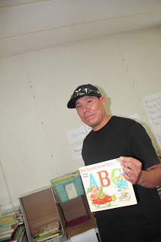](http://1.bp.blogspot.com/-7k0ZutMbeV0/Ue7jdyJm5uI/AAAAAAAAEXU/RBNgp-yKnqM/s1600/IMG_6563.JPG)Oct 23**: Library in a Box delivered to Ermineskin Daycare [Loyal client]  
  
**Oct 23**: Ermineskin daycare's Michelle called and gave her theme list for November which included Remembrance day, Ice skating and safety, and dinosaurs. [Client need]   
  
**Oct 22**: Ermineskin adult literacy program coordinator Ms. Francis Strongman Bull brought 16 students for a field trip to the library. All the students checked out books. The library will provide books and resources for the bookclub. All participants invited to borrow Library in a Box. [New institutional client]  
  
**Oct 29:** Books distributed at the Ermineskin Soup kitchen - The grave savers by Sherri Fitch, Silver by Andrew Motion and Dracula by Bram Stoker. Piggybacked with bulk borrowing Library in a Box promotion

**Nov 3:** Twins Nate and Sabine Harris on their 8th birthday told their friends to bring books as gifts and they contributed the books to the Maskwacis Community Library. Children help children read. Some of the books were added to the Library in a Box service.

**Nov 7:** New board books given to Ermineskin Daycare [Library in a Box]

**Nov 7:** Developed a communications plan for November to promote Library in a Box service at community events such as the Diabetes conference on Nov8th, Addictions weeks activities in November and the Children's Day celebration on November 21st.

**Nov 6**: Maskwacis Community Library space was used by Jason Wolfe and Grace Dion to hosted an 'Introduction to Postsecondary Education' workshop and all participants were invited to borrow Library in a Box  
  
**Nov 6**: Champions of Change program coordinator Ms. Michelle brought her clients for a tour of the community library and the students used Library in a Box Service

**Nov 6**: History teacher and counselor Llyod Saddleback gave the Library in a Box service brochure to his class

**Nov 18:** Montana Daycare requested for Library in a Box for 1 to 4 year olds

**Nov 18:** Library staff prepared the Library in a Box for Montana Daycare. Plus free books for each child

**Nov 19:** Library in a Box for Montana Daycare picked up by Denise Potts

**Nov 20:** Library in a Box requested by Michele from Ermineskin Daycare. The themes requested for are winter fun, winter is here, dress warm, and Christmas. Library in a Box prepared, list of books typed and delivered to Ermineskin Daycare

**Oct-Dec:** Participants at the literacy workshops were giving Library in a Box posters to post them in their institutions and to send them home to parents via students.

**Jan 15, 2014**: Michelle from the Ermineskin Day care requested for Winter fun and safety books.

**Jan 17, 2014**: ECD students orientation for the Library in a Box and invitation to them to use it in their practicum and work experience sites.

**Jan 24, 2014**: Literacy Day Guest presenter Dr. Ozlem Cankaya shared early literacy skills bookmark and this could be included in the Library in a Box.

**Jan 24, 2014**: Literacy Day celebration results in families browsing and checking out Library in a Box. <http://www.pipestoneflyer.com/Article.asp?id=4079>

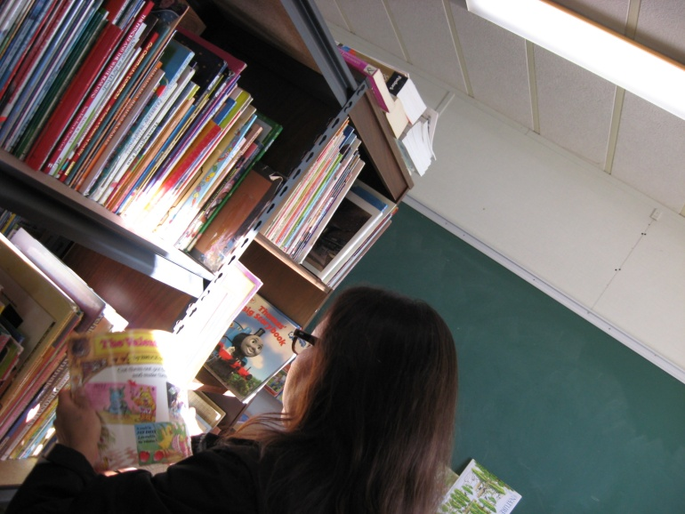

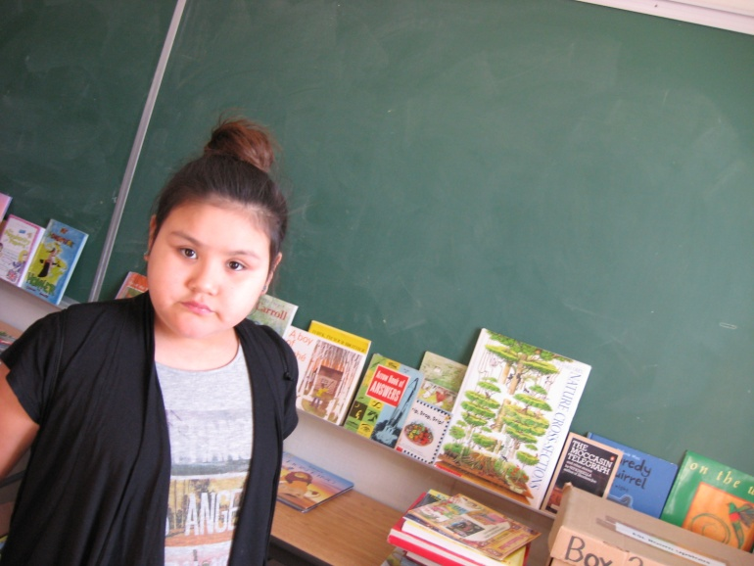

***Headstart Coordinator Laurreen Ermineskin borrowing books and making a Library in a Box with her daughter on January 24,2014***

**Feb 6, 2014**: Connection with teachers

From: Lisa Scott   
Date: Thu, Feb 6, 2014 at 3:29 PM  
Subject: Education Day Feedback  
To: Manisha Khetarpal  [mkhetarpal@mccedu.ca](mailto:mkhetarpal@mccedu.ca)  
Students enjoyed the Science experiment (testing acids and bases).  Worth the trip!  *Providing students with free books was an awesome gift.*  The more hand we can put books the better. I will send home the Library in a Box' flyers.  
**Lisa Scott, Meskanahk Ka Nipa Wit School, Grade 9**

**Feb 8, 2014**: Activity kits Library such as sand station, water fun and measuring in a Box prepared by ECD instructor Lucinda for daycares [Partnership with faculty to enhance the service offerings]

**Feb 27, 2014**: Honoring our children contributors Harris Twins http://libraryinaboxservice.blogspot.ca/2014/02/collection-development-by-children-and.html

**Feb 27, 2014**: Profiling our users and consumption of library services. 163 books borrowed by daycares http://setuppubliclibrarywithfncommunity.blogspot.ca/2014/02/163-books-borrowed-by-ermineskin.html

**March 1,2014**: Meeting with Mr. Gord at his NoFrills office to brainstorm a collaboration and the outcome was a Dinner and Story Library in a Box draw

Next steps - Service Development

1. Develop theme related boxes such as treaties, Spring, Christmas, legends, etc
2. Reading Party boxes which could be borrowed for birthdays or siblings get together
3. Create posters for daycares, families, reading parties, and youth clubs
4. Approach local retailer for a partnership for a Dinner and story Library on a Box draw for literacy celebration occasions such as World Read Aloud Day or the Adult Learners Week Celebration in March

***“Human interactions and meanings are understood to form part of the (community) context***

***itself, as systems interconnected and nested within the larger systems in which they act.”***

***Fenwick, 2001***

**ABCD Plan**

**A: Access to books**

**B: Borrow books**

**C: Centre for library use and education**

**D: Digital literacy**

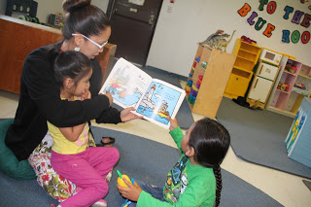

### [Picture Above] [Tessa Headman using the resources from the Library in a box for reading circles](http://communicationsprogress.blogspot.ca/2013/08/tessa-headman-using-resources-in.html),

### Ermineskin Daycare, August 15, 2013

**People are Talking  
Outcome: Media and web coverage is expanding**

[Library in a Box: A service for everyone](http://www.nald.ca/sites/default/files/library_in_a_box.pdf), [Headline News](http://www.nald.ca/news) | Posted: September 3, 2013 | [National flag](http://www.nald.ca/news?f=70), September 3, 2013

Category: Learning

During the summer months of 2013, Maskwacis Cultural College in Maskwacis, Alberta, offered a ‘Library in a Box’ service for families, employment centers, health centers and anyone interested in nurturing reading.

http://www.nald.ca/sites/default/files/library_in_a_box.pdf

***“No fees, no memberships, no fines, easy access and comfortable for my lifestyle***

***and in Maskwacis.”***

***Borrower Trudy Whitebear, August 1, 2013***

**People are using the service**

**Outcome: Increase in access to reading resources in Maskwacis**

Louise was a teacher for the Cree Teachers Instructor Training Program at the Maskwacis Cultural College during the summer of 2013. Now, (September 2013) Louise is a student at the Canadian University College in Lacombe and she is taking the Children's Literature course. Louise made a 'Library in a Box' for herself which included pop-up books, Zoe Hall's fall theme books, How to make pioneer craft books, and children's games books.

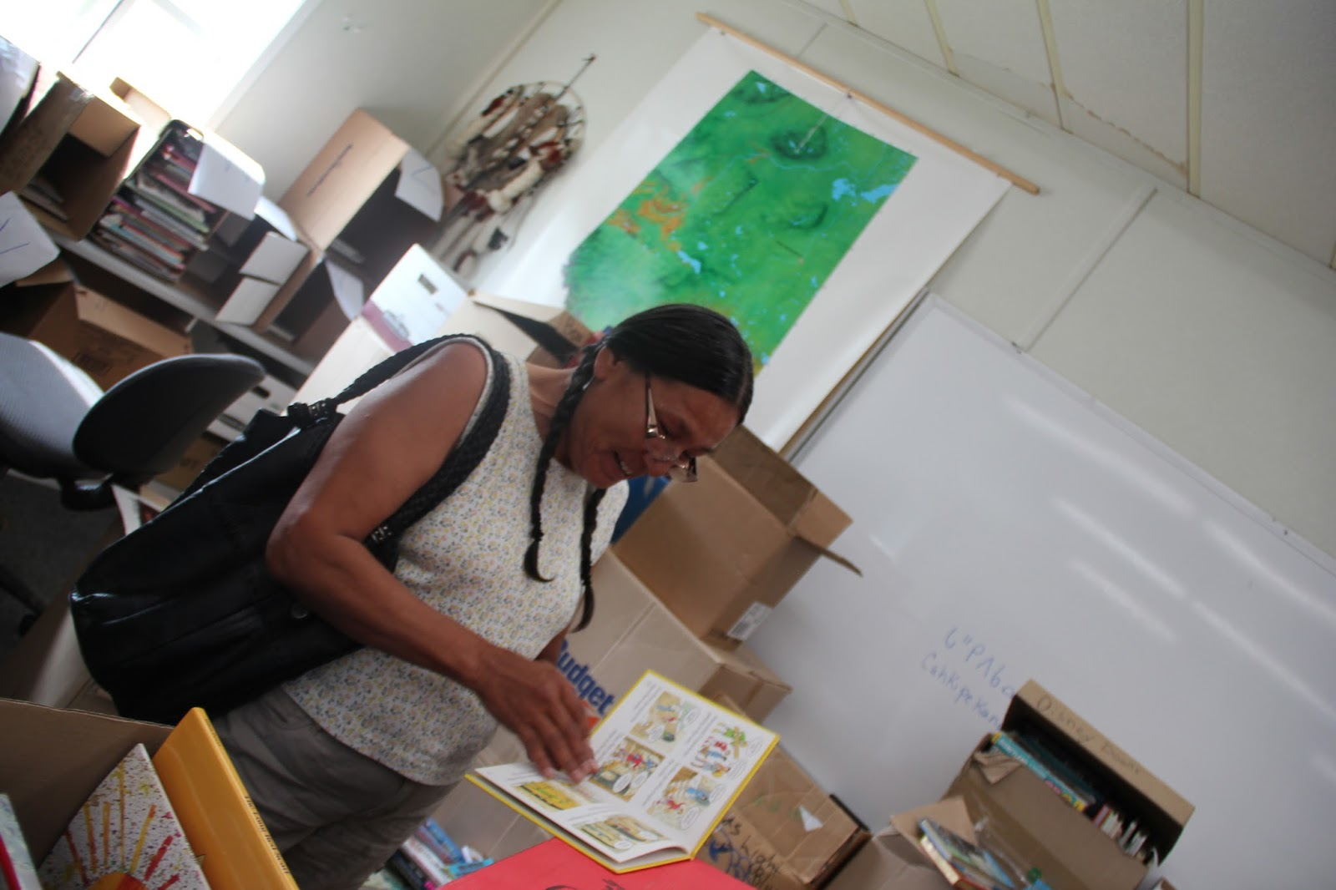

* No fees, No memberships, No fines

**Borrow a "Library in a Box" boutique today!   
Call 780 585 3925**

[**Library in a Box borrowed by Tyrone family,   
July 31**](http://setuppubliclibrarywithfncommunity.blogspot.ca/2013/07/library-in-box-borrowed-by-tai-family.html)

**Outcome: Increase in print awareness early literacy skill**

[](http://4.bp.blogspot.com/-eFHd2bJ6bnE/Uflff7y4zZI/AAAAAAAAEbc/_FSvj_SRyo4/s1600/IMG_6599.JPG)

Tai's son Wayne and Zoran enjoying books.

Print awareness and motivation begins at a early stage.

[](http://2.bp.blogspot.com/-msfuCPb6emE/Uflfmzxd29I/AAAAAAAAEbk/HCn-LJO3kaw/s1600/IMG_6600.JPG)

* No fees, No memberships, No fines

**Borrow a "Library in a Box" boutique today!   
Call 780 585 3925**



*Poster created by Jaylene during the Advanced Computer Processing class, Fall 2013*

Appendix 1: Job description

“Library in a Box” Borrowing Volunteers

The Maskwacis Community Children’s Library is seeking volunteers to assist with its “Library in a Box” program. A Library in a Box volunteer borrows books from the library, tells other people about how they are using the "Library in a Box" to do family reading programs and reading circles; visits families to deliver or restock books and shares reading secrets.

**Timeshare**: Volunteer attends once a month "Library in a Box" forum and sharing meeting. Time commitment is one hour/week.

**With whom will I be working?:** Volunteers will work with the Librarian to stock the “Library in a Box” according to observed demand, visits homes, daycares, schools, and gatherings to offer books, nurture reading habit, and promote library services.

**Values**: Sensitivity, empathy, and knowledge of children’s literature are essential to this role.

**Qualifications**:

In order to qualify for this position you should be a student of Maskwacis Cultural College or a resident in Maskwacis with a special interest in children's libraries and literature. You should also be outgoing, fun, and sensitive to the unique situations of families coping with circumstances unique to FNs communities.

**Application deadline**: September 20, 2013

**How to apply**: Please send a resume and a brief note about what interests you in the role to [mkhetarpal@mccedu.ca](mailto:mkhetarpal@mccedu.ca)

Appendix 2: Borrow campaign template

**People are using the service**

**Outcome: [Insert text] Increase in access to reading resources in Maskwacis**

### Outcome of the service: Print awareness

**[Talk about the user, relationship, and books borrowed** ] Louise was a teacher for the Cree Teachers Instructor Training Program at the Maskwacis Cultural College during the summer of 2013. Now, (September 2013) Louise is a student at the Canadian University College in Lacombe and she is taking the Children's Literature course. Louise made a 'Library in a Box' for herself which included pop-up books, Zoe Hall's fall theme books, How to make pioneer craft books, and children's games books.

**[Insert picture]**

**[Tagline and call for action] Borrow a "Library in a Box" boutique today! Call 780 585 3925**

Appendix 3: Donors and contributors posters

“Library in a Box” Donors

**A Library in a Box contains ABC**

* A: Art and Craft supplies
* B: Books
* C: Creative reading aids such as bookmarks, pointers and post-it notes

*Note: The box could be theme based or just odd supplies such as puppets, stationary and   
 an activity box for the family.*

For more information contact the librarian at [mkhetarpal@mccedu.ca](mailto:mkhetarpal@mccedu.ca)

Appendix 4: Bloom's Taxonomy in Educational Technology and Mobile Learning.

**Remember/Understand**

The outer circle of the following was used to target reading segments in the community and  
 to connect with the education segment.

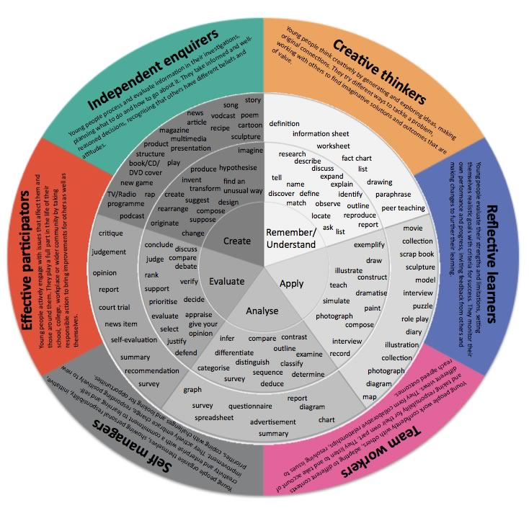

Appendix 5: Library in a Box Concept Development

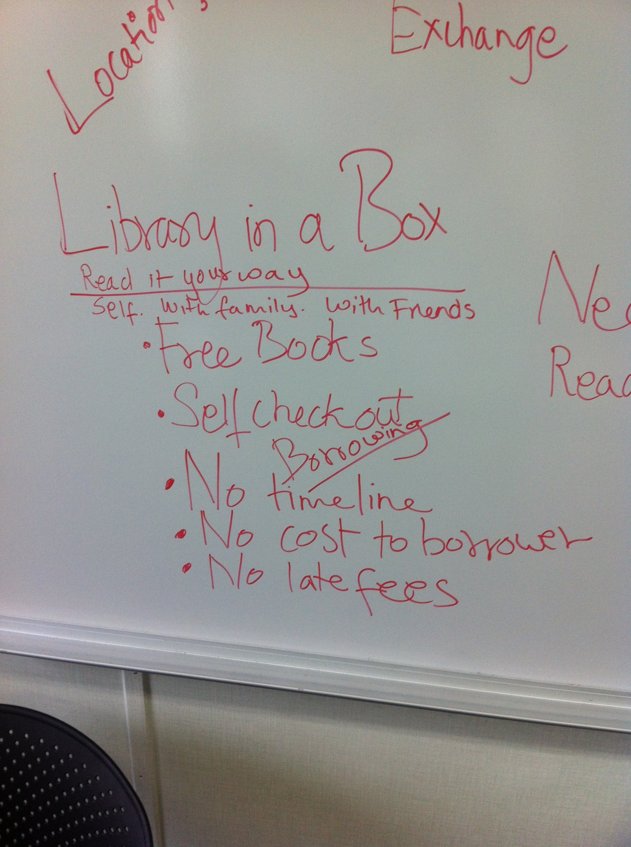

Let’s Talk About Libraries Forum outcome was the, “Library in a Box” service concept, May 29, 2013

**Read the proposal and post a comment.**

<http://setuppubliclibrarywithfncommunity.blogspot.ca/2011/10/proposal-to-set-up-public-library-in.html>

**Send us your views. Your opinion matters to the Maskwacis Cultural College. 780 585 3925 mkhetarpal@mccedu.ca**

**[](http://www.google.ca/imgres?imgurl=http://moodle.mccedu.ca/theme/image.php?theme=formal_white&component=theme&image=logo&imgrefurl=http://moodle.mccedu.ca/&h=100&w=400&sz=18&tbnid=5gTUYtyIctKdPM:&tbnh=29&tbnw=115&zoom=1&usg=__1jGxbsxSkGYNxvA_hg5LOHR_DxI=&docid=5_BqBE8IYqKhXM&sa=X&ei=v6kgUvrnNKL0iQLnwICwCQ&ved=0CDkQ9QEwBA&dur=3491)News Release Maskwacis Community Library Communications - 780 585 3925**

**Library in a Box service for everyone**

Maskwacis Cultural College in Maskwacis, Alberta, offered a 'Library in a Box' service for families, day homes, daycares, employment centers, health centers and anyone interested in nurturing reading during the summer of 2013.

The focus of this service was to provide access to books to First Nations families living in remote areas. The integrated library service was developed with the community after many community conversations. The goals were to introduce a bulk-borrowing culture; use the resources in the box to offer programming kits for reading circles or story reading; nurture reading; and to create volunteering opportunities on First Nations reserves.

Each Library in a Box contains:

* Books
* Art and craft supplies
* How to read information
* Reading aids such as bookmarks, pointers and notepads

Library in a Box opened an avenue for reading resource partnerships. The daycare staff came to the college to make their own theme-based "Library in a Box." TD Summer Reading Club materials were distributed with this service.

“There were no fees, no fines and no memberships,” said Trudy Whitebear, an outreach worker at Young Maskwacis Spirits. “The program provided easy access and was flexible and comfortable for my lifestyle in Maskwacis.” Ms. Whitebear, a mother of a 13-year-old, was excited with what Library in a Box had to offer.

The dental clinics and employment centres were happy to use this service in particular for walk-in clients with children. The next step as an extension of this service is to prepare indigenous culture, history, art and literature kits.

The pilot project report can be viewed on the [NALD website](http://www.nald.ca/sites/default/files/maskwacis.pdf).

-30-

**Profiling our users and consumption of library services (February 27,2014)**

**Daycares** borrowed 163 books from July 22, 2013 to February 27, 2014 on eight occasions via a Library in a Box service. Michelle from the Ermineskin Daycare likes to use this service as it gives children an opportunity to look at books.

We achieved our goals: 1. Promoting print motivation 2. Putting books in the hands of children at an early stage.

We have indigenous history box, arts and crafts, Treaties, ........Try a Library in a Box service today! It's Free! Thanks to CBC viewers and listeners.

**List of books lent to the Ermineskin Daycare. Monday July 22, 2013 (Checkout 1)**

1. The Bernstein bears go to camp
2. What happens in the autumn?
3. A prairie boy's winter and summer
4. Have you seen birds?
5. Fall changes
6. Step into fall
7. Step into summer
8. Arthur goes to camp
9. Mr. Mcmouse
10. Over in the meadow
11. Fresh fall leaves
12. To everything there is a season
13. Frog in the kitchen sink
14. Coyote's new suit
15. Indian two feet and his horse
16. Coyote sings to the moon

**List of books lent to the Ermineskin Daycare. October 8, 2013 (Checkout 2)**

1. Halloween fun
2. The Halloween class
3. Our Haunted house
4. Halloween mice
5. We celebrate Halloween
6. Best Halloween book
7. Pumpkin eye
8. six creepy sheep
9. Skeleton meets the mummy
10. It's pumpkin time
11. Thanksgiving fun
12. Cranberry thanksgiving
13. Thanks for thanksgiving
14. Ugh
15. Strange creatures
16. the funniest dinosaur book
17. Dinosaurs: an adventure back in time
18. Dinosaurs and other first animals
19. Dinosaurs
20. Taekwondo dinosaurs
21. My dinosaur

**Books lent to the Ermineskin Daycare on October 24, 2013 (Checkout 3)**

1. Animals in the winter
2. It's fall
3. Animals in the fall
4. To everything there is a season
5. A book of seasons
6. the falling leaves
7. Winter is here
8. fresh fall leaves
9. Giant dinosaurs
10. four and twenty dinosaurs
11. How do dinosaurs say goodnight?
12. I can read about dinosaurs
13. animals from the dawn of time
14. Can I have a tyrannosaurus Rex, dad? can I? please?
15. Dinosaur fun
16. The very dizzy dinosaurs
17. Dinosaurs pop-up book

**Baby board books November 7, 2013 (Checkout 4)**

1. Frog in the kitchen
2. Chester the crab
3. A pirate's life
4. The napping house
5. Duck's truck
6. Too big for diapers
7. The more we get together
8. Doc Hudson
9. What does baby see?
10. My big animal, world, & dinosaur book (3 books in one)
11. Alien Al
12. On the go
13. Cinderella
14. Bedtime kiss for little fish
15. Big Red barn
16. Look & listen fire trucks
17. Starry nights
18. Tinie's book of nursery rhymes
19. Bumble B. bear
20. Five noisy ducks

**The list of books on loan to the Montana Daycare. Nov 18 2013 (Checkout 5)**

1. Eyes & nose, fingers and toes
2. Goodnight moon
3. Curious George goes fishing
4. brown bear, brown bear
5. Slobcat
6. Chester
7. The aboriginal alphabet for children
8. The true story of the 3 little pigs
9. Munschworks 3
10. Pete's a pizza
11. The white pony
12. Danny and the dinosaur
13. Bernstein's A book
14. Knuffle bunny
15. Ernie gets lost
16. Ten little dinosaurs
17. Madeline and the bad hat
18. Where's my hockey sweater?
19. Leo the lop
20. Grunter: a pig with attitude

**The list of books on loan to the Ermineskin Daycare. November 20, 2013 (Checkout 6)**

1. Franklin's Christmas gift
2. Snowy sports, ready, set, play
3. A perfect snowman
4. The three snow bears
5. Flip and flop
6. Stranger in the woods
7. The smiley snowman
8. Snowriders
9. The biggest snowball fight
10. My leafs sweater
11. The perfect Christmas gift
12. I've seen santa
13. A porcupine in a pine tree
14. Here comes santa
15. How the grinch stole Christmas
16. How cold was it?
17. Meet santa bear
18. The snowy day
19. 50 below zero
20. Ice is nice a promise is a promise
21. Gregory's shadow
22. Northern lights in the soccer trail
23. There was an old lady who swallowed a bell
24. The night before christmas

**Books loaned to Ermineskin Daycare, Nov 26, 2013 (Checkout 7)**

**Theme base Library in a Box: Christmas Bin**

1. Thomas' snowsuit
2. A killing freeze
3. Christmas puzzles
4. 24 things to do until Christmas
5. Winter poems
6. Knee high nature: Winter
7. Winter Fun
8. Animals in the winter
9. winter in the meadow
10. How the Grinch stole Christmas
11. Baseball bats for Christmas
12. Arthur decks the hall
13. The Dennis bones mystery book
14. 50 below zero
15. The polar express
16. The mountains of Tibet
17. Franklin's Christmas gift
18. Petunia's Christmas
19. A Prairie boy's winter and summer
20. The arctic coast
21. Arctic stories

**Books loaned to the Ermineskin Daycare's now at the Elder's centre location Thursday, February 27, 2014 (Checkout 8)**

1. Animals in the winter
2. spring story
3. Rabbit's spring adventure
4. I don't want to go back to school
5. Rabbits and raindrops
6. Here we go 'round the year
7. Scaredy squirrel at night
8. a treasury of Curious George
9. Shoes from Grandpa
10. Architect of the moon
11. Are you my mother?
12. Chopsticks
13. Five minute tales for four year olds
14. Scaredy squirrel
15. Anook the snow princess
16. Do I have to go to the Dentist?
17. Howard B. Wigglebottom learns to listen
18. My race into space
19. Our favourite stories from around the world
20. White snow bright snow
21. Oh Canada
22. Now I know Changing seasons
23. A Book of seasons
24. Spring has sprung

**Join the conversation.**

Please write your views on this page and email them to [mkhetarpal@mccedu.ca](mailto:mkhetarpal@mccedu.ca)