Activity Sheet:

Ebooks and Audiobooks with the Libby App

About library ebooks/audiobooks
- What is the difference between an ebook and an audiobook?

ebook | audiobook

- What are some benefits of these formats, compared to print?

- True or false: ebooks and audiobooks are listed in the library’s regular online catalogue at www.westvanlibrary.ca? True False

- Fill in the blank: if an ebook or audiobook you want is checked out by someone else,
you can _________________________________________________.

- In order to enjoy an ebook or an audiobook on your mobile device, what do you need to download?
______________________________________________________________________

  - Maximum number of digital titles you can have checked out at once: _____

  - Maximum number of digital titles you can have on hold at once: _____

Download and open the app
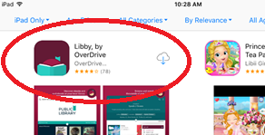
- May need to connect to Wifi, if not already
- Tap on the icon for your app store (Google Play for Android or App Store for iPhone/iPad) and search for Libby
- Locate and tap on the Libby by OverDrive icon, then on Install/Get
- Once the app has finished downloading and installing, open the app

Add a library and sign in to the app
- Tap on Yes when the app asks if you have a library card
- Tap on I’ll search for a library
- In the search box, type West Vancouver and then tap on British Columbia Libraries—West Vancouver Memorial Library
- Tap on Sign in with your library card
- On the next screen, select West Vancouver Memorial Library from the drop-down
- Enter your Library card number and your PIN (the last four digits of your phone number) as prompted. Then tap Sign In
- Tap Enter the Library

Browse and search the collection
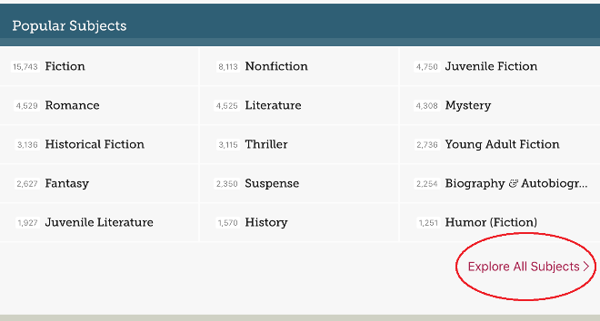
- Swipe down to browse Popular Subjects or tap Explore All Subjects to see all categories
- Try tapping on the name of a category to explore. (You can always swipe back up to the top and tap < in the top left to go back a page)
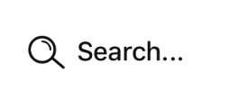
- Search for a book by title, author or other keyword by tapping search field (magnifying glass) at the top of the screen
- Try tapping on the search field and entering the name of a book, author or topic

Find an ebook and check it out
- Tap Library at bottom of screen to return to the collection page
- Browse to a subject (eg fiction) and find an ebook that is available to check out. (If it available, it will say “Borrow” next to the cover. If not, it will say “Place Hold.”)
- Tap on Borrow to check out the book. On the next screen, tap on the Borrow! Button to confirm.
- Once you have borrowed the book, you have the option to Open Book (or Open Audiobook) right away, Keep Browsing for books or Go to Shelf to see the book(s) you have borrowed.

Open the ebook, and find the Reading Settings menu to change display options
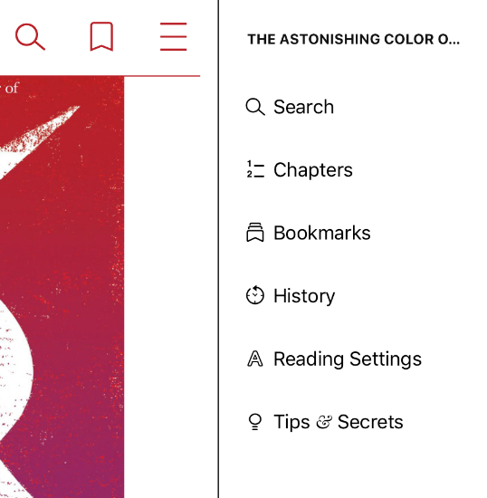
- Tap on Go to Shelf
- Find the ebook you borrowed and tap Open Book
- Tap centre of screen to toggle navigation menu off
- Swipe left/right to turn pages
- Tap centre of screen to toggle navigation menu on again
- Tap ≡ (top right) to open side menu
- Tap Reading Settings
    - Change the Text Scale
    - Change the Lighting
    - Change the Book Design
    - Tap Done (or ) to exit menu
- Tap ≡ again to close side menu

Find an audiobook and check it out
Try this quick way to browse items in the right format, which are also available right now:
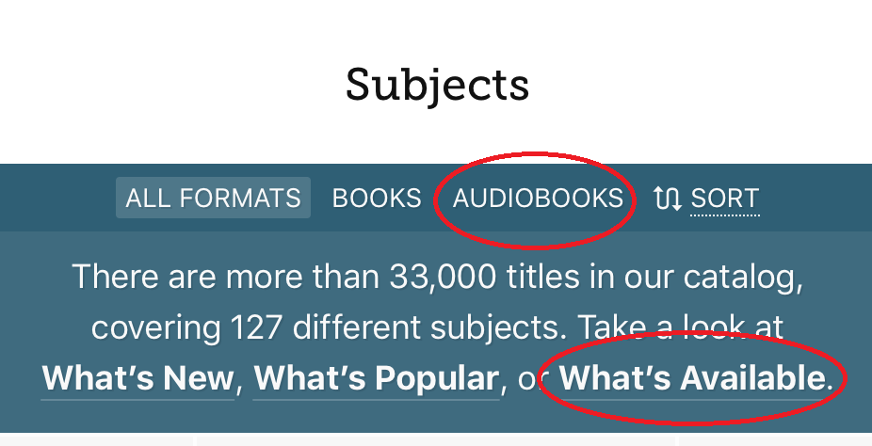
- Tap Library at bottom of screen to return to the collection page
- Swipe downward and tap Explore all subjects
- Tap Audiobooks to see only the audiobooks (no ebooks)
- Tap What’s Available to see only the audiobooks that are available right now
- Choose a title and borrow it

Open the audiobook, and find the Settings menu to explore playback options
- Press Play ► to begin the audiobook. Press Pause ▌▌ to stop
- Tap in the middle of the screen to toggle menu options
- Tap on the timer/clock icon a few times to change the speed of the playback
- Tap the moon icon to turn a sleep timer on/off
- Tap the bookmark icon to see how to create a bookmark
- Tap ≡ (top right) to open side menu – most useful for skipping to certain chapters

Return an item early or renew
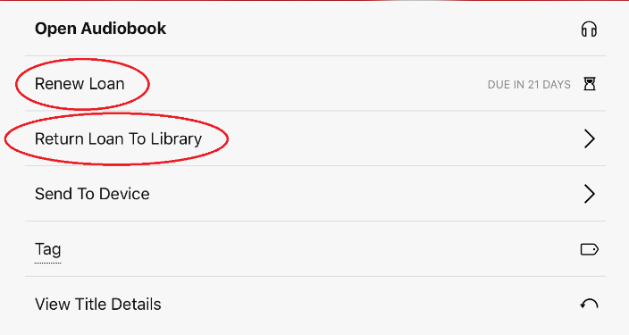
- Tap Shelf to go to your checked out items
- Tap Manage loan for one item
- Here you can renew the item, only within 3 days of due date (“Renew Loan”)
- Tap on Return Loan to Library (if you want to let others borrow it – if you leave it, it will return automatically on the due date)

Place a title on hold
- Tap Library at bottom of screen to return to the main collection page (BC Libraries co-op logo)
Tap this icon to see an estimate of how long your hold would take to come in
- Find a title (ebook or audiobook) that is NOT available right now
- Tap “Place Hold” and confirm
- To cancel the hold: go to your shelf and pick the Holds tab. Tap on Manage hold. Tap on Cancel hold.

Need help?
Call the Community Computing Centre at 604.925.7405,
email tech@westvanlibrary.ca
or visit any of our Information Desks

