Internet Searching Teaching Script

Introduction

Starting over 20 years ago, the Internet and the World Wide Web have become part of the lives of millions people around the globe. We use the Internet in a variety of ways including: communication with family and friends; shopping' watching videos and television programs; reading online news; and playing games.

The World Wide Web, which was developed in the early 1990's – is actually one component of the Internet. The web is made up of electronic documents that consist of text and multimedia information. These files live on computers and the computers are connected to the Internet.

When you visit a website, your computer sends a request or a signal to a server. A server is where websites are stored. Once the request arrives, the server retrieves the website and sends the correct data back to your computer.

Search engine – When you don’t know the website address for the information you want, you click on a search engine icon. An icon, remember, is the small square button on your desktop that will open into a program that you want to use.

Which search engine can you use? There are options, but Google is a good starting point when you go online and you want to find something. Google lets you type in keywords and retrieve webpages containing your keywords.

Every website on the internet has an address. If you don’t know the exact address, you can do a search – that’s what Google does. Google is like the yellow pages and it’s what most people use to find what they’re looking for. Simply type in a few key words for what you’re looking for and Google will give you a list of websites that are relevant.

Another search engine is Duck Duck Go. The only difference between them is that Google tracks your searches and Duck Duck Go does not.

Exploring the Internet is exciting; however the Internet is not magic. Not everything is online and not everything on the Internet is accurate and reliable.

Internet Terms

Note: We are using Internet Explorer 11 in the Computer Learning Centre.
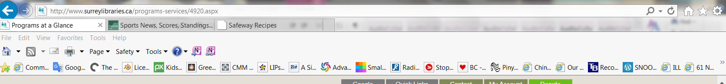
Web address in the address bar

Left / Right Buttons
Refresh
Home

- Browser – software, such as Microsoft Internet Explorer or Google Chrome, is used to find information on the internet.
- Website – a location on the Internet that contains information about a specific topic. A website usually contains multiple pages with different types of information about the topic. A website is also often referred to as a “webpage”.
- Home Page – the first page that you see when you come to a website, or the opening page of a website. It provides information about the site and directs you to other pages on the site.
- Link (Hyperlink) -- a highlighted or underlined feature on a web page that will take you to another web page when you click on it. Most often a link appears as underlined words or an image. Whenever your cursor turns into a pointing hand, the image or word that you are pointing to is a link.
- Back Arrow – This arrow is found at the top of the browser. When you click on the back arrow, it takes you back (in order) through all of the web pages you've seen. Sometimes it is also called the Back button.
- Forward Arrow – This button allows you to move through pages you have recently viewed.
- Refresh button – This button will reload the current page. If a website stops working, try using the Refresh button. While a page is loading, the Refresh button will temporarily become the Stop button. Click this button to stop a webpage from loading.
- Home – this button will navigate to surreylibraries.ca by default. You could choose your own homepage by customizing the browser.
- Website address (URL – Uniform Resource Locator) -- the address for a website. On the Internet, you get to a website by typing in the web address into the address box of the browser. The address box is the narrow,long rectangular bar in the browser where you can type in a website address. Typing in the website address in the address box and hitting Enter on the keyboard will take you to a website.

For example, to get to the website of Surrey Libraries, you would type surreylibraries.ca in the address box. A website address must be typed exactly or else it may not work – it is just like typing a phone number. If you type the website address wrong, you may see that your browser has a suggestion for you (show example)
- Domain. Each website address has a “dot” something at the end. This gives you a clue as to what type of website it is. Dot CA means it’s Canadian. Dot “gov.ca” means it’s an official government website. Non-profit organizations often end in dot “org”. Businesses usually end in dot com. Each country has its own domain code like an area code in a phone number.
- Button – a small box that looks like it's being depressed when you select it. Buttons can turn on and turn off many types of functions on the Internet, e.g. send, submit, logout.

- Search Box – a small rectangular blank space on a web page when you can type in a word or phrase to look for information. Clicking on the button next to the search box or hitting the Enter key on the keyboard will take you to a page where that information is located. A search box usually has a picture of a magnifying glass on it, next to a blank rectangle.
- Scroll – To move text or other information on a computer screen up, down or sideways, with new information appearing as the old information disappears. You can tell if there is more to read down below if there is a scroll bar on the right and how big it is: the smaller the scroll bar, the more information there is.
- Scroll Bar – A narrow, rectangle bar on the right edge and bottom edge of a web page that lets you move the page to see more information. The scroll bar on the right moves the web page up and down.

Navigating to the Internet

Typing a Web Address

- Type in the website address for Surrey Libraries into the address box. The website address is surreylibraries.ca. Then, type in the website address for the Vancouver Sun into the address box. The address is vancouversun.com. The screen will change to the Home page of the Vancouver Sun.

- When you have looking at the Vancouver Sun website, click on the Back arrow at the top of the screen to return to Surrey Libraries Home page.

- Click on the red X in the upper right hand corner to close the browser window and return to the desktop.

Opening a New Tab and Switching Between Tabs
Tabs
Web address
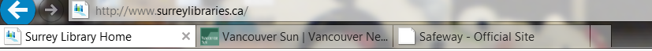

New Tab Button

- To open a new tab, click the New Tab button on the right of the open tab. The new tab will appear. Type a URL in the address bar and then press Enter to navigate to a new page. The page will open in the new tab.

- Type these two web addresses: safeway.ca and weathernetwork.ca.

- Whenever you open a new tab, you can see the New Tab page. The New Tab page will show you the thumbnails of the websites you visit most frequently. You can click any thumbnails to navigate to that site.

- To switch between tabs, click on any tab that is not currently selected. The tab will then be selected.

- To close a tab, move your mouse over the tab and click the Close Tab button, or the X

Understanding Hyperlinks

- Click a link to navigate to another webpage, You may notice that your cursor changes into a hand icon whenever you mouse over a link

- Lots of websites use images as links. You can click the image to navigate to another page.

- Most websites use their logo as a button that goes to their “home page”. Go to an article on the Vancouver Sun’s website then click on the Vancouver Sun logo. It will take you back to their main “home” page.
Understanding website layout: common website organization
Most websites have similar design. If we go to www.vancouversun.com, we can see some common elements:
- The Vancouver Sun logo is present on every page (and it takes you back to the main “home” page).
- Different sections of the website are listed on the top. It is like the table of contents in a book. Often when you move the mouse over a section heading, more subsections appear below it. Try moving the mouse over Homes and then Gardening. Click on Gardening.
- You might notice that there are advertisements on the right hand side of the page. You might learn to ignore the right hand side of every webpage! Most websites have what’s called “click bait” on the right. This is how websites are free – they post advertisements and if you click on an ad they get a bit of money. Often when you click on one of these it will take you to another website in another tab. Try clicking on an ad and see what happens. If it opens a tab, close that tab.
- Go back to the Vancouver Sun. Scroll down to the very bottom of the website. Usually there’s another set of categories on the web page that you can find. If you are looking for a way to phone a company, usually their contact information is at the bottom under the term “contact us”. Try looking for the Vancouver Sun’s phone number.

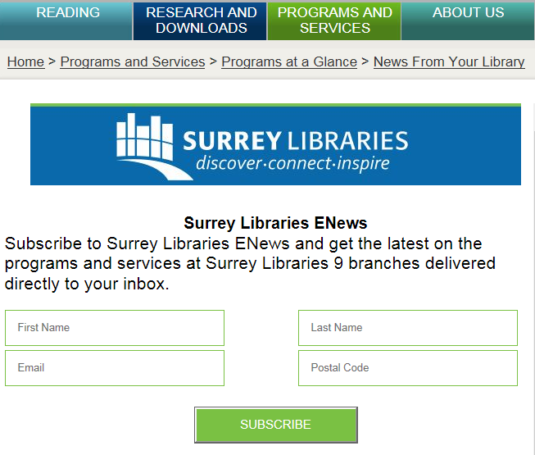
Words / phrases as link

Image as link – click on it

Button as link

Using Search Boxes

Most websites have a search box. When you use a website’s search box, it looks within that website only (rather than the whole internet). The difference between a search box in a web site and a Google search is that Google looks for things on the open internet, and the search box inside a website only looks within their site (it’s like looking at the index in the back of a book).

As an example: go to londondrugs.ca

- Click on the magnifying glass on the right (most search boxes are on the top right of a web page)
- Type in “blender”
- You’ll see search results that are only for London Drugs products (not blenders sold anywhere else).
- Refine your search by picking a brand on the left.
- Order your results by sorting by “Price – low to high”

Another example: go to surreylibraries.ca
- Find the search box on the right hand side of the home page.
- Click inside the box with your mouse.
- Type in the term "cooking" for book titles about this topic.
- You should see a list of search results on the screen.
- Click on the first title and read the pager that appears.
- Move the screen down so you can see all the information on the page.

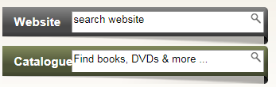

Another example: use the Chrome browser and go to www.google.ca, then find Safeway’s website for Canada. Find the weekly flyer.

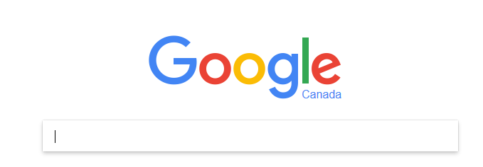
Search Box

Type your search terms here when the cursor is blinking.

Using a Search Engine

- Open your internet browser, like Chrome, IE / Internet Explorer, Mozilla
- Open a search engine, like google.ca or duckduckgo.com

- Type one or more keywords (search terms) in the search box and then press Enter on your keyboard. Don’t worry about grammar or punctuation, just type in the words for what you are looking for.

For example – we will search for banana bread recipes. After you do a search, you will see a list of relevant websites that match your keywords or search terms. This list is called your search results. If you see a site that looks interesting, you can click on the blue heading to open it.

The blue title is the name of the webpage that Google is matching with your search. Below that is a little description (like a little preview of the actual webpage). Below that in green, is the actual address of the website that the link belongs to. This is important to look at the actual address before you click on a link because it gives you a clue as to what website you’d like to visit.

Back to our example, search for “banana bread recipe”. A long list of recipes and websites will show up. If you go down the list, you’ll see one of them is from the magazine Canadian Living. If you read this magazine and trust their recipes, you’ll want to click on that link instead of all the other ones above it

- If you don't find what you are looking for on the first try, you will need to try different search terms to find what you are looking for. If you are having problems thinking of new search terms, you can use search suggestions. These will usually appear as you are typing. To use a search suggestion, you can click on it with your mouse.
- If you find you are getting too many results that don’t quite match what you are looking for, you can use some special characters to help refine your search and decrease the number of search results.
For example, you can search for exact words or phrases to narrow down your results. All you need to do is to place quotation marks around the desired terms. For example, if you search for recipes "sugar cookies", you search result will only include recipes for sugar cookies, instead of any cookies that happen to use sugar as an ingredient. If you put your keywords in quotations, Google will look for those words together on a website.

Search Options: Images/ News /Videos

- Ask participants for an example, perhaps pets, kittens or puppies usually go over well.
- Demo a search in Images
- Repeat for News and Videos/YouTube

