**How to Save Pictures onto Your Computer**

If you want to save a picture from the Internet, here is a quick guide.

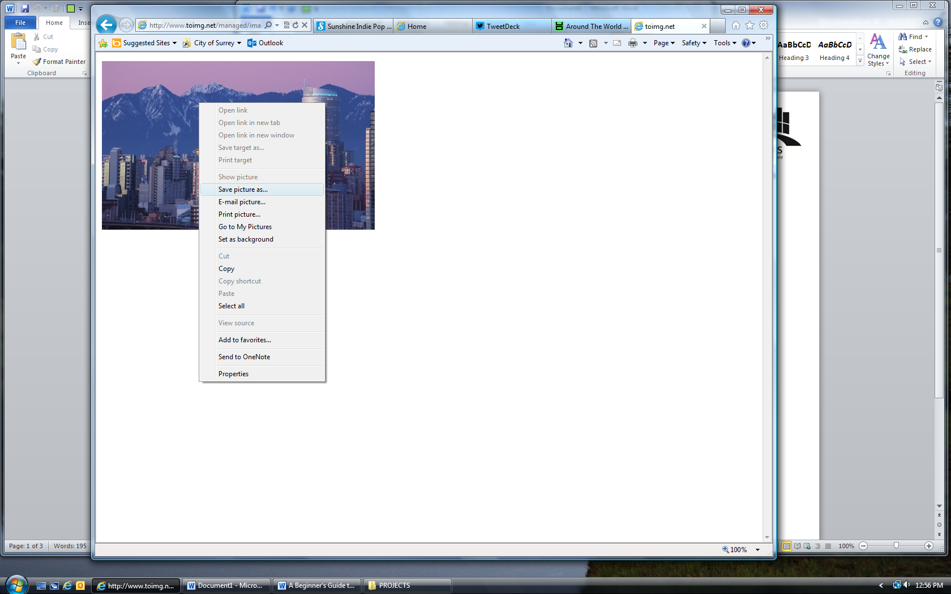

1. Find a picture that you want to save (can be from any page on the Internet, or from Google Images, etc.)
2. **Right click** on the picture – this will load a menu.
3. Click on ‘**Save picture as…**’ – this will open a new window.

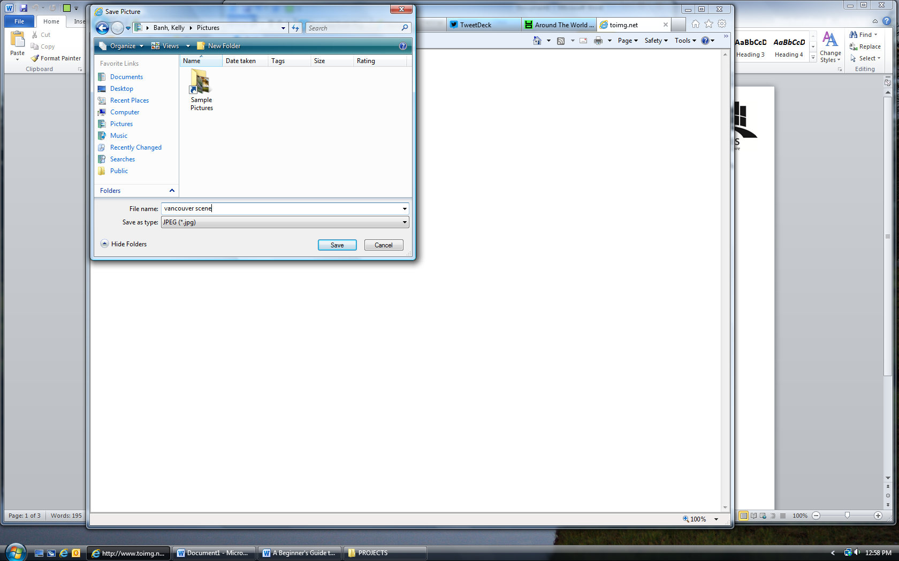

***You can also save the picture to a different location (such as the Desktop) by clicking and searching for a destination you like from the side panel here

Type in a name for the file here.

Click on **Save** when you are done.

1. Click on **Pictures** (located in the sidebar).
2. Where it says ‘**File name:**’, type in a name for the picture (e.g. Vancouver scene).
3. Click on **Save** when you are done.
4. Now you can find the picture you saved by going to your **Pictures**.