How to Access and Use the Rocket Languages Database

- On the homepage of the TNRD Library System website (www.tnrdlib.ca) click on the Databases link under the Online Resources heading.
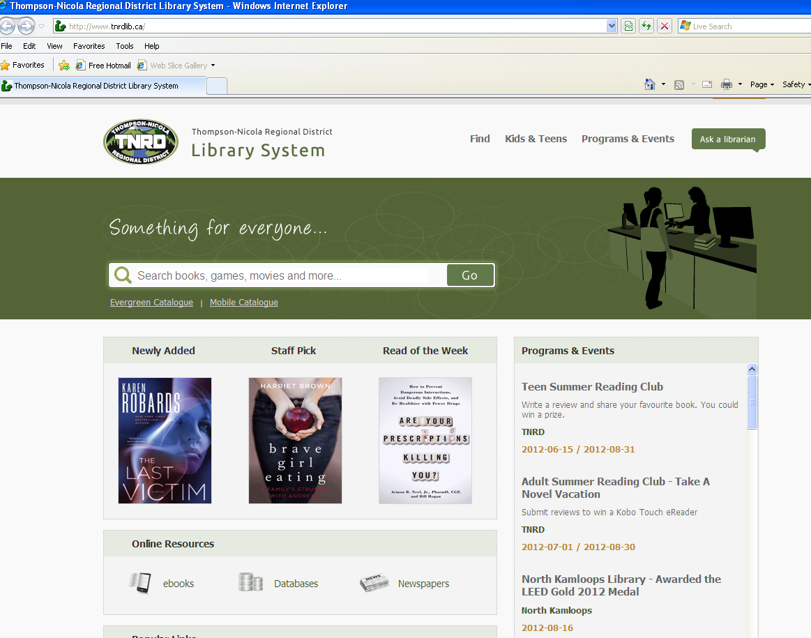

- The Online Resources webpage will come up providing a list of all of the databases available through the TNRD Library System. Scroll down towards the bottom of the list and click on the Rocket Languages icon.
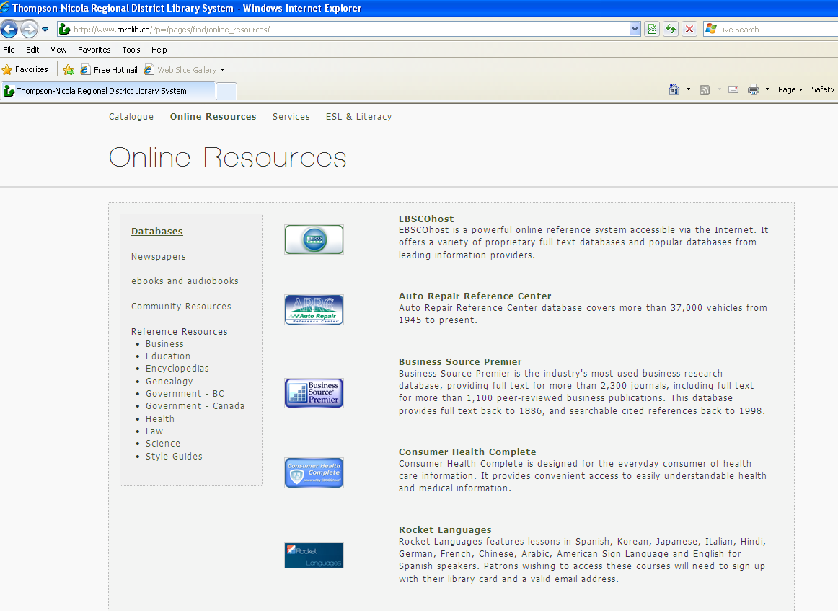

3) This will bring up a new window with the Rocket Languages homepage (www.members.rocketlanguages.com). To start you will need to create an account. To do this simply fill out the New Users registration form by including your library card #, name, email address, and then a password of your choosing.
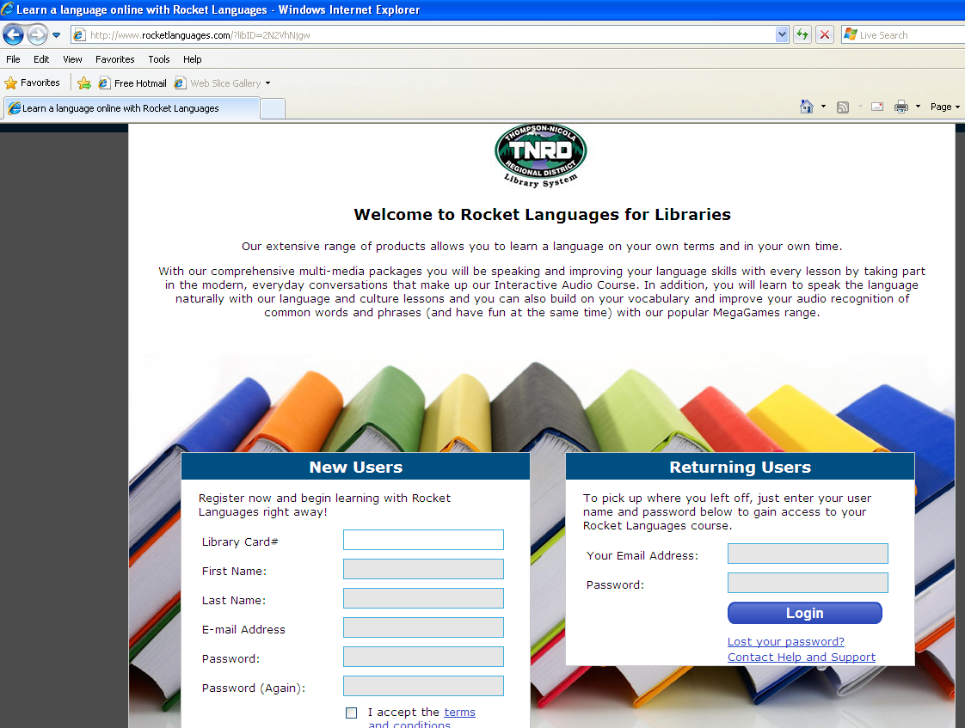

- Once your account is all set up you can then log into your account by filling in your email address and password in the Returning Users form on the Rocket Languages homepage (www.members.rocketlanguages.com)

5) After logging in you will be directed to the Rocket Languages Reception Area. On this page all of the available languages to learn on the site are listed for you to choose from. Click on your desired language.
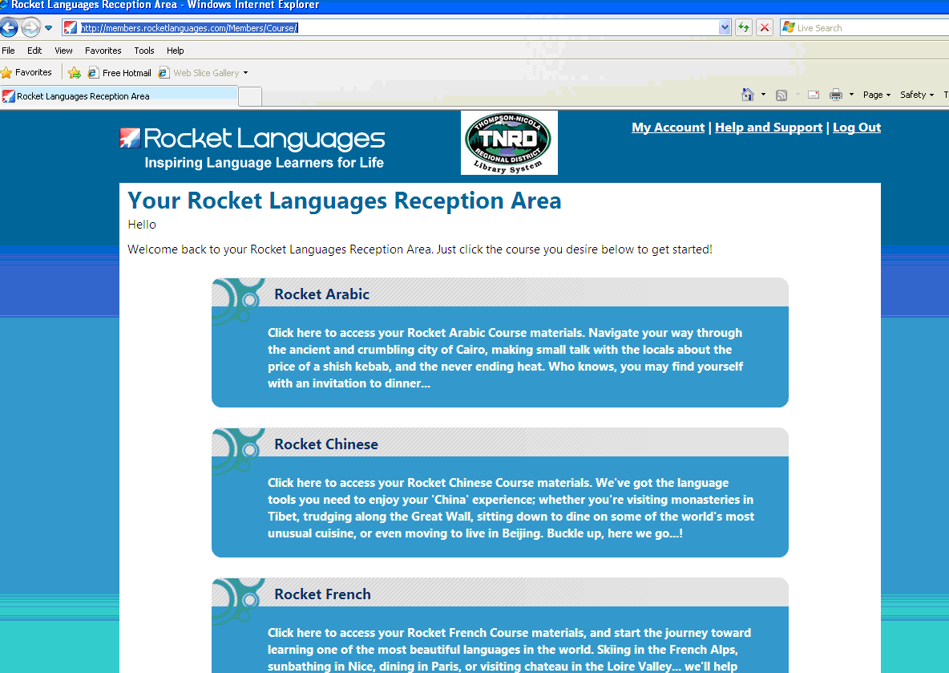
- You will then be taken to the main page for your selected language. Here you can watch a video that gives you a tour of the ways you will learn your selected language through Rocket Languages. There are also various charts showing your overall progress and proficiency as well as other handy tools such as My Notes and My Vocab.

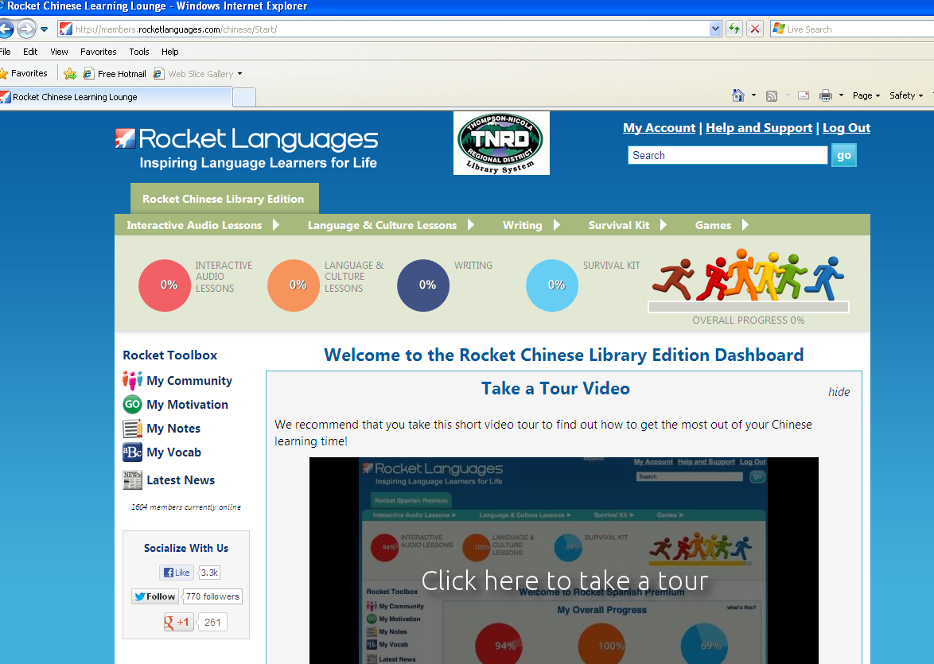

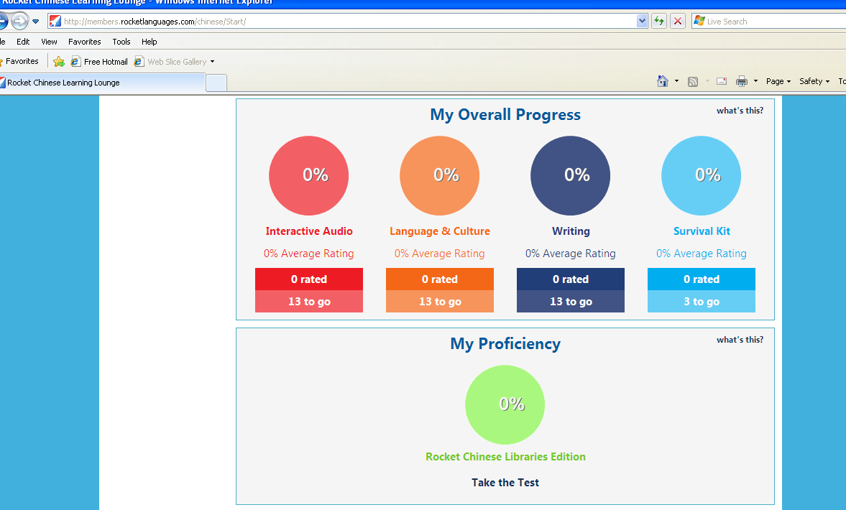

- If you require further help with the site you can click on the Help & Support link up at the top right-hand corner of the Rocket Languages webpage.

August 28, 2012

