How to Access and Use the Auto Repair Reference Center Database

- On the homepage of the TNRD Library System website (www.tnrdlib.ca) click on the Databases link under the Online Resources heading.
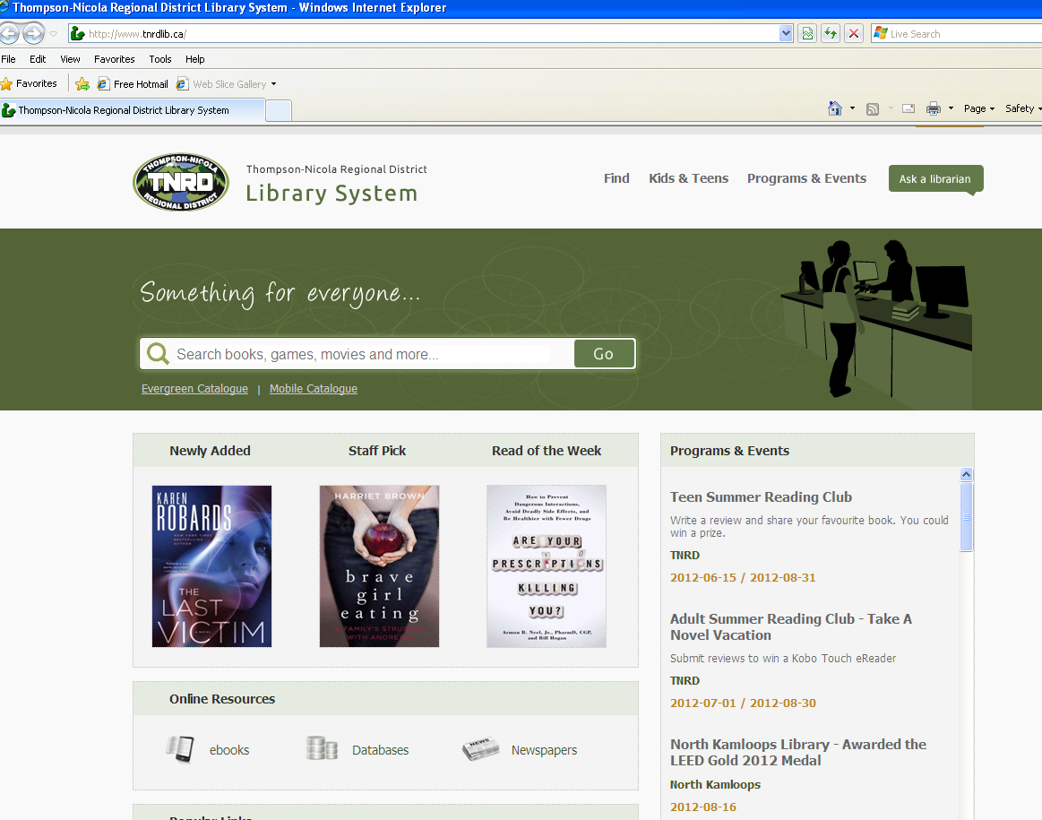

- The Online Resources webpage will come up providing a list of all of the databases available through the TNRD Library System. Scroll down to the second item on the list and click on the Auto Repair Reference Center icon.
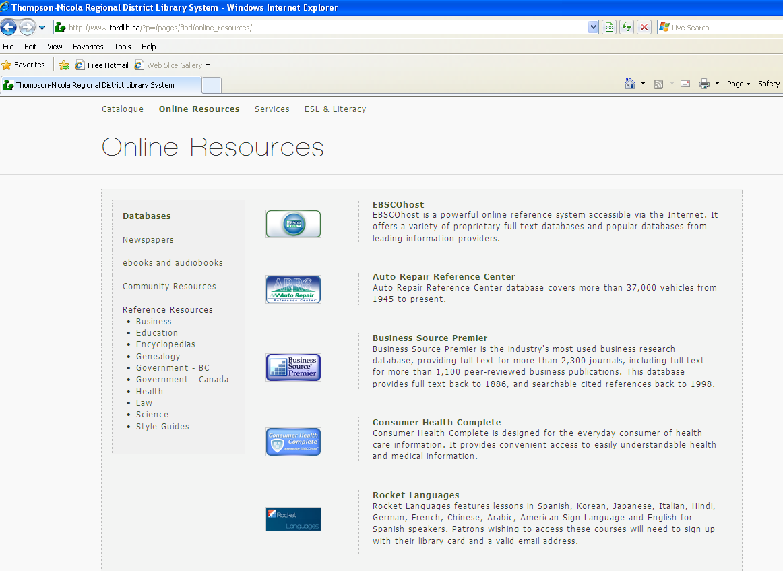

3) This will bring up a new window with the Auto Repair homepage (http://arrc.ebscohost.com/?key=10.1.20.22_8000_889580166&site=arrc). If you are accessing the database while using the internet stations within this library branch, you will be able to immediately access the search options. However, if you are accessing the database from a personal computer or device, you will need to log in by entering your library card number.
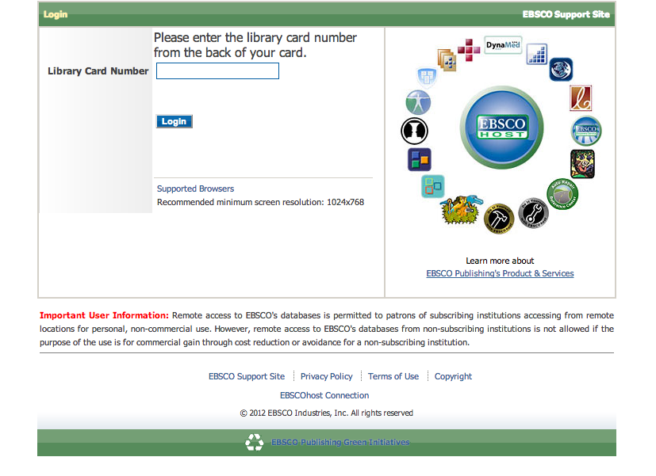
4) Once you are at the initial search page, follow the steps to select your vehicle’s year, make, and model by clicking on the arrows in the drop-down menus provided. 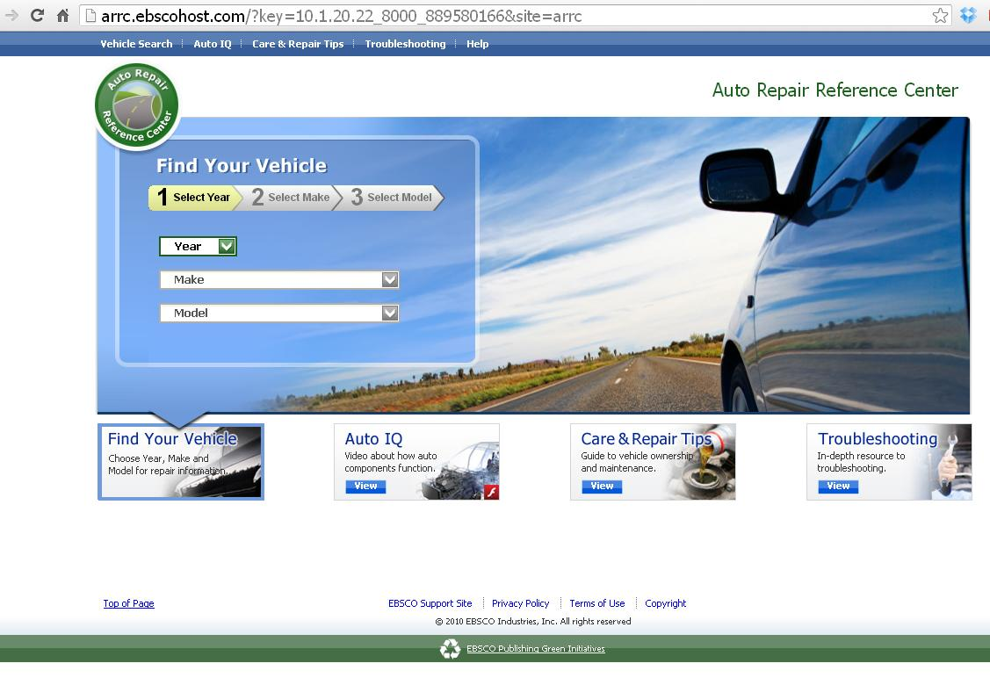
- Once you have chosen your year/make/model, a list will come up with the variations of that vehicle that came out that year (i.e., submodel, engine type, liters, etc). You may need to use the green arrows to scroll through the list if it is longer than can be shown in the box. Click on the appropriate “Select” button to choose your specific vehicle.
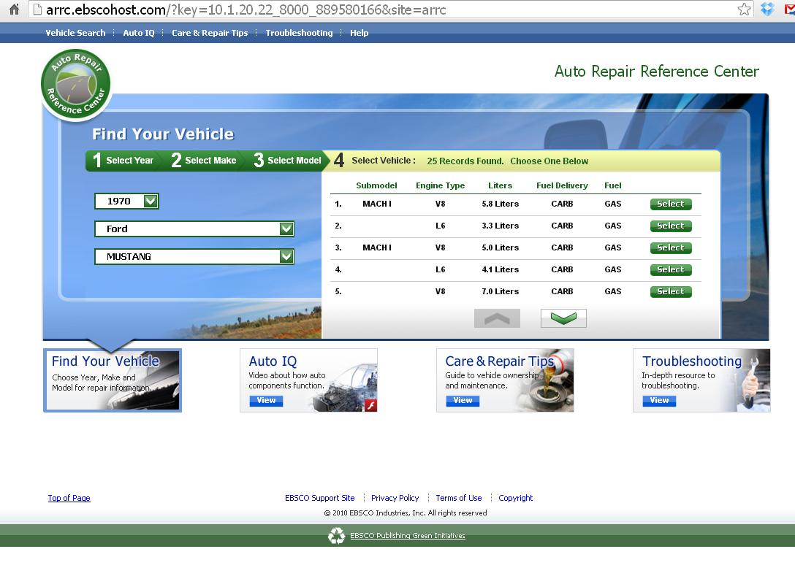
- Depending on the vehicle, there could be a range of 1-7 topics pertaining to that particular model. Topics may include Repair Information, Technical Bulletins & Recalls, Diagrams, Maintenance Intervals, Specifications, Labor Times, or Diagnostic Information. Select the topic by clicking on the topic title.
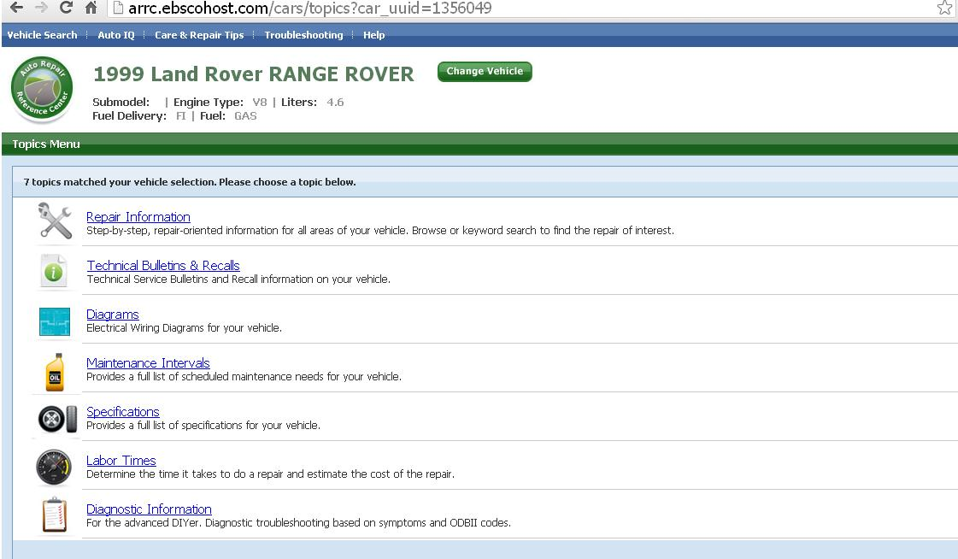

- Use the Search box to the left or select from the available Contents in the sidebar:
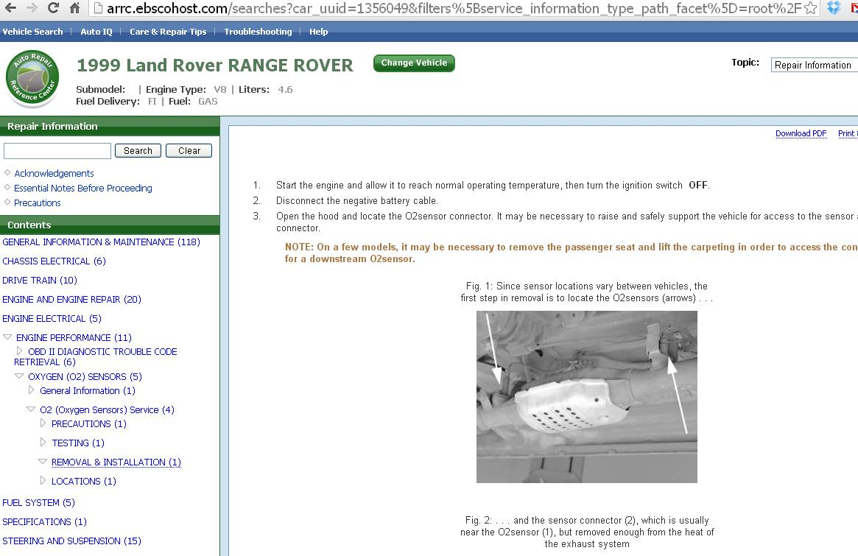

- To print, email, or save the documents, click on Download PDF or Print & Email Version over on the far upper right of the screen. 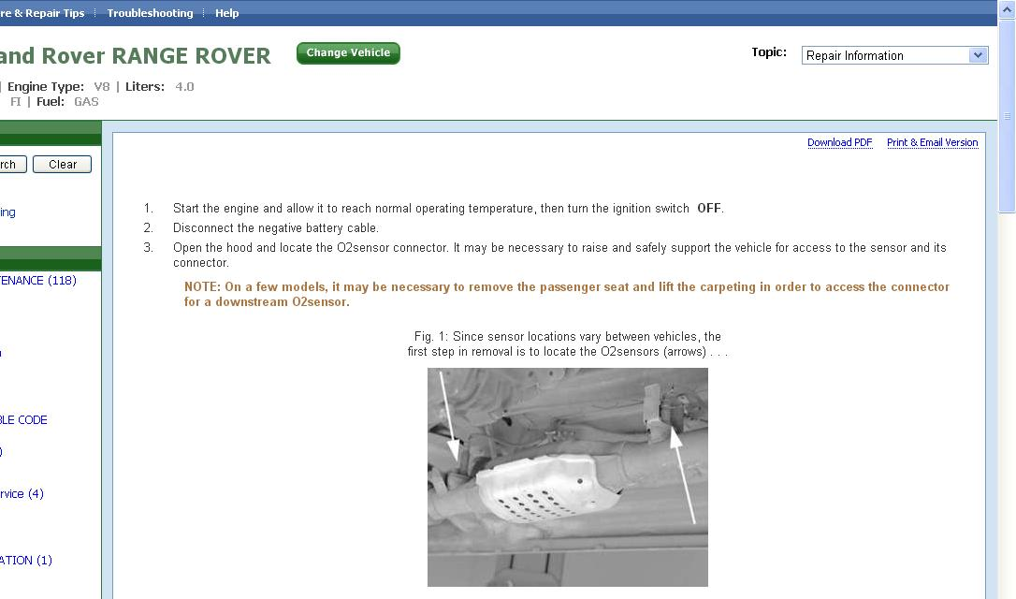

- Clicking on Print & Email Version will bring up a printer-friendly version of the document, with options to Download PDF, Email PDF, or Print Page. 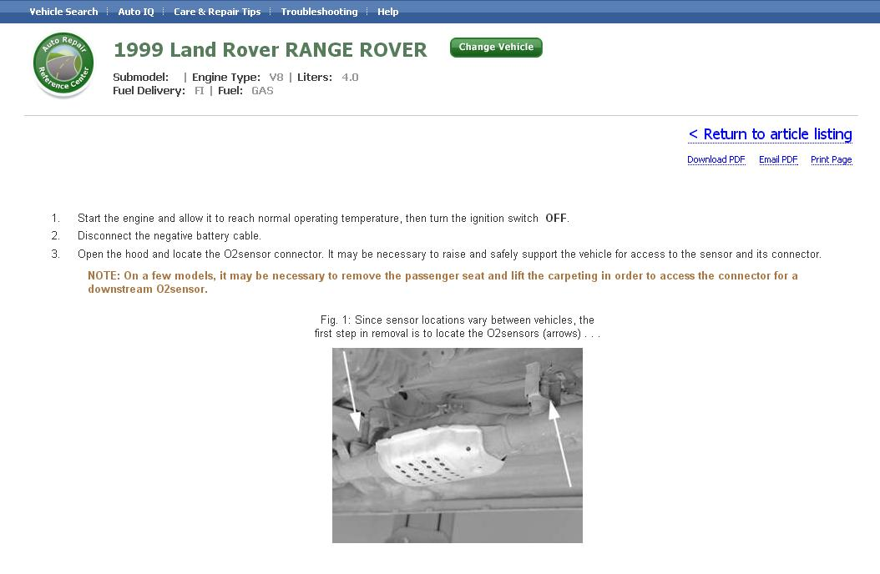
- To access the Auto IQ informative videos section of the reference center, click on Auto IQ at the top of any screen in the site or the View link at the base of the front page. Auto IQ will open in a new browser window or tab.
- After choosing to view Auto IQ with or without audio, a menu will come up to the right of the screen. Select an area of the vehicle you would like to view information about in the top selection area. Select a topic from the lower selection area. As your hover the mouse over the topics, a glowing circle will indicate the area of the car on the map. 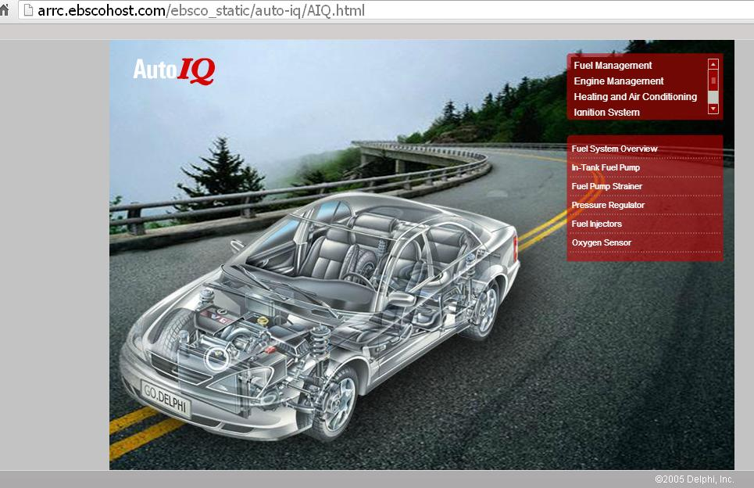
- Click on a topic to view a description as well as any available video clips, images, or audio clips. When finished with an image or video, click the Close Image or Close Video link to close the pop-up window displaying the image or video.
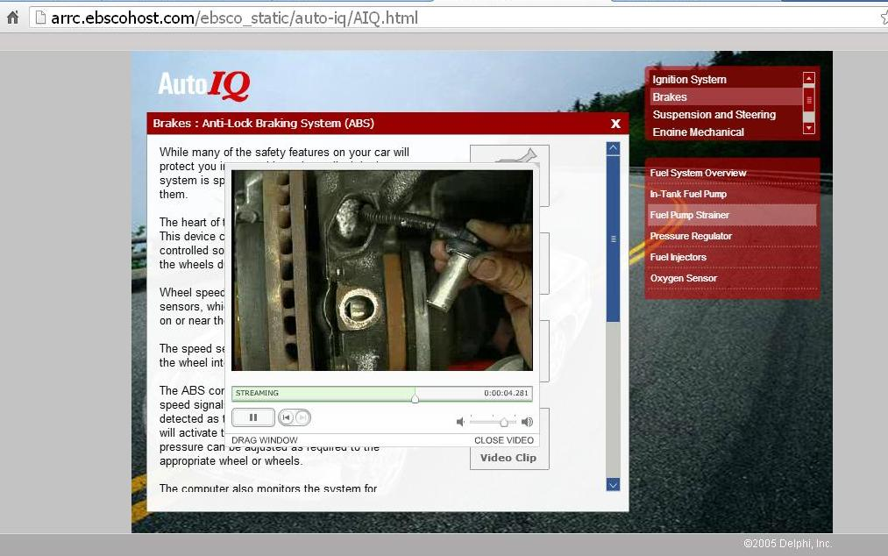
- To access the Care & Repair Tips or Troubleshooting sections of the reference center, click on the links at the top of any screen in the site or the View links at the base of the front page. The Care & Repair Tips or Troubleshooting area of the site will open in a new browser window or tab.
- Both the Care & Repair Tips and Troubleshooting sections of the page look similar and utilize a menu in the left sidebar in the window. Click through appropriate sections to open topics and subtopics. Or, click on Search to look for specific terms.
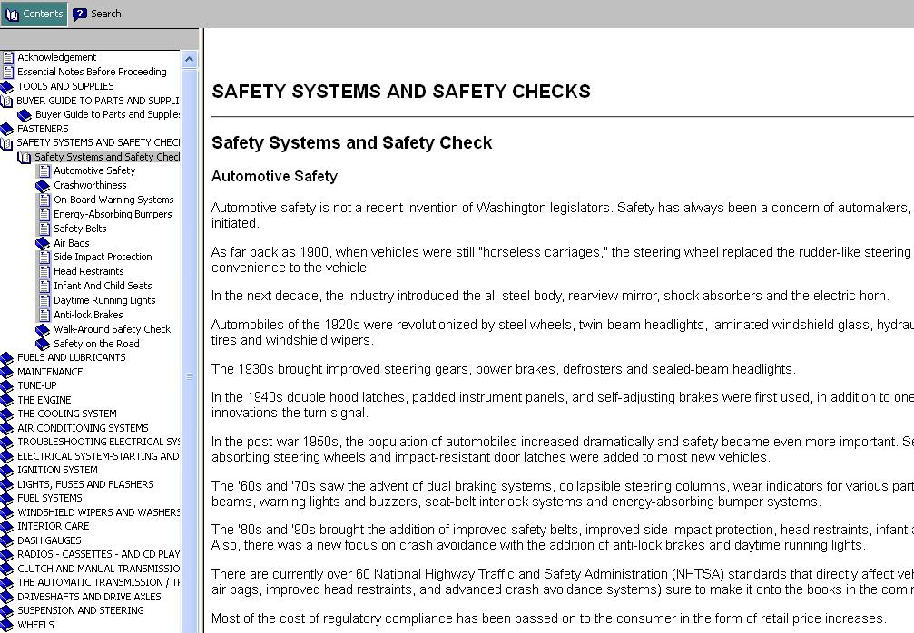
- There is a thorough Help page which can be accessed from the Help link at the top centre of the page. Clicking this will open a new browser window or tab.

December 28, 2012

