How to Use Gmail

Signing into/Creating a Gmail Account

- Using your computer’s Internet browser direct yourself to the Gmail website: www.gmail.com

- On the Sign in page, if you already have a Gmail account, then type in your existing Gmail address and password into the provided text fields and then click the Sign in button. If you want to sign up for a Gmail account, then click on the Create an Account button located in the top right-hand corner of the page.

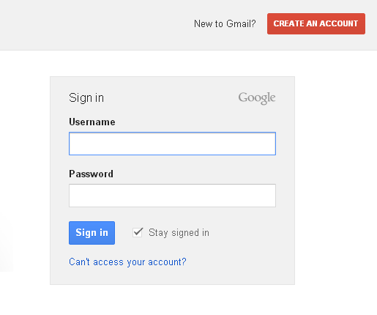
- If you chose to create a new account then you will be directed to the New Gmail Account page where you will need to fill in the appropriate contact information and create a Gmail email address. Create a secure password, fill in the remaining required information and then click the Next Step button. Go through any of the remaining optional steps until you are welcomed to Gmail.
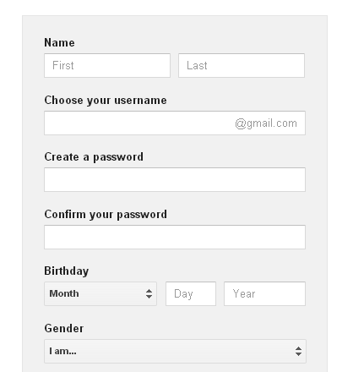

Using your Inbox

Once you have signed in or created your account you will be directed to your Gmail inbox. From here you can access your email messages, calendar, contacts, and account settings. You can also access a variety of other Google owned websites from your Gmail account such as YouTube, Google+, and Google Drive.

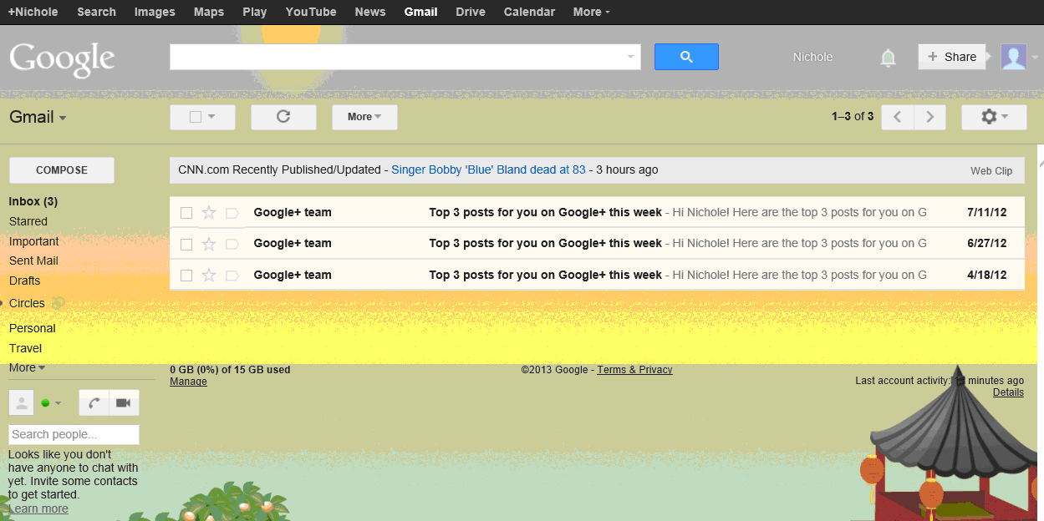

Labels (folders)

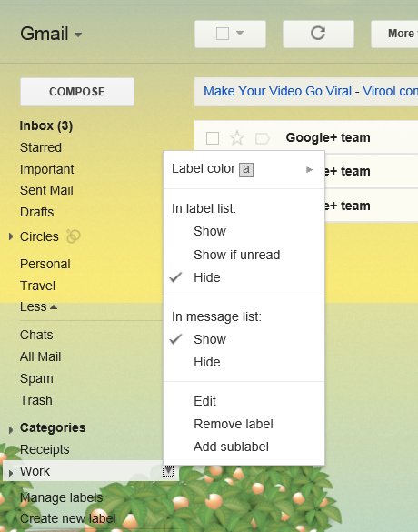
- At the Inbox page you can perform a number of steps. If you want to create folders (known as labels on Gmail) for your emails to be organized into, click the More button on the very left-hand side of your inbox. Then click Create new Label. You can create and edit multiple labels to help organize your important emails such as those regarding work, personal life, online purchases, etc.

- If you move your mouse cursor over a label and then click the downward arrow that appears to the right of the name you can choose from a number of options to perform on that label. These can include deleting the label, adding a sublabel to it, changing its colour, etc.
- If you ever want to move certain emails into a specific label simply click and drag the email from your inbox over to the label and then let go so the email drops into it. *You can move multiple emails at a time if you check off the boxes beside each of them and then click, drag, and drop them into a label.

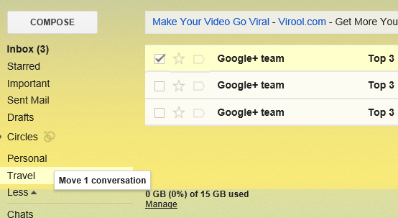

Alternatively you can check off the box beside an email you want to move into a label and then click the Label button that appears above your inbox. Then click the name of the label where you want your email to be stored. *You can have multiple emails selected at a time if you want to move more than one into the same label.

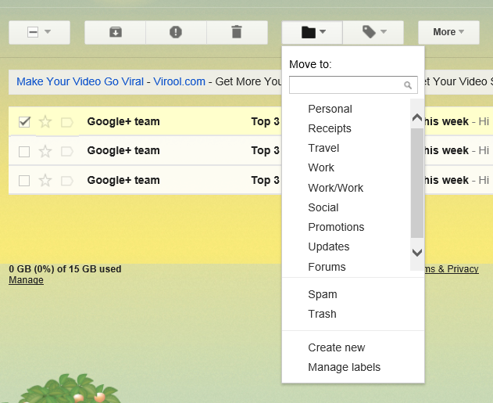

Opening Emails:

- If you want to read an email that is in your inbox, click anywhere along the line of the email.

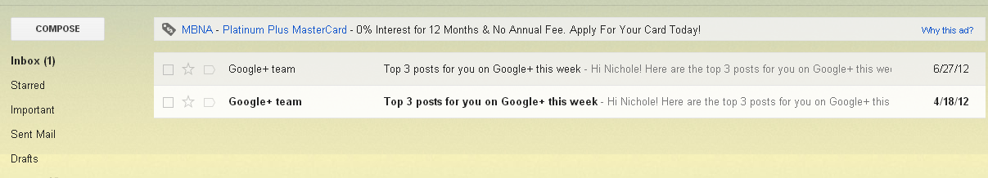
- The email will now be open for you to read. Use your Internet browser’s scroll bar to scroll up and down the email if it’s longer than the length of your computer screen. *You may see a message displayed at the top of an email from an unknown sender stating that there are images in the email that aren’t being displayed. If you trust the sender of the email you can allow the images to be displayed by clicking the “Display images below” link shown beside the warning message.

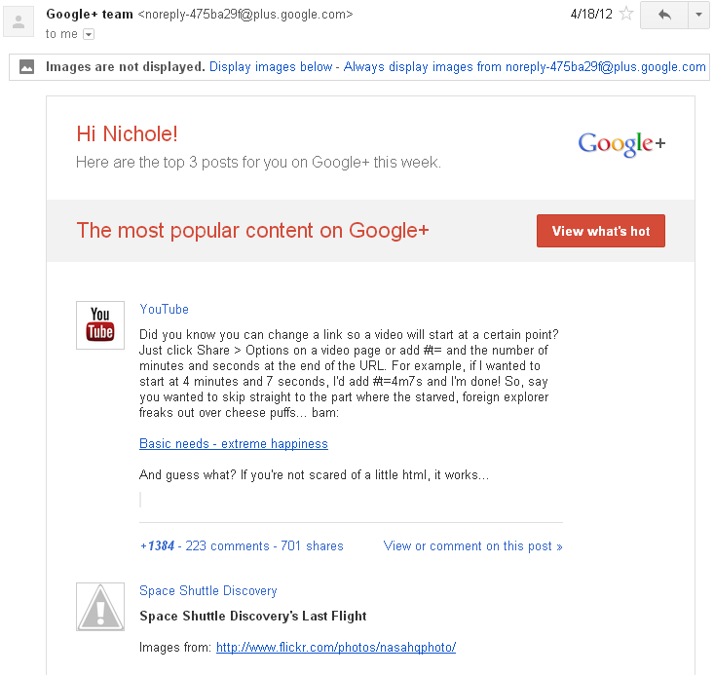

Deleting Emails:

- You can either delete emails while you have one open or while you are viewing the entirety of your inbox:

  - With Email Open: Above your open email click the Delete button (trashcan icon).

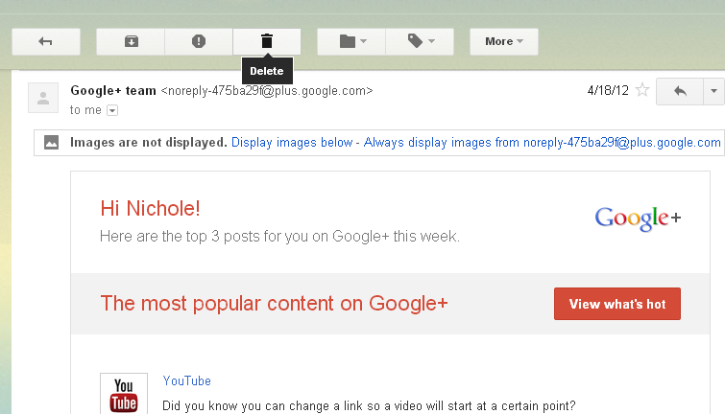

  - From within Inbox: Click the box beside any emails you want to delete and then click the Delete button above your inbox.

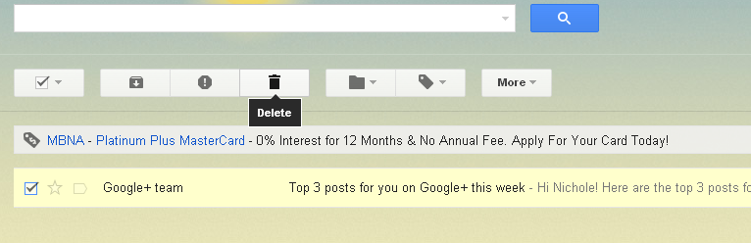

- You will notice that after deleting an email a note will appear near the top of the page saying that you can undo the deletion. Click the provided “Undo” link if you ever want to undo a deletion of an email.

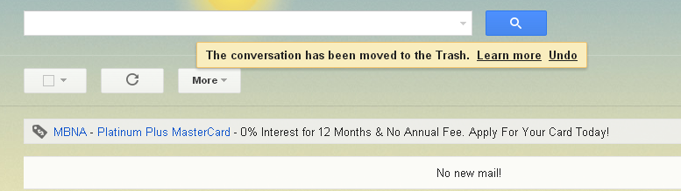

Composing an Email:

- If you want to compose a new email to someone click the Compose button on the left-hand side of your inbox.

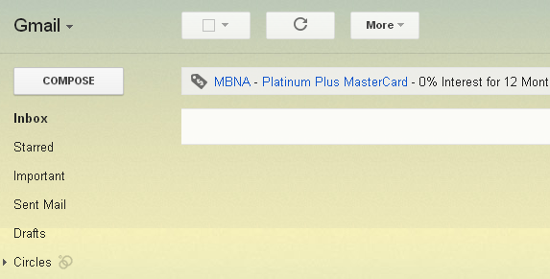

- *Gmail has switched over to a new Compose window. If you ever want to temporarily switch back to the old version click the More Options button (small downward arrow) in the very bottom right-hand corner of the window and then click “Temporarily switch back to old compose” This may not always be an option in the future.

After clicking the Compose button the Compose window will appear. It almost looks like a chat window now. If you’d like to make the window a bit bigger click the Pop-out button located in the upper right-hand corner of the window.

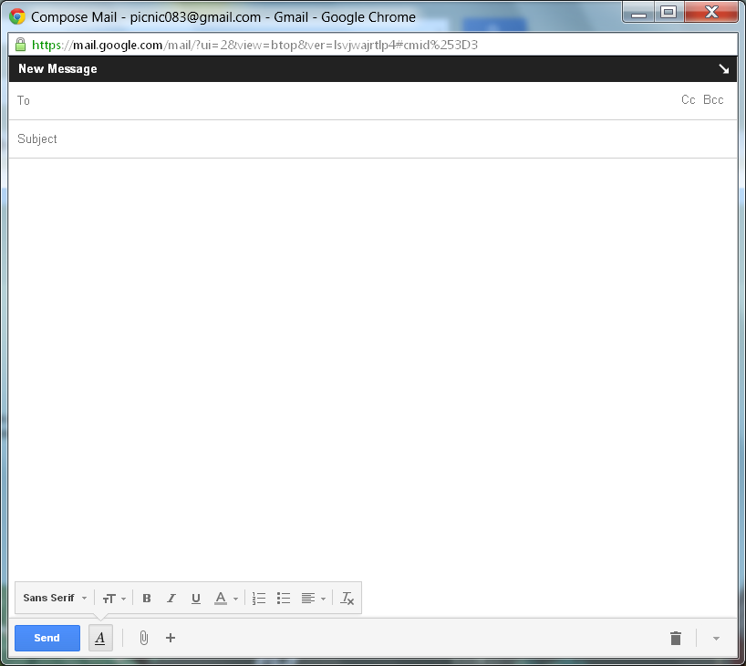
Type the recipient of your email within the “To” text field.
Type the subject of your email within the “Subject” text field.
Change your font style using the various Font options.
Type your message here.
Click the Send button when you are ready to send your email.
Click these buttons if you want to use the Cc and Bcc options.
To print your email or use spell check click the “More Options” button (downward arrow).
Click the Attach button (paperclip icon) if you’d like to attach a document/picture to the email.

For more options such as inserting links, emoticons, and invites, click the + symbol.

Other Options for Open Emails:

Replying:

- If you’d like to reply directly to the recipient who sent you an email, open the email and then click the Reply button.

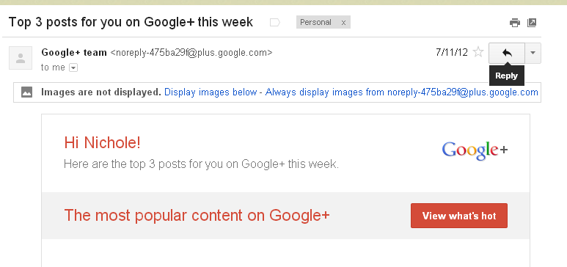
- A Reply window will appear at the bottom of the open email. Type your reply message here and then click the Send button.

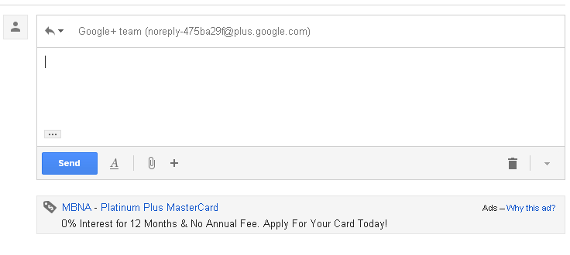
Forwarding:

- To forward an email to either one recipient or a group of them, open the email and then click the More button. Then from the drop down list that appears click the Forward button.

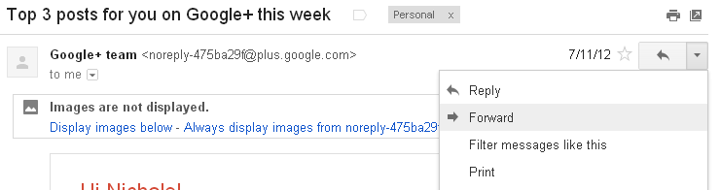

- A Forward window will appear at the bottom of the open email. Type your forward message above the “----Forwarded message----“text and add you’re your recipients in the “To” text field. Click the Send button when you are ready to forward the email on.

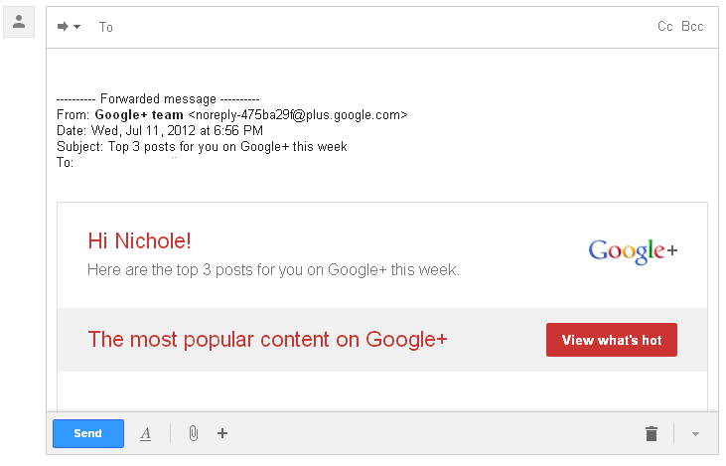
Printing Emails:

To print an email open it up and then click the Print icon within the email message window. This will allow you to print only the content of the email message rather than the rest of the clutter around it. *Don’t use your Internet browser’s print option as it will print all of the clutter around the email.

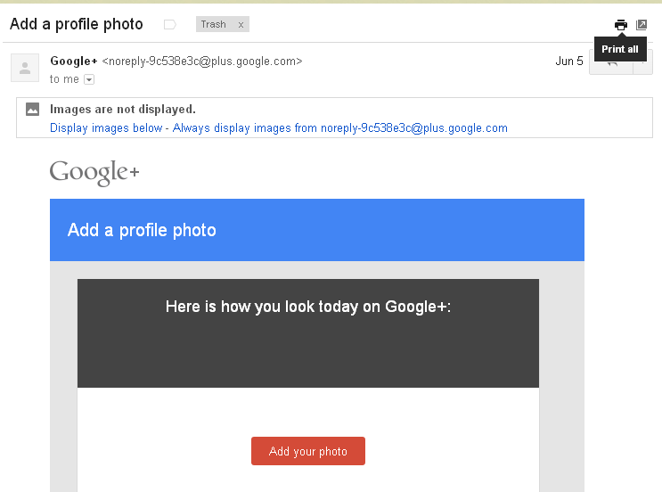

Creating/Viewing Contacts

- To access the Contacts page, direct yourself to your inbox and then click the Gmail button located in the upper left-hand corner of the page. From the drop down menu that appears click Contacts.

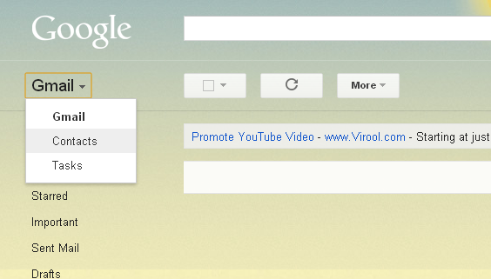

- You will be directed to the Contacts page. If you already have contacts added you can view/manage them here. To add a new contact click the New Contact button located on the left-hand side of the page.

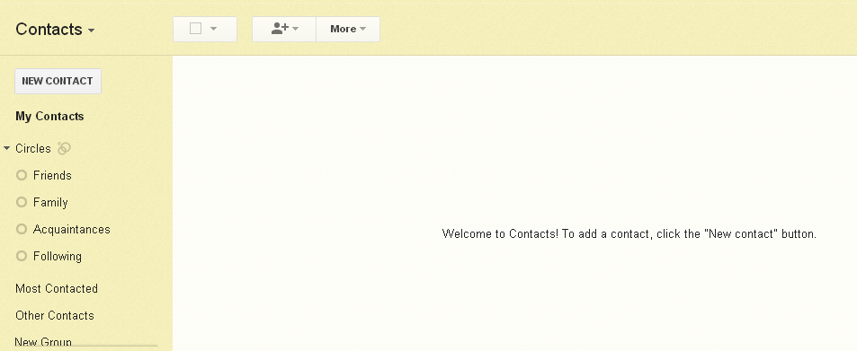

- Enter in the name and email address of your recipient (the rest of the contact information is optional) and then click the Save Now button.

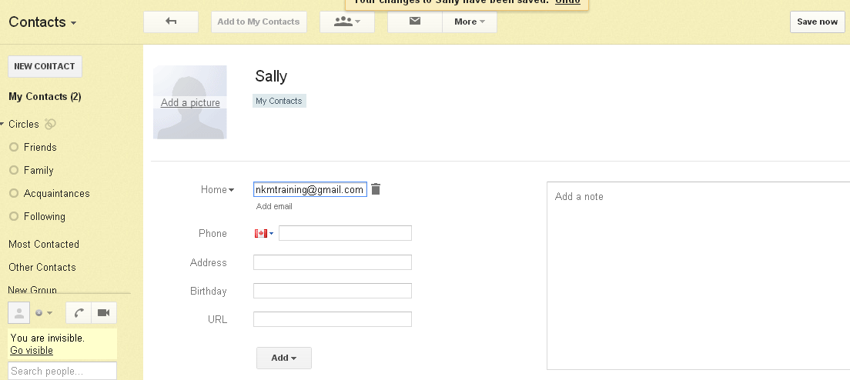

- Your contact will now be saved within your contacts list. If you click the My Contacts button on the left-hand side of the Contacts page you will be able to view all of your saved contacts. From here you can delete and edit contacts as well as organize them into certain groups.

*Another way adding contacts can be done is through emails you’ve received. Open an email from a recipient of whom you’d like to add to your contacts and then click the More button. From within the drop down menu that appears click Add <recipient’s name> to Contacts list.
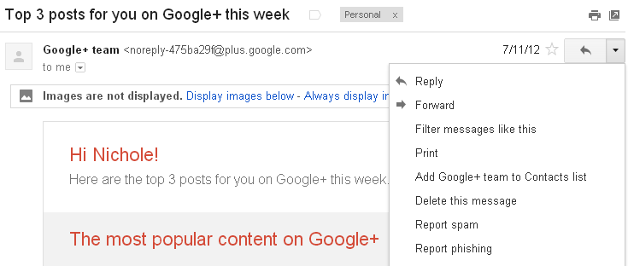
- To delete a contact click the box beside the contact’s name and then click the More button. From within the drop down click the Delete Contact button.
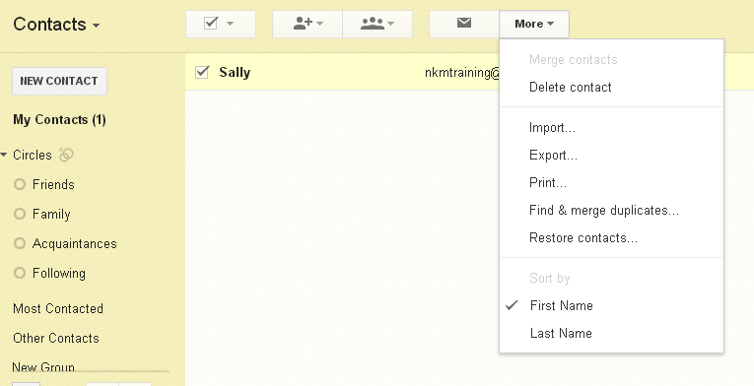

- If you want to edit a contact simply click on that contact’s name from within the list.

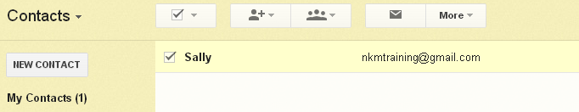

- To make a group and add a contact to it click the box beside the contact’s name and then click the Groups button. Either click a group you’d like to add the contact to from the drop down list or create a new group for it.

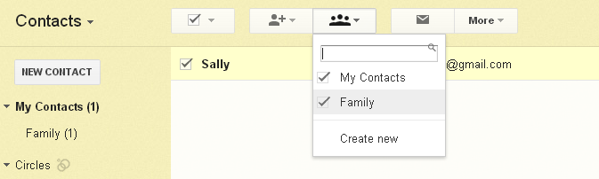

*Once you have contacts added you can quickly add them as recipients to any of your outgoing emails. You can do this either by beginning to type in their names in the “To” text field or by clicking “To” and then choosing their name from your contacts list.
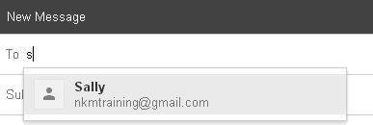

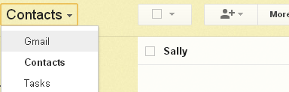
- To return to your inbox from the contacts page click the Contacts button located in the upper left-hand corner of the screen. From within the drop down menu that appears click Gmail. This will bring you back to your inbox.

Gmail Settings

If you ever want to change your Gmail settings click the Settings button (gear icon) located in the upper right-hand corner of your inbox. From within the drop down menu that appears click Settings. You will be presented with a wide range of settings that you can adjust to your liking. Make sure to click the Save Changes button located at the bottom of each Settings page to save any changes you make.

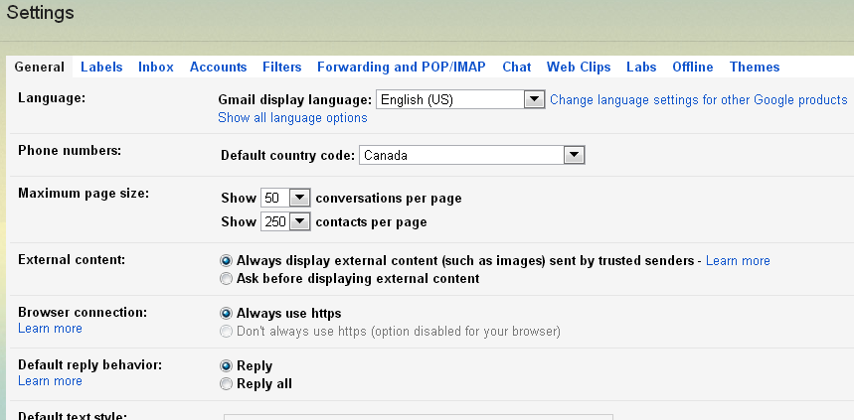
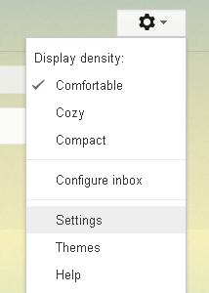

Signing out of Gmail

To sign out of your Gmail account click the mini person picture (or it could be a completely different picture if you chose to add a profile picture) that is located in the very upper right-hand corner of any Gmail page. Click the Sign Out button from within the menu that appears.

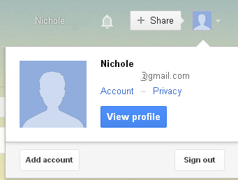
June 24, 2013

