How to Edit a Word Document Using SkyDrive

*You can create/edit Word, Excel, and PowerPoint documents within SkyDrive. These instructions will be focusing on SkyDrive Word documents but the steps are very similar to those of SkyDrive Excel and PowerPoint.

- Using your computer’s Internet browser direct yourself to the SkyDrive website: www.skydrive.com and type in your Outlook.com (Hotmail) email address and password in the correct text fields. Next, click the Sign in button. *SkyDrive is connected to your Outlook.com account so you can access it directly from the SkyDrive website or through the Outlook.com website.
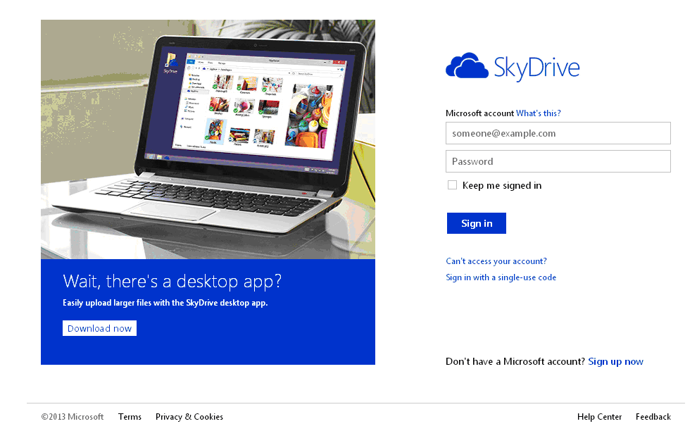

- To edit any documents that you have already stored in SkyDrive, click on the Documents box.

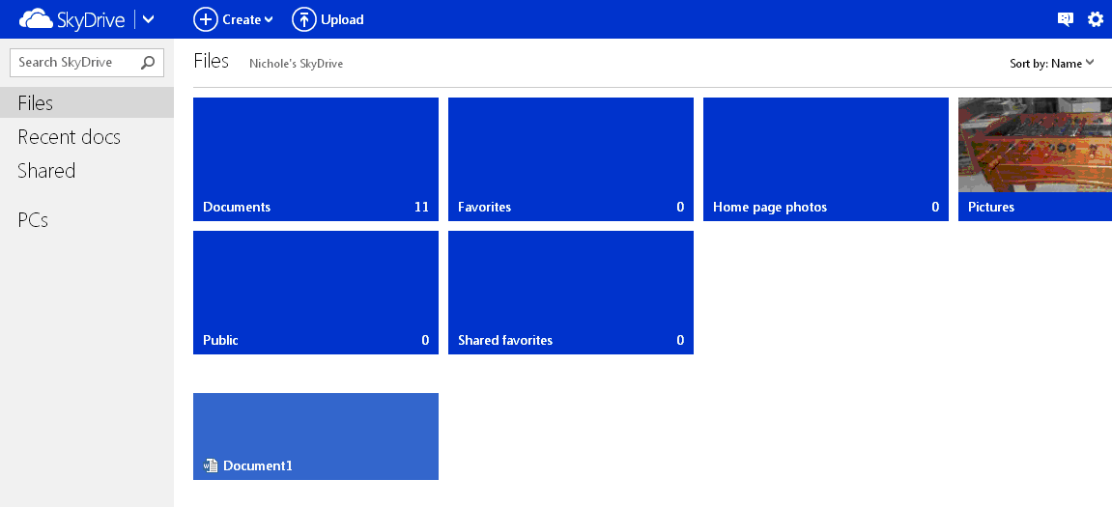

- All of your SkyDrive documents will now be displayed. Click on the title of the document that you would like to edit.

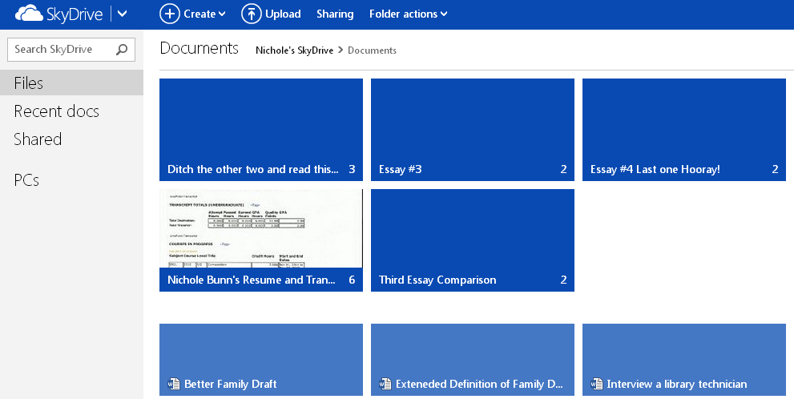
- Your document will now be displayed on screen. Click the Edit Document button located on the top left-hand side of the page.

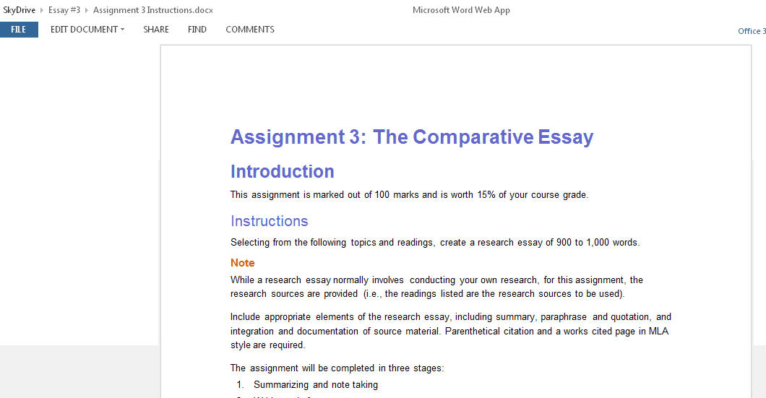

- A small drop down menu will appear allowing you to choose from either editing the document in the Microsoft Word program or within your web browser. If you want to have access to this document from just your SkyDrive/email account, then click the “Edit in Word App” option. If you have Microsoft Word installed on your computer and would rather work on it within that program then click the “Edit in Word” option. For the purpose of these instructions we will mainly focus on the “Edit in Word Web App” option.
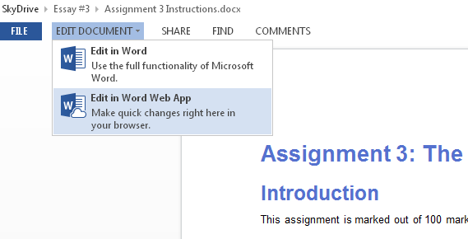

- If you chose to edit the document within Microsoft Word that program will automatically open up displaying your document where you can then begin editing it. If you clicked the “Edit in Word App” option then the Word App page will open with your document displayed for editing.

- You can see that the layout is almost identical to that of the installed version of Microsoft Word. Click anywhere you want on the document to start editing.

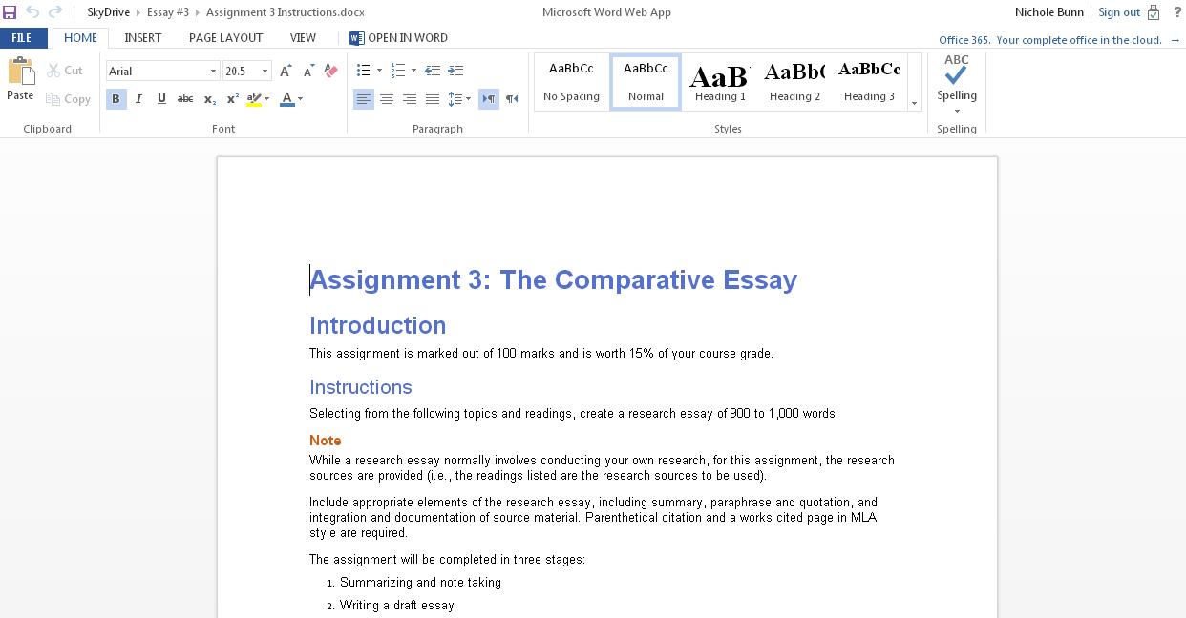

- Use the tabs at the top of the formatting options to switch between different editing tools. Most of the essential editing tools are under the Home tab such as font type, font size, content alignment, bold, underline, Spell Check, etc.

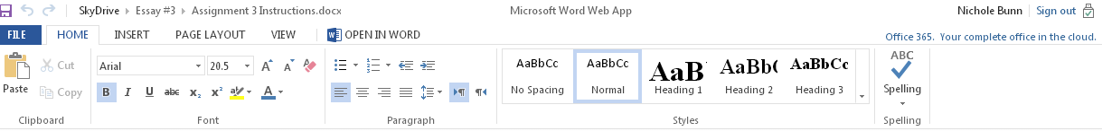

Under the Insert tab you can choose to insert a table, picture you have saved on your computer, clip art or an Internet link.

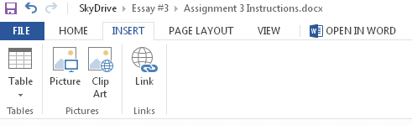
Under the Page Layout tab you can choose to change the margins, page orientation, paper size, and other sizing options.

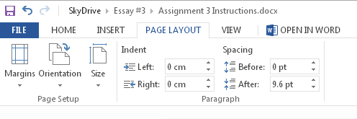
Under the View tab you can switch between Editing and Reading view.

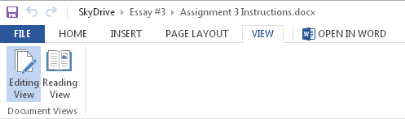

- Make sure to click the Save button in the top left corner frequently to save any changes you’ve made to the document. The changes will be saved within SkyDrive.



- If you decide that you want to start editing your document within the installed version of Microsoft Word at any point click the Open in Word option on the right-hand side of the tabs. A window will appear asking you if you’d like to close the Word Wed App and continue within Microsoft Word or you can choose the “Continue Editing in Word Wed App” option if you’ve changed your mind. If you want to purchase and install Microsoft Word onto your computer click the “Get Microsoft Word” option.

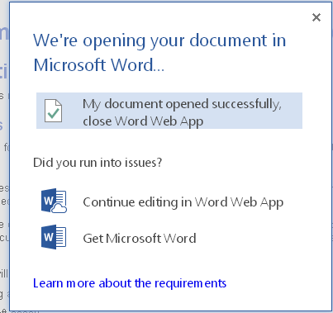

- If you want to save your document to your computer or print out a copy click the File tab.

The File menu will open.

The Info option allows you to open the current SkyDrive document with Microsoft Word if desired and to view older versions of the document that you have stored.

The Save option will save the document within SkyDrive.

The Save As option allows you to save the document onto your computer or USB stick.

Click the Print option to print the document as a PDF file.

The Share option allows you to share the document with others through email, Facebook, Twitter, etc.

The About and Help options offer information and advice on using SkyDrive.

→ See screenshot on next page
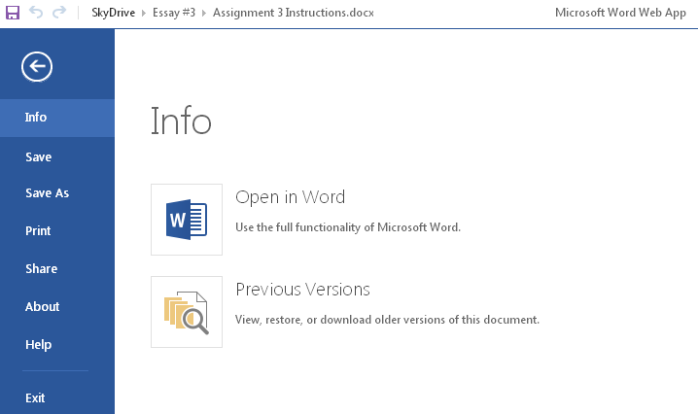

*If you chose to save your file within SkyDrive you can access it any time you want from within your SkyDrive account. The SkyDrive cloud is truly helpful for anyone as it allows one to obtain documents straight from the Internet rather than having to transfer them from computer to computer.

Downloading a SkyDrive file to your computer:

If you’d ever like to download a saved SkyDrive file onto your computer or USB drive go back to the main SkyDrive page and then click on whichever folder holds the document you’d like to download (Documents, Pictures, etc.) With that folder open click the little check box in the corner of your desired document and then click the Download button located at the top of the page. The document will now download onto your computer.

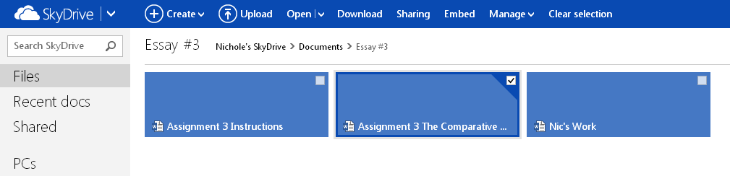

Creating a brand new document in SkyDrive:

- At the SkyDrive homepage click the Create button at the top of the page. From within the drop down menu that appears click whichever type of document you’d like to create (Word, Excel, PowerPoint, etc.)

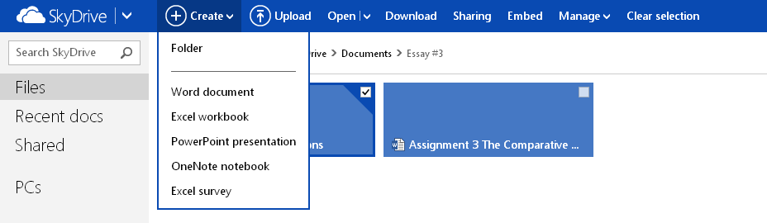

- Create a name for your document within the provided text field and then click Create. A blank document will then appear for you to start working within.

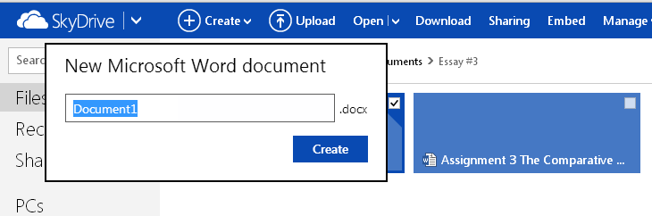

Uploading a Document to SkyDrive:

- Click the Upload button located at the top of the page.

- Within the window that appears find the file you’d like to upload, click it, and then click the Open button. Your file will now be uploaded onto your SkyDrive account.

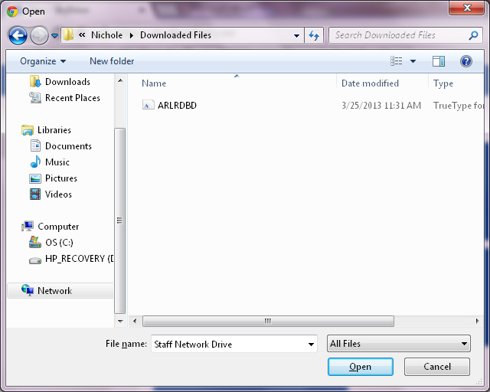

April 15, 2013

