FREEGAL
- Database of free music from the Sony Catalog.
- GVPL users can download up to 5 songs per week (Monday to Sunday) and keep them permanently.
- Music tracks are downloaded as MP3 files and can be saved on your computer or portable device.
- There are apps for both Apple and Android devices. Search in the Apple App store or in the Google Play store under “Freegal Music”.
- There are approximately 15,000 videos on the website. Downloading a video counts as two songs. (note: if you do not have 2 songs left in your weekly allotment you will not be able to download the video).
- Currently GVPL does not have access to the “Streaming” service.

You can search by album, artist, composer, genre, song or video titles. The search capabilities have also improved. You can also browse by Artist or Genre.
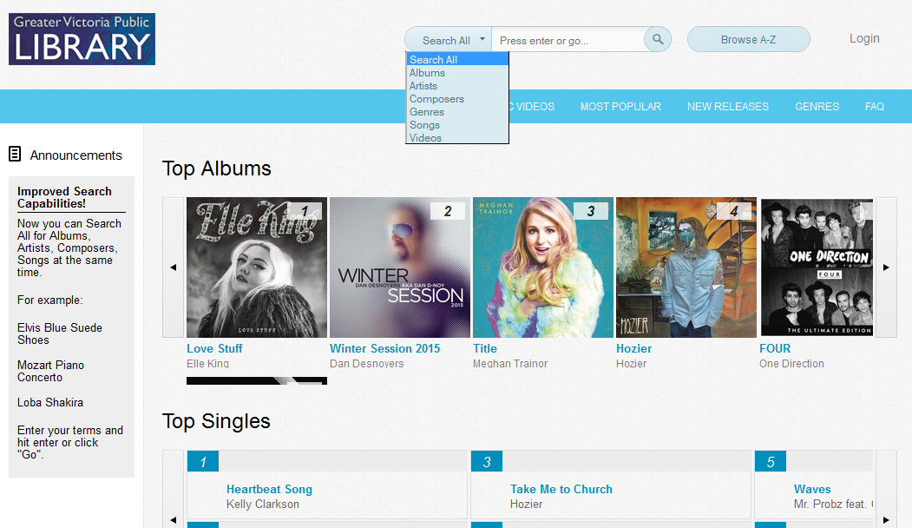

Once you login with you library barcode and password:
You will be able to listen to samples of the music and see how many downloads you have remaining in your account. The
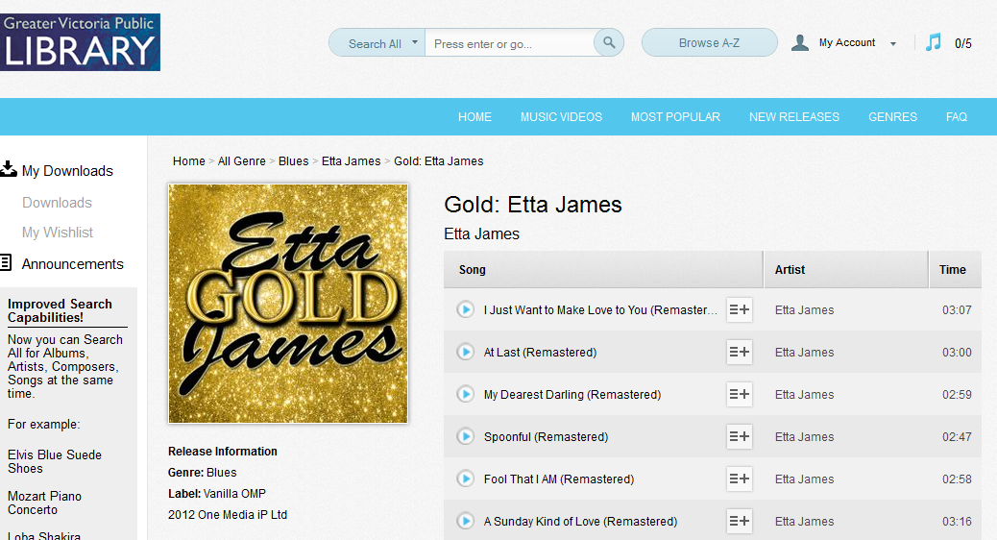

Troubleshooting Freegal
The FAQs are a good place to start if patrons have questions about how to use Freegal. In particular the FAQs explain in detail how to:
- Backup Freegal Music from the iOS mobile device into iTunes
- Transfer songs via iTunes
- Get music off your Android device and onto your computer

Fun things to check out:
- Can you find music for gym workouts or Zumba?
- I want to find an album of German jive music – are there albums any in Freegal?

