File Management
There are a few essential skills to learn when managing your files. One is mechanics: how do you create, move, delete, and find files and folders? To be successful with this skill, you need mouse skills and practice. The other is organizational: what system do you create and use to ensure you can find your files and folders? To be successful with this skill, you need to think in hierarchies. You may find that you want to rename old files and folders to conform to this system.

What is a file? What is a folder?

A file is a collection of data stored in a computer's memory or on a storage device under a single identifying name. The name will have a suffix that will give you an indication of what type of file it is. Common types of files include:

Document files | - .doc and .docx – Microsoft Word file  - .pdf – PDF file  - .xls and .xlsx- Microsoft Excel spreadsheet file  - .ppt and .pptx- PowerPoint presentation file
Image files | - .jpeg or .jpg – JPEG image  - .png – PNG image
Sound files | - .mp3 – MP3 audio file  - .wav – WAV file  - .wma – WMA audio file
Video files | - .mpg or .mpeg – MPEG video file  - .wmv – Windows Media Video file  - .mov – Apple Quick Time movie file  - .mp4 – MPEG4 video file
Compressed files | - .zip – Zip compressed file

A folder is an icon on a computer screen that can be used to access a directory containing related files or documents. The icon most typically looks like a file folder.

Test Yourself: Which of these are files and which are folders? Mark the files FI, and the folders FO. What information helped you make your decisions?

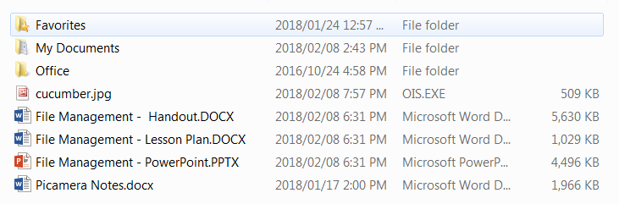

Test Yourself Further:
You receive a series of emails with the following attachments. What kinds of files have you received?

- .jpg
- .doc
- .mp3

Create files and folders

Save
The most common way to create a file is by saving the work you do in a particular program. For example, when you are working on a new document in Microsoft Word, the first time you save it, you will be asked to give the document a name. This creates a file with the name you’ve just chosen. You will also be asked to choose a location to save your file in. Locations may include: Desktop, Downloads, or external storage devices (like USBs).

Right click
From the Desktop, you can right click to create new files and folders. When you right click a menu will pop up on the screen. Select New.

A second menu will pop up. Select Folder to create a new folder. To create a new file, use the program you’d like to create the file in to guide your decision.

New folders will automatically be named New Folder. To rename the folder, simple click in the text box that says New Folder and type the folder’s new name.
Test Yourself: Open Microsoft Word and create a new document. Name the document “Test2018” and save the file to the Desktop.
Test Yourself Further: Create a new folder on the Desktop called File Mgmt Class.
Experiment: What happens when you try use the following in a file name?

- A space

- A special character like !,@,#,$,%, ^, etc.

- A slash or backslash

- A question mark

- Triangular brackets, < or >

Organize and move files and folders

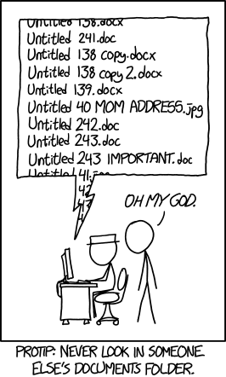
Organizing files and folders can be tricky. First you’ll want to decide on an organization system. Do you want to organize your files into folders by theme (Finances, Work, Children, etc.) or by date (2018, 2017, etc.)? Whichever you choose, you’ll want to make sure that you always name files the same way. For example, if you decide to organize your files chronologically, you’ll always want to record the date in the same format (YYMMDD, for example).

If a folder is on the Desktop, you can simply drag and drop files into it.

Test Yourself: You have the following files that you created between September and November 2017.
You would like to rename them so the all follow the same convention, and put them all into a single folder called 2017. Write down the new name for each file.

Image Source: https://xkcd.com/1459/

File Name | New Name
Fall 2017 Receipts – October - home repair.pdf

Roof repair – 20170921.pdf

Oct Groceries.xlsx

Groceries – September.xlsx

Groceries.xlsx

20172111.docx

New Document.docx

Don’t worry! There is no one right answer; answers will vary.

Test Yourself Further: You decide you need to create subfolders within 2017 to better organize the above files. Which subfolders do you create?

Experiment: Create a file called 2017. Create the subfolders you chose in the Test Yourself Further exercise. Move these folders into the 2017 folder.

Storing files and folders

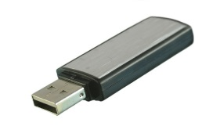
USBs
You may want to store files and folders in more than one place either to make a backup copy or to create a portable copy. To create portable copies of files and folders, many people use USBs. USBs are also called memory sticks, flash drives, thumb drives, or jump drives; they all mean the same thing.

To save files onto a USB:
- Insert the USB into a USB port on your computer. The location of the USB port will vary depending on the make and model of your computer. Check the front, back, and sides for a port that looks like this: | 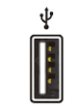
- To find your USB on screen, start by clicking on Windows Explorer. (If you’re on a Mac, Finder would be the equivalent.)

- Your USB will show up under Computer. It may be called Store N Go, by its brand name (ex. Lenovo), or by a name that someone has chosen for it (ex. Maud’s USB)

Once you have located your USB, simply drag the desired files and folders to it and release. You’ll see a blue plus sign and the words Copy to… with the name of your device. In the below example, a document called New Microsoft Office Word Document is being copied to the USB.
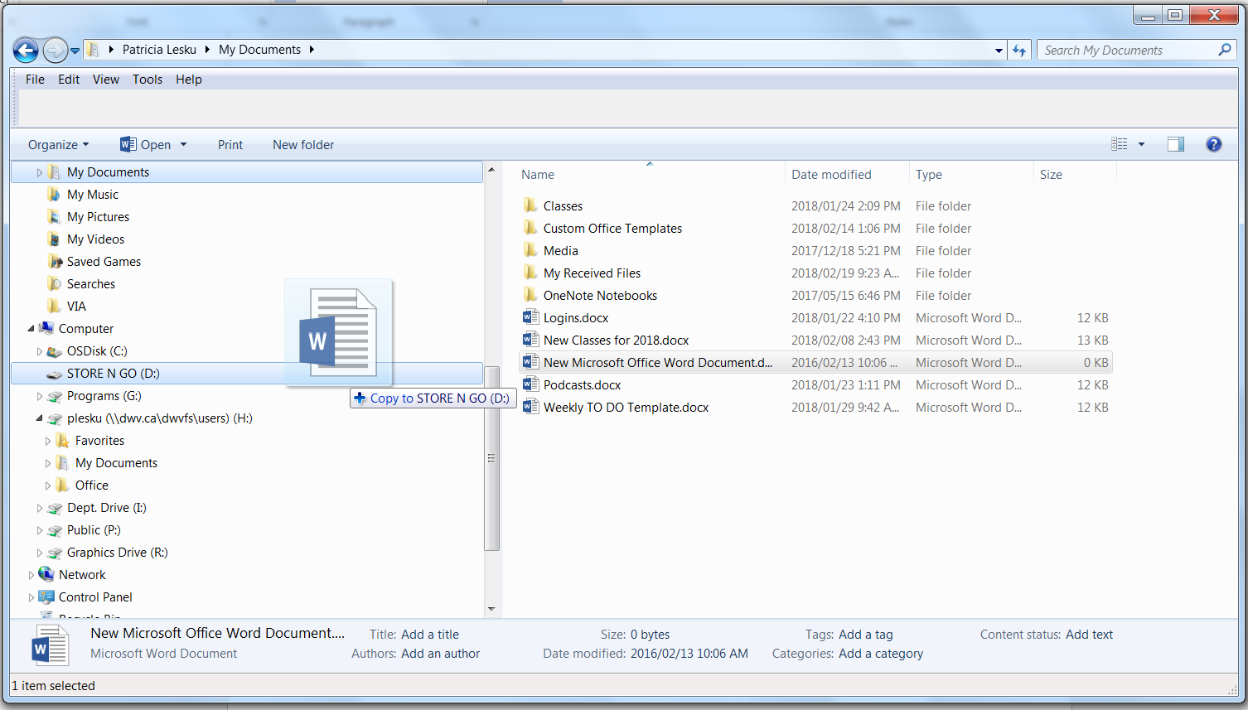
Once, you are finished saving files to your flash drive, eject it.
External Hard Drives
You may want to invest in an external hard drive to create back-up copies of your files. External hard drives typically plug into the USB port on a computer. Simply follow the instructions above to copy files to an external hard drive.

Cloud Storage
The cloud is an increasingly popular place to store and save files of all types. For more information about cloud computing, please ask at the Community Computing Centre or come to a Cloud Computing class.

Searching for and finding files and folders

Click on the Start Menu and a Search Box will pop up. Type your file name and hit enter to find it.

Test Yourself: Search for one of the folders you created using the search box on the Start Menu.

Deleting files and folders

A file must be closed before it can be deleted. To delete a file, simply drag it to the Recycle Bin. If you delete a file from the Desktop, it will go to the Recycle Bin, and will sit there until the bin is emptied. If you delete a file from a USB; it will be permanently deleted. If you delete a file by accident and it is still in the Recycle Bin, you can recover it by dragging it from the bin to the desired location.
Test Yourself: Delete all the files and folders you created for this class.

Learn More

- Lynda.com courses:
  - Visit https://www.westvanlibrary.ca/research-learn/learn/online-courses-lectures
  - Click on “Lynda.com” and enter in your library barcode and PIN
  - You can also download the Lynda.com app. Under the “Organization” tab type in westvanlibrary.ca and click on Login. You’ll be taken out of the app to login through the website with your library card number and PIN. Use the app like you would the website, or download videos for offline viewing.
  - Search for “Organizing Files and Folders Windows”

- Useful articles:
  - 10 Ways to Keep Your Digital Files Organized https://www.thebalance.com/computer-file-management-tips-2948083
  - What are the most common file types and file extensions? https://www.computerhope.com/issues/ch001789.htm

- Library books:
  - File Management: 005.74

For more information contact the Community Computing Centre 604.925.7405 or tech@westvanlibrary.ca

