Email Basics Teaching Script
Managing Your Email – Gmail

Email (Electronic Mail) consists of messages which are sent and received using the Internet. There are many different email services available that allow you to create an email account and send/receive emails and attachments. Many of these email accounts are free. Today we will focus on the services available through Gmail. It is free and one of the popular email services available.

The Pros and Cons of Email

The Pros
- It is fast. Most messages are delivered within minutes.
- It is personal. Its efficiency is an excellent substitute for telephone conversations.
- You can think through your response. Like a letter, you can type your reply and make changes before sending. Every email you start gets saved in your Drafts folder for you to revisit later.
- The sender and the receiver don’t have to be on the computer at the same time. It’s flexible.
- Email makes it easy to keep a record of your communication. Every email you send gets saved to your Sent folder.
- You can reach a lot of people at once.

The Cons
- Junk Mail = Spam. Try not to send unnecessary messages. For example, if you give your email address to a store or an organization, you might start receiving daily or weekly emails from them (like flyers) or from other companies that you didn’t give your email address to.
- Advertisements. The reason that you can get free email services like Gmail or Hotmail is because of advertisements.
- Email arrives without tone or hand gestures, which can lead to misunderstandings.
- Email messages can be passed on to others. Be aware of the possibility that your message could be sent to someone it wasn’t intended for.
- It is tempting to use email instead of facing a person when you have to deal with an unpleasant situation. It is best to talk to a person face-to-face under these circumstances.

Don’t use Email for:
- Long and complicated messages. Sometimes it is more effective to speak to someone in person or on the phone.
- Questions that require a lot of clarification. If a message is going to require several exchanges back and forth to make sure it is understood, more direct communication is best.
- Delivering indiscreet, sensitive or private information.
- Angry or emotionally upset exchanges.
- Things you should say in person.
Email Steps for Beginners
- Sign in to your email account.
- Open a web browser, e.g. Goggle Chrome.
- In the address bar, type in gmail.com, and then hit the Enter key on your keyboard.
- Type in the first part of your email address.
- Type in your password.
- Click on the Sign in Button.
Note: Click to uncheck “Stay signed in.”

- Read your email
- If you have unread (new) emails, they will appear in bold.
- To view a list of your email, click on Inbox.
- To open an email, click on the line of the email you wish to read.

- Delete an email
- To delete an email message, click on the checkbox next to that email.
- You can delete several emails at the same time by selecting multiple checkboxes.
- Click on the Delete button to delete the selected email(s).
- Open your Trash folder to see where the deleted emails go

- Send an email
- Click on Compose Mail.
- Type in the recipient’s email address in the box next to “To.”
- Type in the subject of the email. This is what will be seen when the recipient receives an email.
- Type your message into the large text box.
- When you are ready to send the message, click on the Send button.

- Reply to an email
- To reply to an email sent to you, first open the email.
- Click on Reply.
- Type your response.
- Click on Send.
- Forward an email
- Forwarding an email is similar to replying, with two differences.
- Click on Forward.
- Type in the email address for the individual you want to forward the message to.
Receiving / Opening an attachment
- When you receive a message with an attachment, a paper clip appears next to the subject of the message in your inbox.
- Click on the subject of the message to open an email. At the bottom of the message, you will see a box that lists the attachments.
- If you click on the picture, you will see the download link, i.e. the down arrow.
- To open the attachment, click on the down arrow button. The program that runs this type of file will open the attached file.
- Note: Never open an attachment if you don’t know the person who sent it. This is the most common way computer viruses are sent. If you would like to learn more about computer viruses, how they are transmitted and what damage they can do to your computer, go to this web address: http://computer.howstuffworks.com/virus.htm
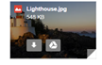
Attachment

Click here to download the attachment.

After clicking on the “down arrow”, you can see the attachment downloaded to the bottom of the monitor.

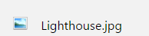

Attaching a file to your message
- When you finish composing your message, click on the paper-clip button at the bottom of your message screen. This opens the Attachment window.
- Find your file on the computer.
- Double click on the file you wish to attach.
- If you have more files to attach, repeat these steps.
- Once the file is attached, you will see the name and the size of your file.
- Click on the Send button. This returns you to the composition screen.
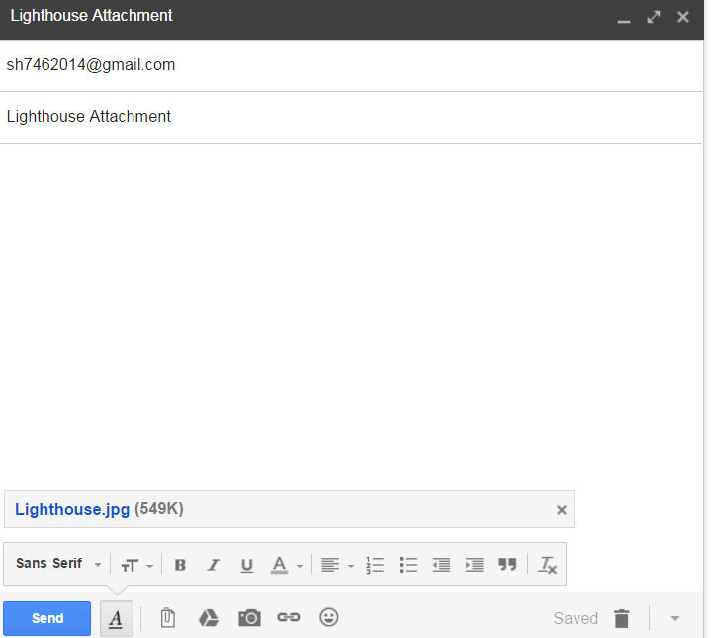

Attachment File

Sign in to continue to Gmail
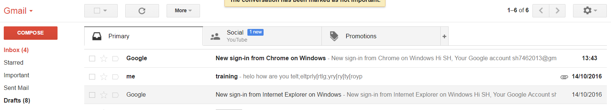
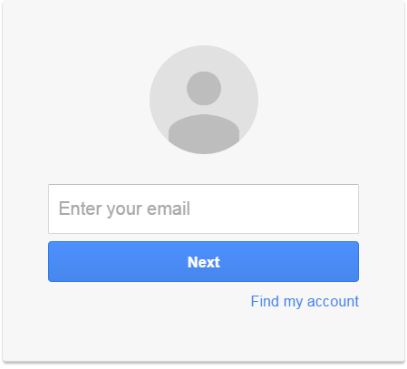
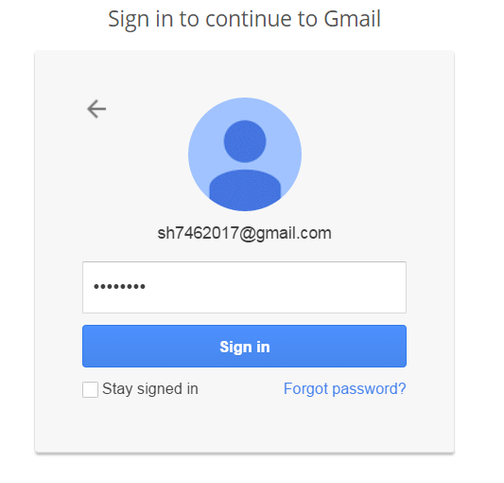
Enter your password (could be case sensitive)
Enter your personal email address
Subject of the message.
Click here to open the message.
Click the box to select a message
In Box – keeping your emails (read and unread)
Click here to delete a message
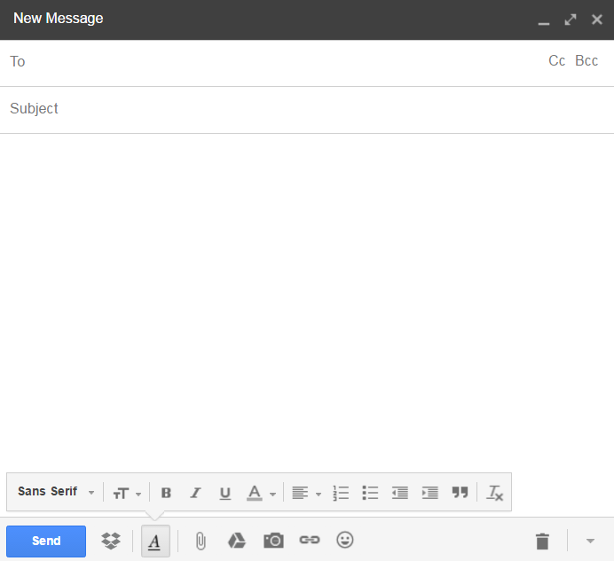
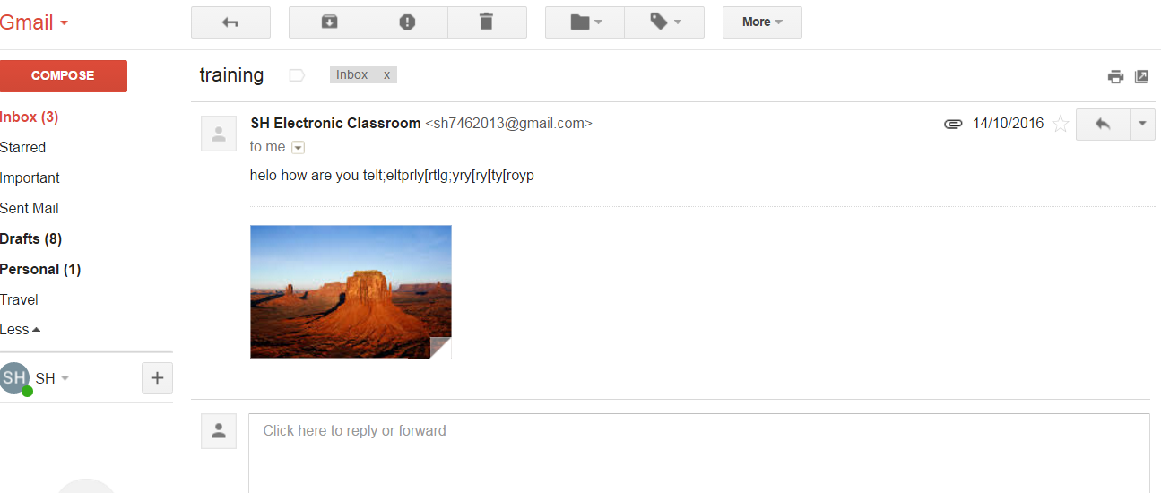
Click to send a message
Type your message here
Subject of the message
Type recipient’s email address
Forward a message
Reply a message
Create a new message

