Vancouver Public Library
After-School Drop-In for 8-12 Year-Olds
Duct Tape Notebook Program Report

Date

Branch >

 |  | X
Program description
Today we decorated composition notebook covers with duct tape! Everyone was given a blank notebook and free rein to decorate it however they chose with the following materials: coloured and patterned duct tape, letter stickers, chalkboard speech bubble cutouts and markers.

I set out ‘Doodle Diary’ and ‘Wreck This Journal’ for ideas of things to put inside the book (ie. Draw with only your left hand on this page, cover this page in stickers, rub dirt on this page and turn it into a doodle, tear out this page and make a paper airplane, etc.)

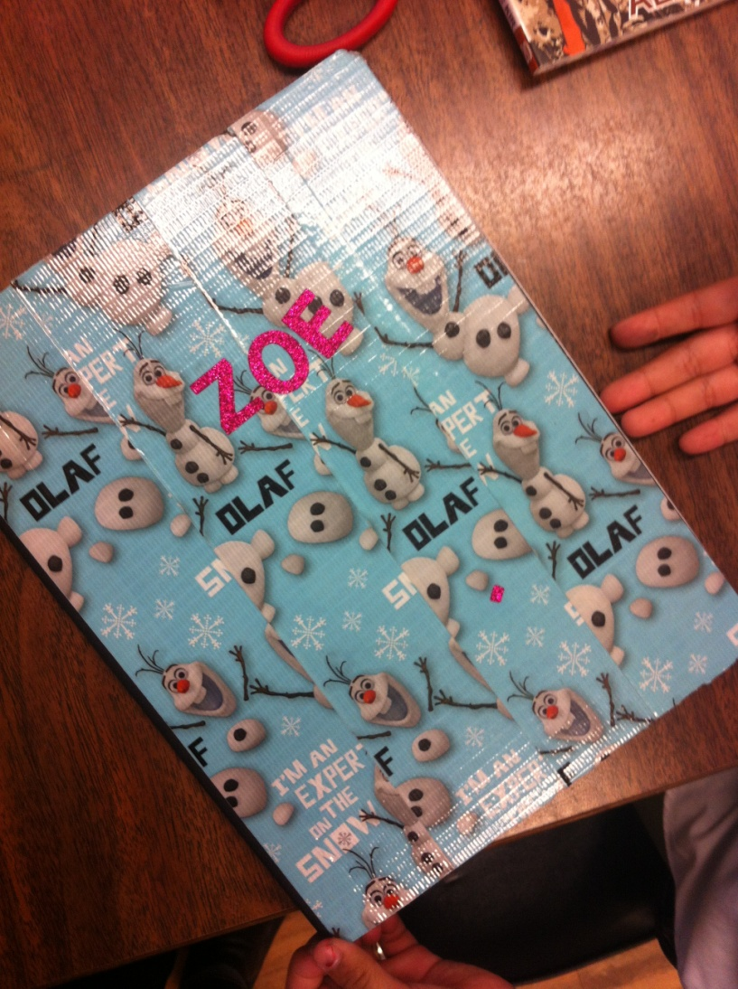
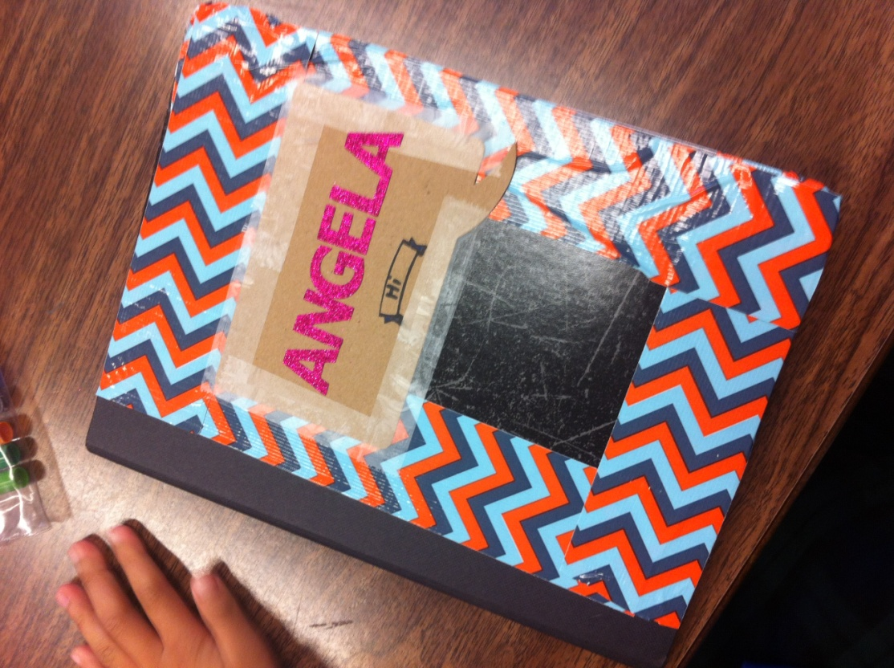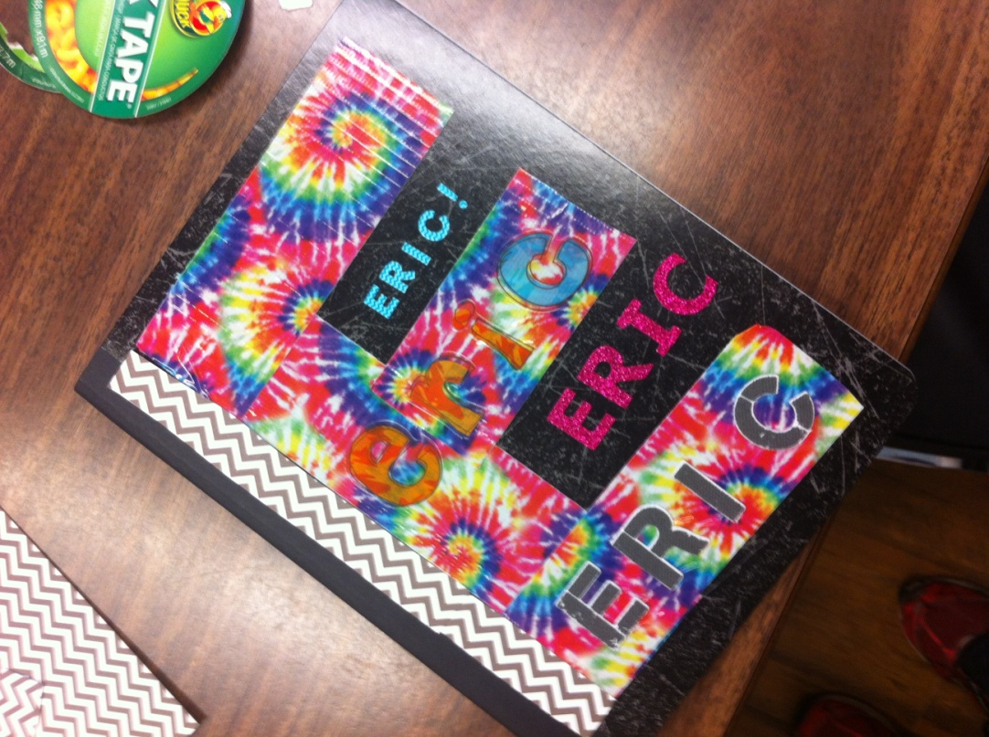

Attendance > |  | 12
Observations
This program went over really well today with both my regular attendees and kids that I enticed in from the children’s area (by holding up a blank notebook and a roll of Angry Birds duct tape).

Feedback
I got some good feedback from a parent today. Last week a girl named {} came to the ‘Zine Making’ program and could only just get a start on her zine because her family had only dropped into the library for a quick visit. This week {} came back especially for the program and was waiting outside the meeting room door at 3:30. Her mother, younger sister and brother joined in the program about half way through and they all stayed until the end of the program. The mother told me that {} had such a good time last week that she had asked to come to the library this Tuesday so that she could come to the program. She said they planned their afternoon so that they could stay for the whole program this time and that they are looking forward to coming again next week.
VPL staff  (name(s)) |  |  |  | Reported by:

