|  |  |
| --- | --- |
|  | Database User Guide  Step by step instructions to help you research needs |
|  | |

|  |  |
| --- | --- |
| C:\Users\ct2\AppData\Local\Microsoft\Windows\Temporary Internet Files\Content.IE5\QF2BJHYC\MC900437603[1].wmf | Brief introduction and write up about the database. List goal of this database user guide. If you have any questions, please contact the Information Desk at your local Surrey Libraries branch. Font Calibri, size 14. |

**w w w . s u r r e y l i b r a r i e s . c a**

1. Begin with step by step instructions including screen shots. Centre screen shots and choose a solid line on the outside (right click on image > format picture > line colour > click circle beside solid line). Use arrows to highlight details. Make arrow bright red and weight 2.25 (right click on arrow > format autoshape).

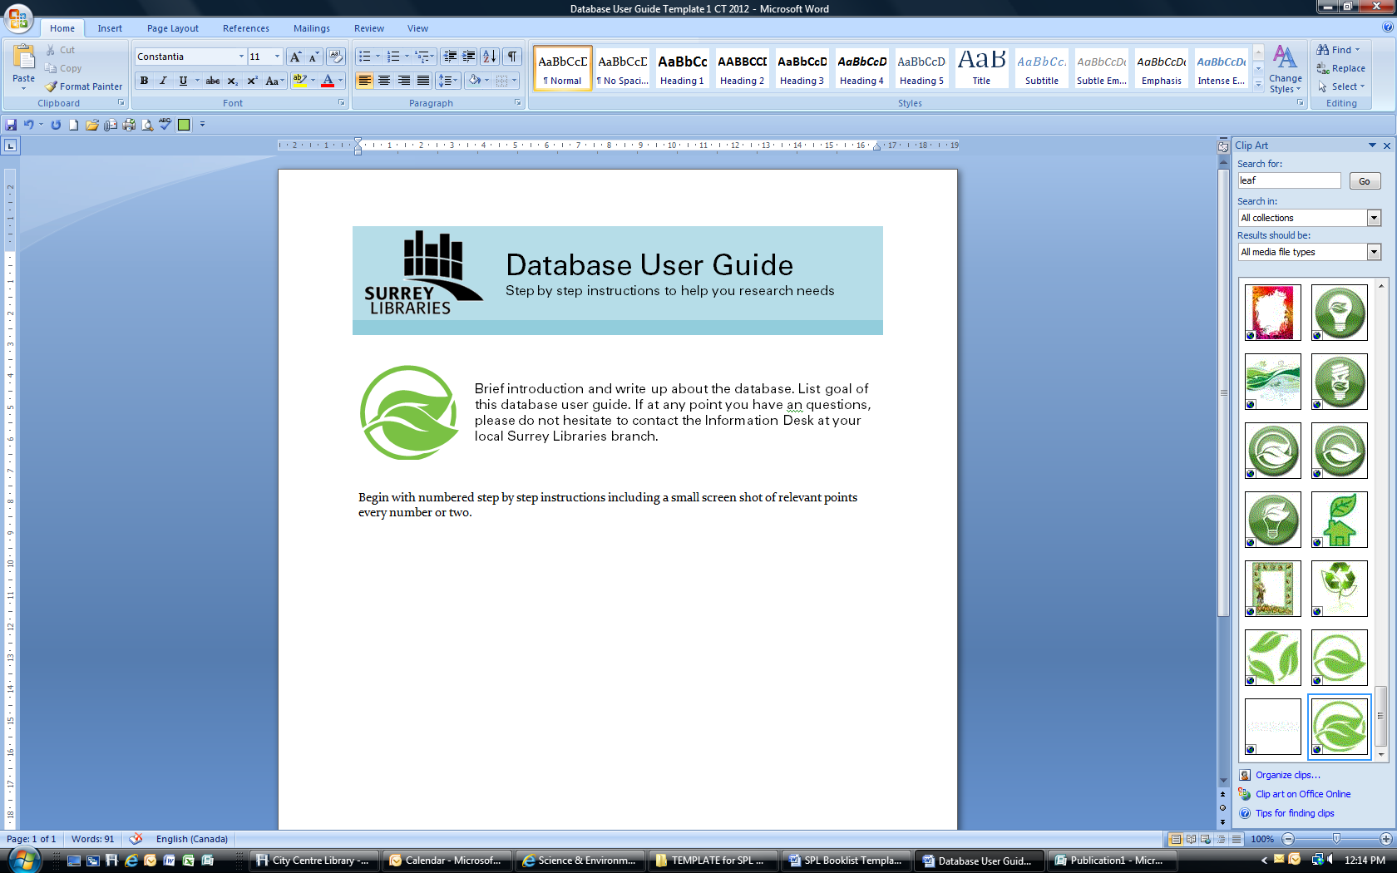

1. For help when making user guides, please see this article: <http://www.ehow.com/how_2131551_great-user-guide-almost-anything.html>
2. Outline where patrons can find more help, i.e. “For help when using this database, click the “Help Me!” button on the top right corner of the screen. Or, call the information desk or your local Surrey Libraries branch.”
3. Please use font type: Calibri, size 12. Proof read work and/or ask a colleague to read over and comment on clarity, simplicity/conciseness and flow ☺. Submit to Jennifer Wile for final proofing.