Appy Hour: Newspapers with PressReader

PressReader has digital versions of current newspapers and magazines from all over the world, in dozens of languages. PressReader keeps archives of all papers from 5 to 90 days.

Creating an Account

Before using the app, you will need to create a PressReader account via the WVML website.

- Open an internet browser (Google Chrome, Firefox, etc.) and type www.wvml.ca into the address bar.

- Hover your mouse over or tap Books & Media and then select Magazines & Newspapers

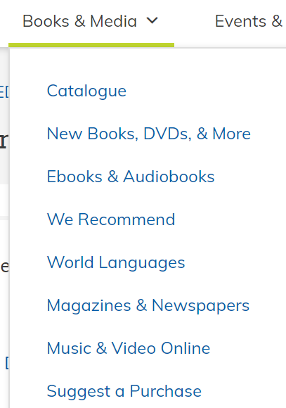

- Scroll down and select PressReader

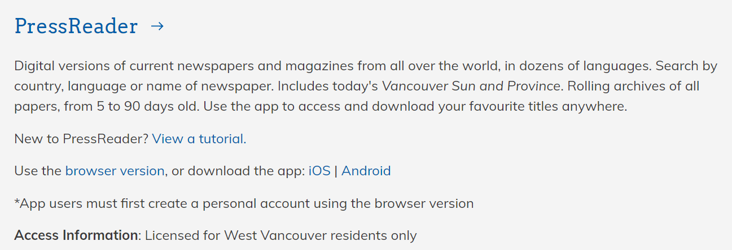
- You will be prompted to enter your library card number and PIN

- Then select Sign In at the top

- Then select New user? Sign up now and enter your first and last name, email address, and choose a password

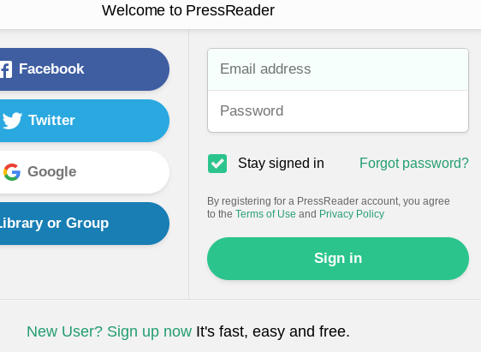

Downloading the App

Once you have created an account via the WVML.ca website, download the app by going to the Google Play Store (Android devices) or the App Store (Apple mobile devices) and searching for and installing PressReader.

Or you can also download the PressReader app by going to the WVML.ca website on your mobile device and selecting iOS (for Apple devices) or Android.

Please note the screen shots on pages 3-8 of this handout were taken using PressReader on an iPhone.
Tap on the app to open it and then select Sign in

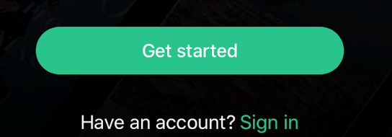

Then select Email and enter in your email address and password

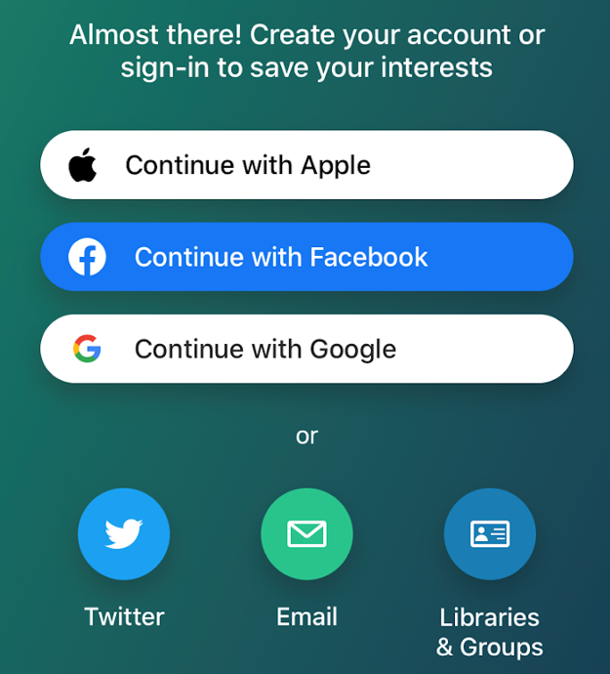

Finding Newspapers/Magazines

To Browse Publications
At the top of the screen, select Categories, Countries, or Languages to filter newspapers/magazines to your region/language/area of interest.
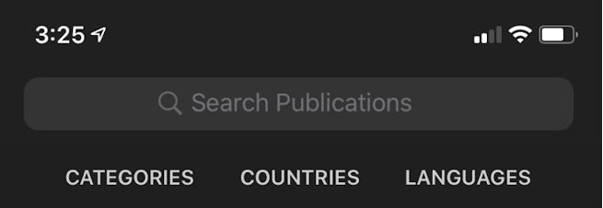
To Search for a Specific Publication
Enter the title or your keywords into the search box at the top of the screen
Please note that the due to restrictions from the publisher, the Globe and Mail is only available through the library’s wi-fi or when using one of the library’s public computers.
Reading Publications

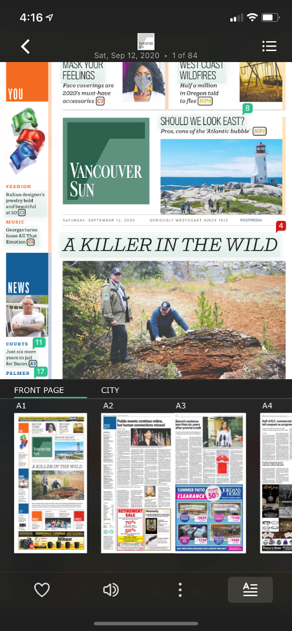

Once you have found a publication you would like to read, select Read and then tap on an article title to expand it.
Tap on the centre of the screen to bring up the menu.
The small numbers that appear at the top right of article titles indicate the number of comments left by readers. Tap on a number to read the comments.
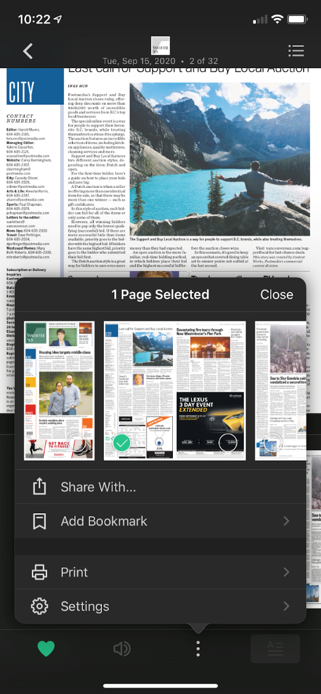
In a newspaper/magazine, select to share the page you’re on with someone, to bookmark the page, or to print the page.

After selecting Add Bookmark, select Save, or Create New Collection to create a folder of specific bookmarks.

View your bookmarks at any time by selecting Bookmarks at the bottom of your screen.
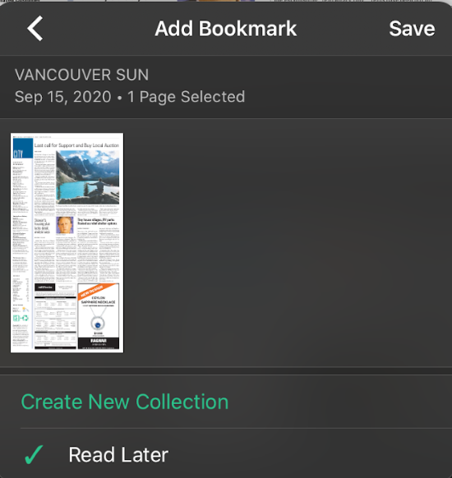
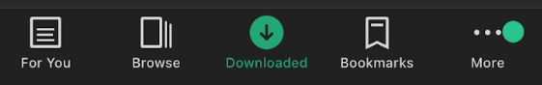
PressReader Settings

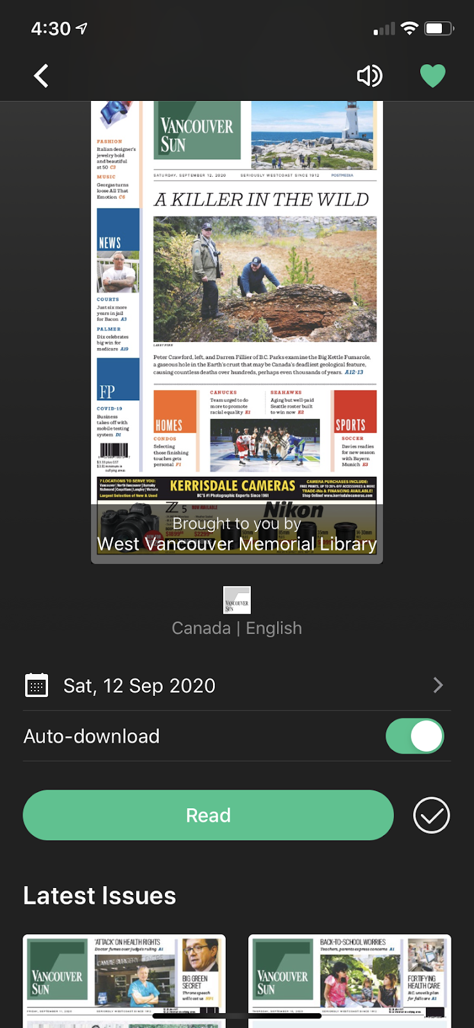
Once you find a publication you are interested in, you can:
Select the heart icon to add the publication to your favourites so that it appears in your home page.
Select the volume icon to hear the text read aloud.

Toggle the switch next to Auto-download so that new issues of the publication automatically download so that you can read them offline.
Select Read to read the publication.

Scroll down to see older issues. PressReader keeps an archive of back issues from 5 to 90 days, depending on the publication.

At any time you can select Downloaded at the bottom of the screen to see which publications you have downloaded and can read when not connected to wi-fi or data.
Select More at the bottom of the screen then Settings to adjust your storage and wi-fi settings
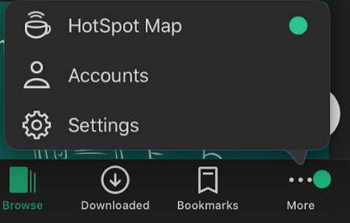
Toggle the switch to green to download issues over wi-fi only
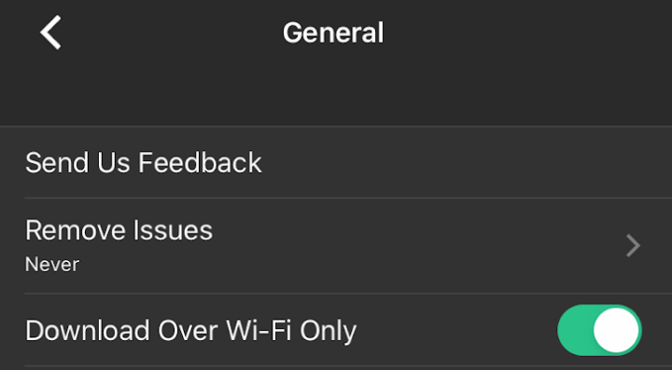
Select Remove Issues to change how many back issues you want PressReader to keep downloaded for publications you previously selected Auto-download for.
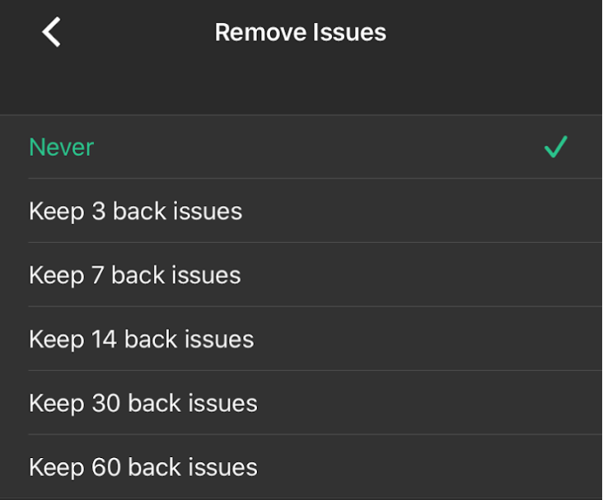
Learn More

- A PressReader tutorial is available via NicheAcademy https://my.nicheacademy.com/westvanlibrary/course/2373

For more information contact us through LibraryConnect at 604.925.7400 or tech@westvanlibrary.ca

