TYPING GUIDE 打字指南
- Click in the address bar, on top of the existing website
在地址欄上按一下現有的網址
- Type/輸入 sense-lang.org/typing/
- Press/按 ‘ENTER’ on your keyboard
To practice typing online, go to www.sense-lang.org/typing/
要在網絡上練習打字，請至：www.sense-lang.org/typing/

- Click on/按Tutorials
- Click on/按Lesson
- Click on the lesson you wish to complete
選擇您想要複習的課
Use this button to erase text to the left of your cursor. (Your cursor is the flashing black line that appears when you are typing)
用這個按鈕刪除在光標左邊的字(光標是在打字時一閃一閃的黑直線)
- Type the letters that you see above
打出屏幕上顯示的字母
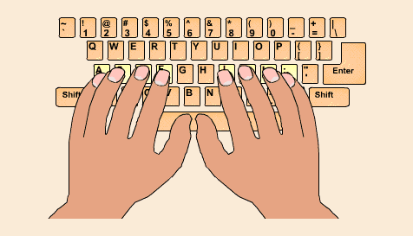How to place your fingers on the keyboard (鍵盤上該怎麼擺手指):
This set of keys is called your Home Row. This is where your fingers rest.
Your pointer fingers should rest on F and J.
這些按鍵是您的 “母排”。當您沒有在打字時或者是要剛開始打，手指都應該先到這個位置上。左手從小指至食指擺在A至F鍵。右手從食指至小指擺在J至 ; 鍵上。
Backspace

For the keys that have two characters on them such as the numbers (or to type capital letters), you must keep the Shift button held down and press the other key once. Most people use their pinky for Shift.
若想打出特別符號（同在數字鍵上的符號），要按住Shift鍵和那符號的按鍵。
*小提示:使用小指按Shift會比較簡單。

Example: For typing @, hold down Shift and press 2 once, and then let go of the keys.
例如: 想要打出@，按住Shift鍵並按下 2。

LEFT HAND左手  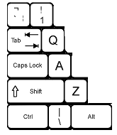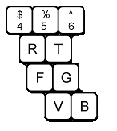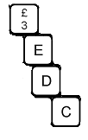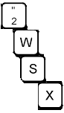  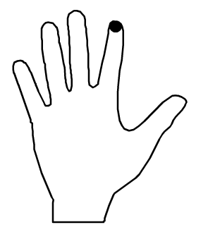  Use your thumbs to press the Spacebar  用您的大拇指按空白键 | RIGHT HAND右手  