This workbook belongs to:
calgarylibrary.ca/coding
2016
Coding Workbook
ADVANCED
Calgary Public Library
Calgary Public Library

Activity One

Today’s Module
http://studio.code.org/s/course3/stage/6/puzzle/1
- Learn about functions: how to define your own set of instructions that can be used in a program.
Vocabulary Words
- Function: a piece of code that you can easily call over and over again.

Today I Learned… (write or draw about something you learned today)

I Really Liked… (write or draw about something you enjoyed today)

Activity Two

Today’s Module
http://studio.code.org/s/course3/stage/11/puzzle/1
- Learn how to nest loops: repeat a set of instructions that includes a repeat loop.
- Once again, you’re practising pattern matching.
Vocabulary Word
- Loop: the action of doing something over and over again.
- Pattern Matching: Finding similarities between things.

Today I Learned… (write or draw about something you learned today)

I Really Liked… (write or draw about something you enjoyed today)

Activity Three

Today’s Module
http://studio.code.org/s/course3/stage/12/puzzle/1
- Today’s activity is about a different kind of loop: while loops.
- When you use a while loop, the action continues for as long as the statement is true.
Vocabulary Words
- Conditionals: Statements that only run under certain conditions or situations.
- Loop: the action of doing something over and over again.

Today I Learned… (write or draw about something you learned today)

I Really Liked… (write or draw about something you enjoyed today)

Activity Four

Today’s Module
http://studio.code.org/s/course4/stage/6/puzzle/1
- Learn about variables, an important part of coding.
- You are also working on the skills of pattern matching and abstraction.
Vocabulary Words
- Abstraction: Pulling out specific differences to make one solution work for multiple problems.
- Variable: A placeholder for a piece of information that can change.

Today I Learned… (write or draw about something you learned today)

I Really Liked… (write or draw about something you enjoyed today)

Activity Five

Today’s Module
http://studio.code.org/s/course4/stage/14/puzzle/1
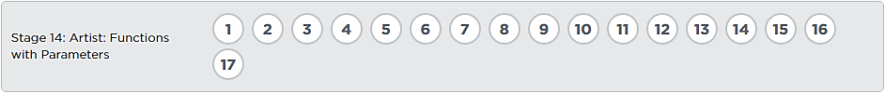
- Learn how to use parameters with your functions to create more useful programs.
Vocabulary Words
- Function: a piece of code that you can easily call over and over again.
- Parameter: An extra piece of information that you pass to the function to customize it for a specific need.

Today I Learned… (write or draw about something you learned today)

I Really Liked… (write or draw about something you enjoyed today)

Activity Six

Today’s Module
http://studio.code.org/s/course4/stage/15/puzzle/1
- Practise everything you learned by creating your own original game!
- When you’re done, share the link with your family and friends so they can play the game you created.
The link for your game is: (write it out carefully)

Today I Learned… (write or draw about something you learned today)

I Really Liked… (write or draw about something you enjoyed today)

Online coding modules are provided by Code.org under a Creative Commons Attribution-NonCommercial-ShareAlike 4.0 Unported license.
More information about this license can be found at https://creativecommons.org/licenses/by-nc-sa/4.0/

Vocabulary word definitions were taken directly from the glossary at code.org: https://code.org/curriculum/docs/k-5/glossary

