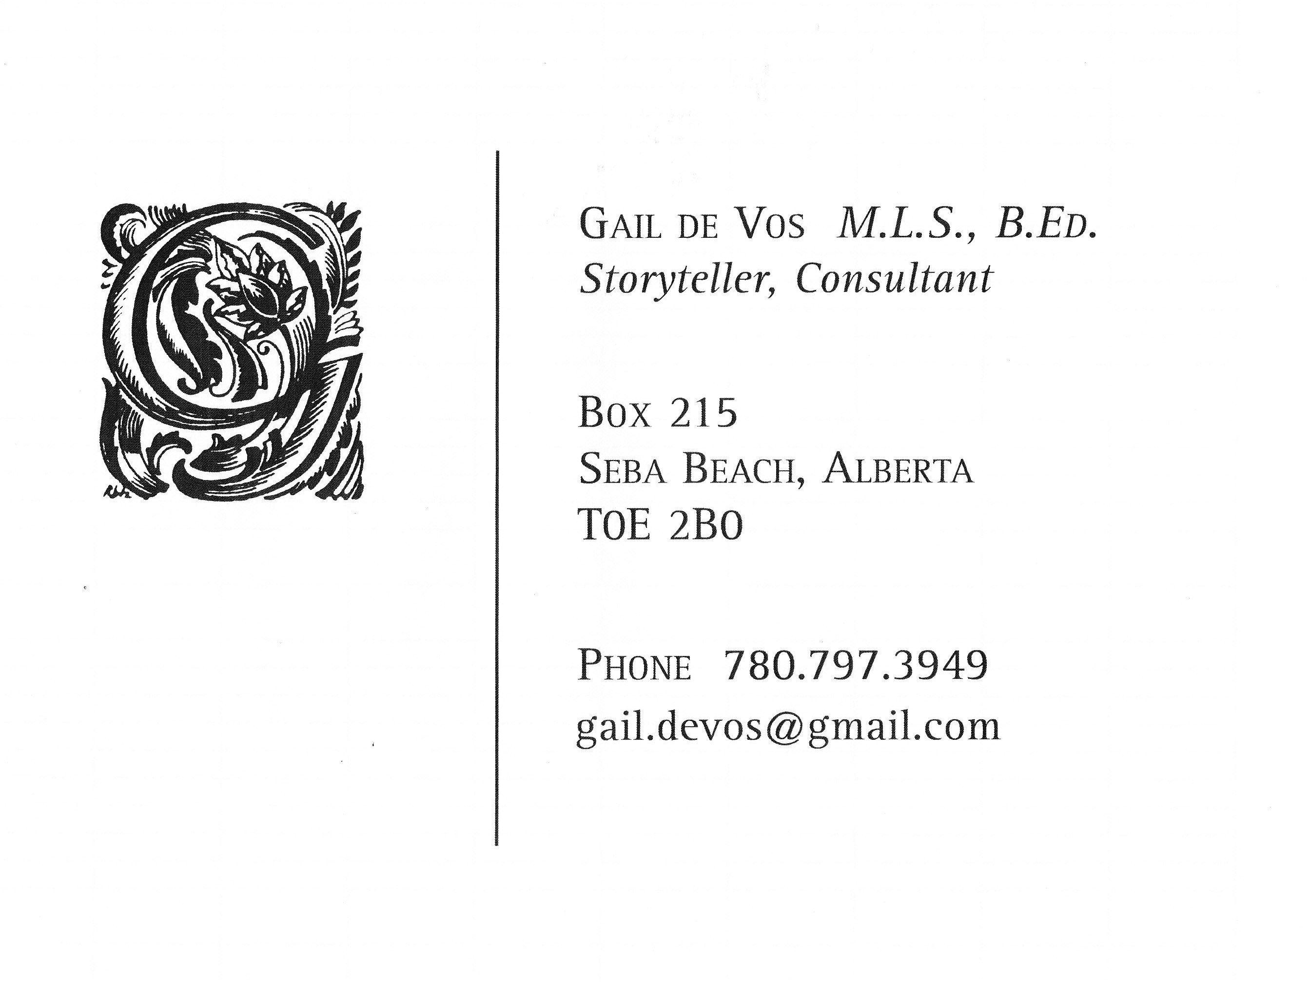

Bibliography for First Nations People in Picture Books Presented at the ALC Conference, April 28, 2018

Justice, Daniel Heath. Why Indigenous Literatures Matter. Waterloo, ON: Wilfred Laurier Press, 2018.

McCall, Sophie, Deanna Reder, David Gaertner and Gabrielle L’Hirondelle Hill, editors. Read. Listen. Tell: Indigenous Stories from Turtle Island. Waterloo, ON: Wilfred Laurier University Press, 2017.

Purdy, Joyce. “Aboriginal Children’s Literature in the Classroom.” Teacher-Librarian Today. 12:1, 2005, 14-19.

Reese, Debbie. “Authenticity and Sensitivity: Goals for writing and reviewing books with Native American Themes, December 1, 1999. online.

Reese, Debbie. “Proceed with Caution: Using Native American Folktales in the Classroom.” Language Arts 84:3, January 2007, 245-256.
Seale, Doris and Beverly Slapin. A Broken Flute: The Native Experience in Books for Children. Berkley, CA: AltaMira Press, 2005
Vowel, Chelsea. Indigenous Writes: A Guide to First Nations, Métis & Inuit Issues in Canada, Portage & Main Press, 2016.
Wolf, Doris and Paul DePasquale. “Home and Native Land: A Study of Canadian Aboriginal Picture Books by Aboriginal Authors.” In Words: Discourses in Children’s Literature in Canada. Edited by Doris Reimer, Wilfred Laurier University Press, 2008, 87-105.

Suggested Online Resources
http://wherearethechildren.ca/en/ This site is a counterpart to Where are the Children? Healing the Legacy of the Residential Schools, a touring exhibition that explores the history and legacy of Canada’s Residential School System through Survivor stories, archival photographs, and documents, curated by Iroquois artist Jeff Thomas. Includes a reading list for all ages.
Indigenous Publishers: http://guides.library.utoronto.ca/Aboriginalpublishers
Lakeland college http://libguides.lakeheadu.ca/c.php?g=412978&p=2814111
http://nativeappropriations.com/ Native Appropriations is a forum for discussing representations of Native peoples, including stereotypes, cultural appropriation, news, activism, and more.
https://americanindiansinchildrensliterature.blogspot.ca/ Debbie Reese. Established in 2006, American Indians in Children's Literature (AICL) provides critical perspectives and analysis of indigenous peoples in children's and young adult books, the school curriculum, popular culture, and society. Highly recommended.
http://www.oyate.org/ Oyate is pleased to provide resources that can help the Native peoples and the community at large. We strive to provide resources that teach respect for Native peoples and help parents and educators to provide their children with historically accurate, culturally appropriate information about Native peoples. “How to Tell the Difference” checklist http://www.oyate.org/index.php/resources/41-resources/how-to-tell-the-difference

http://cynthialeitichsmith.com/lit-resources/read/diversity/native-am/ Native American Children’s and Young Adult Books, website maintained by children’s book author Cynthia Leitich Smith, an enrolled member of the Muscogee (Creek) Nation.

Recommended Titles from the presentation
Auger, Dale. Mwakwa Tales to the Loon. Surrey, B.C. Heritage House, 2006.
Bouchard, David with illustrations by Allen Sapp. The Song within My Heart. Red Deer Press, 2013.

Boyden, Joseph, with illustrations by William Kent Monkman. Wenjack. Hamish Hamilton, 2016. [not recommended]

Budd, Robert, with illustrations by Roy Henry Vickers. Raven Brings the Light: A Northwest Coast Legend. Harbour Publishing, 2013.
Campbell, Nicola I., with illustrations by Julie Flett. A Day with Yayah.
Vancouver, BC: Tradewind Books, 2017.
Campbell, Nicola I., with illustrations by Kim LeFave. Shi-shi-etko. Toronto, ON: Groundwood/House of Anansi, 2005. Also mentioned: Shin-chi’s Canoe. Toronto, ON: Groundwood/House of Anansi, 2008.
Downie, Gord and Jeff Lemire. Secret Path. Toronto: Simon and Schuster, 2016.
Dupuis, Jenny Kay and Kathy Kacer. Illustrations by Gillian Newland. I am Not a Number. Toronto, ON: Second Story Press, 2016.
Eyvindson, Peter, and illustrated by Sheldon Dawson. Kookum’s Red Shoes. Pemmican, 2015.
Flaherty, Louise and illustrated by Jim Nelson. The Gnawer of Rocks. Iqualuit, Nunavut: Inhabit Media, 2017.
Flett, Julie. Wild Berries. Vancouver, BC: Simply Read Books, 2013.
Highway, Tomson. Illustrations by John Rombough. Caribou Song: Atihko Nikamon. Markham, ON: Fifth House, 2013.
Kalluk, Celina with Illustrated by Alexandria Neonakis. Sweetest Kulu Iqaluit, Nunavut: Inhabit Media, 2013.
King, Thomas, with illustrations by William Kent Monkman. A Coyote Columbus story. Toronto, ON; Groundwood, 1992
Kusugak, Michael Arvaarluk. Arctic Stories. Illustrated by Vladyana Langer Krykorka. Toronto, ON: Annick Press Ltd., 1998.
Kusugak, Michael Arvaarluk. Northern Lights. Illustrated by Vladyana Langer Krykorka. Toronto, ON: Annick Press Ltd., 1993.
Jordan-Fenton, Christy and Margaret Pokiak-Fenton. A Stranger at Home. Toronto, ON: Annick Press, 2011.
Jordan-Fenton, Christy and Margaret Pokiak-Fenton. Fatty Legs. Toronto, ON: Annick Press, 2010.
Jordan-Fenton, Christy and Margaret Pokiak-Fenton. When I Was Eight. Toronto, ON: Annick Press, 2013.
LaBoucane-Benson, Patti. Art by Kelly Mellings. The Outside Circle: A Graphic Novel. Toronto: House of Anansi, 2015.
Loyie, Larry with Constance Brissenden. As Long As The Rivers Flow, illustrations by Heather D. Holmlund. . Toronto, ON: Groundwood, 2002.
Olsen, Sylvia, Rita Morris, and Ann Sam. No Time to Say Goodbye: Children’s Stories of Kuper Island Residential School. Winlow, BC: Sono Nis Press, 2001.
Paquette, Aaron. Lightfinder. Neyaashiinigmiing, ON: Kegedonce, 2014.
Robertson, David A. Illustrations by Julie Flett. When We were Alone. Winnipeg, MB: Highwater Press, 2016.
Robertson, Joanne. The Water Walker. Second Story Press, 2017.
Syliboy, Alan. Thundermaker. Halifax, NS: Nimbus, 2015.
Van Camp, Richard. Illustrated by Scott B. Henderson. A Blanket of Butterflies. Winnipeg, MB: Highwater Press, 2015.
Van Camp, Richard. Illustrated by Julie Flettt. Little You. Victoria, BC: Orca, 2013.
Van Camp, Richard and illustrated by George Littlechild. What's The Most Beautiful Thing You Know About Horses? San Francisco: Children's Book Press, 1998.
Waboose, Jan Bourdeau and illustrated by Francois Thisdale. The Spirit Trackers. Markham On: Fifth House, 2017.
Yahgulanaas, Michael Nicoll. Red: A Haida Manga. Vancouver, BC: Douglas & McIntyre, 2009.

.

